92283 class 210, 212 EXAM 1 Oct 8, 2013

Class________ Class ID________ Name______________________

* 1. Normal distribution has three features, please list two: _**single peak, symmetric, bell shape**

* 1. The correlation between math SAT score (X) and total SAT score (Y) is about *R*= 0.9935.

The determination coefficient R2 of least-squares regression line of Y on X should be **0.9870**

* 1. What is the approximate range of Male Wrist Girths? **_5.0 or 14.5 - 19.5**

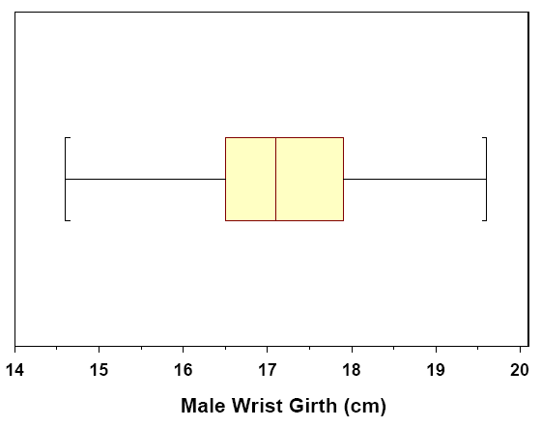

2. The following is a histogram showing the distribution of the average property damage caused by tornadoes per year over the period 1950 to 1999 in each of the 50 states and Puerto Rico. The data are in millions of dollars and the class intervals are 0 to - < 10, 10 to - < 20, and so forth.

 (Hint: the data total: 50 + 1 = 51)

2-1) The percent of the data with average property damage of under 20 million dollars is about

1. 20% b) 30% c) 40% **d)** 60%

**31/51 = 0.61, close to 60%**

2-2) The histogram

1. is skewed to the right b) is skewed to the left c) symmetric

3**. Histogram** Two types of fatty acids, omega-3 and omega-6 are obtained from food oils. Listed below are data of the **ratio** of omega-3 to omega-6 in some common food oils (such as walnut, salmon).

5.33, 0.20, 0.13, 0.38, *2.16*, 2.50, 0.06, 2.00, 0.11, *0.06,* 0.05, 0.08, 0.06, 0.05, *0.00,* 3.56, 0.46, 0.13, 0.00, *1.96,* 2.67, 0.07, 0.05, 0.64, *0.03,* 0.01, 0.01, 0.00, 0.02, *0.04*

3-1) Make a **frequency table** from these data, using classes bounded by the whole number from 0 to 6. Hint: Intervals are : 0 - < 1, 1 - < 2, 2 - <3, 3 - < 4, 4 - < 5, 5 - < 6

**Ratio Frequency**

**0-<1 23**

**1-<2 1**

**2-<3 4**

**3-<4 1**

**4-<5 0**

**5-<6 1**

3-2) Make a **histogram graph** using the above frequency table

3-3) What is the overall shape of the distribution? Is it roughly symmetric, skewed to the right, or skewed to the left?

**Skewed to the right**

3-4) How many of the 30 food oils have more omega-3 than omega-6 based on your histogram? Shade the area that the ratio of omega-3 to omega-6 is larger than 1.

**7 out of 30 foods that the ratio > 1** 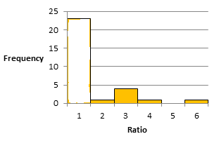

4. In many fast food restaurants, there is a strong correlation between a menu item's fat content (measured in grams) and its calorie content. We want to investigate this relationship. Using all of the food menu items at a well-known fast food restaurant, the fat content and calorie contents were measured. We decide to fit the least-squares regression line to the data, with **fat content**(*x*) as the explanatory variable and **calories** (*y*)as the response variable. A scatterplot of the data (with regression line included) and a summary of the data are provided. One of the menu items is a hamburger with 105 grams of fat and 1412 calories.

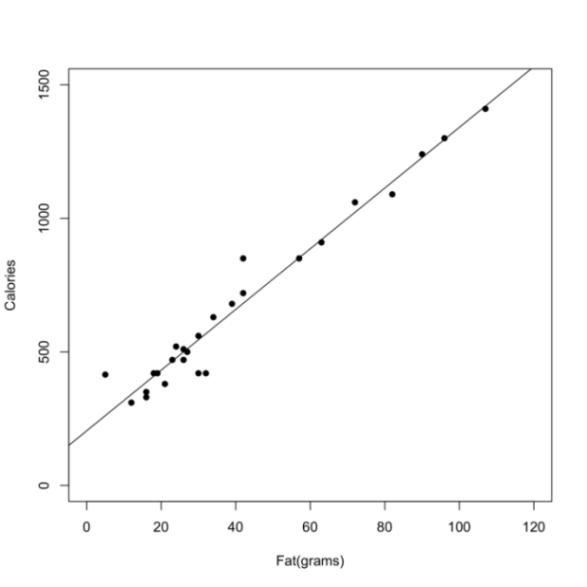

4-1) Least-square regression line is a linear math model describing how the response variable Y changes as the explanatory variable X changes. From the two data sets of X and Y, we got five constants which are used to calculate slope *b* and intercept *a*.

Please list the five constants (using symbol) ___**X-bar**_ __**y-bar**__ __**R**___ ___**Sx**__ ___**_Sy**___

4-2) Write out the regression equation **y-hat = *a* + *bx***

If we knew slope is 11.40, intercept is 203.00

**Y-hat = 203.00 + 11.40 X**

4-3) Refer to the example data point (105 grams, 1412 calories). What is the **residual** corresponding to this observation? Please write the calculation process.

Hint: **residual = y - ‘y-hat’**. calculate y-hat first.

For point (105 grams, 1412 calories) , x= 105, y= 1412

**Y = 1412 calories**

**Y-hat = 203.00 + 11.40 x 105 = 1400 calories**

**Residual = Y – Y-hat = (1412 –1410) calories = 12 calories**

.

**5. Body mass index.** Your body mass index (BMI) is your weight in kilograms divided by the square of your height in meters. High BMI is a common but controversial indicator of overweight or obesity. A study by the National Center for Health Statistics found that the BMI of American young women (ages 20 to 29) is approximately Normal with mean 26.5 and standard deviation 6.4.

|  |  |
| --- | --- |
|  | 1. People with BMI less than 18.5 are often classified as “underweight.” What percent of young women are underweight by this criterion? |
|  | 1. People with BMI over 30 are often classified as “obese.” What percent of young women are obese by this criterion?   [Hint]: Solve the problem step by step. Draw graphs for each case separately, shade the area that the question asked for.   1. **N(26.5, 6.4)**   **X0 = 18.5**  **Z0 = (18.5 – 26.5)/ 6.4 = -1.25**  **P (z< -1.25) = ? Type I, result read from Table A directly**  **P (z< -1.25) = 0.1056** |
|  | 1. **Type II,** |

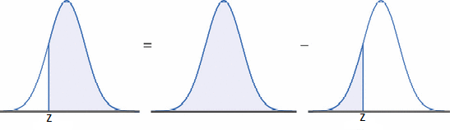

**P (Z > Z0) = 1 – P (Z<Z0) = 1- Table entry**

**Z0 = (30- 26.5)/ 6.4 = 0.547**

**P (Z < 0.547) = 0.7088**

**P (Z > 0.547) = 1 - 0.7088 = 0.2912**