Midterm Exam
Introductory Modern Physics
95.210
Instructor: Prof. Wasserman
3/12/09

Name: __________________________
ID: _______________________

The exam is 75 minutes long and consists of 5 problems, one of which is the short answer section, which has 5 sub-problems. The point values for each problem and sub-problem are given in parentheses after the problem. You are allowed 1 “cheat-sheet” with physical constants, formulas, and notes. No solved problems may be on your cheat sheet. A calculator will be required for this exam.
Please write your answers clearly in the space provided and SHOW YOUR WORK!! Partial credit will be awarded for the long answers (assuming your work is legible).

Please put your last name on each page of the exam.

Problem 1: Short Answer, No Partial Credit (4 pts each).

  - X-Rays are generated in a cathode ray tube. The bremsstrahlung spectrum cuts off at a minimum wavelength λ=0.18nm. From this give the voltage in the tube (in Volts).

  - What is the DeBroglie wavelength (in meters) of a Papelbon fastball? Assume a baseball weighs 142g and Papelbon throws at 100mph.

  - Electrons are incident on a crystal with spacing d=0.2nm between crystal planes. At an incidence angle of 30º (from normal to the crystal planes) a strong peak is seen in the diffracted light. What is the longest possible wavelength of the electrons (in nm)?

  - Using the kinetic theory of matter and the equipartition theorem, what is the specific heat per mole (C_{v}) of Silicon crystal?

a) 3/2kT b) 3RT c) 3/2 d) 3R

  - A blackbody source at 500K is emitting a spectrum with a peak wavelength of 5.7µm. If the blackbody is heated to 700K, what will the shift in the emission spectrum’s peak wavelength be? (Answer in microns)

- (20 pts) The following plot shows the current as a function of voltage between an anode and a silver cathode. Assume the silver cathode is irradiated with light of λ = 198nm.

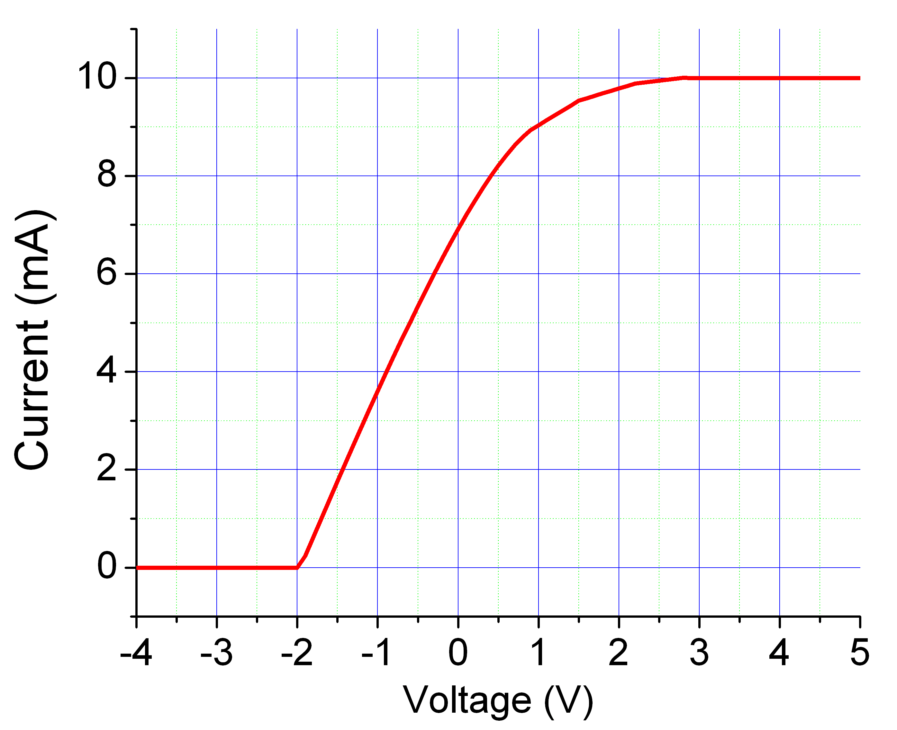
- From the graph above determine the Silver work function (in eV). (8pts)

- Using the graph above, what is the photon flux incident on the silver cathode (photons/s). Determine the power of the light beam incident on the Ag cathode (in J/s). (6pts)

- Assume incident photons of frequency f = 8x10¹⁴ s⁻¹ are now incident on the silver cathode, what is the new stopping potential? (6pts)
- (30 pts) Electromagnetic waves are confined in a 1D cavity of length L, with perfect conductors at x=0 and x=L.

- Give the boundary conditions for this system, express the electric field in the cavity as a function of position (x) and time (t), as well as the integer n_{x}. Show your expression for the electric field satisfies the wave equation 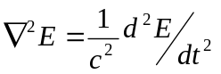. What are the conditions required to satisfy the wave equation? (10pts)

- Give the number of modes (N) within a “radius” of n. Use this to find the linear density of modes (dn/dλ)= (dN/dλ)/L (10pts)

- What is the energy density of such a system ((du/dλ) = (dU/dλ)/L), assuming the classical derivation of the average energy per mode? Does this make sense physically (assuming that such a cavity is physical)? Why or why not? Where is the problem in the derivation of du/dλ , and how do we overcome this?(10pts)

- (15pts) Assume a Bohr model of the Helium atom (Z=2) and assume each electron sits in a different orbit.

  - Assuming the Helium atom likes to be in the lowest possible energy configuration, what are the energies of the two electrons in the atom? (5pts)

  - What is the longest wavelength photon capable of removing an electron from the He atom? (5pts)

  - A photon incident on the He atom excites the ground state electron (n=1) to the n=3 orbit. After excitation, two photons are observed to be emitted from the atom. What are the wavelengths of these photons? (5pts)

- In the reference frame S, a rocket car on the great salt flats leaves position x₁=0m at t₁=0s. The car hits an unfortunately-placed boulder at x₂=5000m, 0.02 milliseconds later (again in reference frame S). Assume the car travels at a uniform velocity, and only in the x direction. If it helps, imagine a ruler stretching from x₁=0m to x₂=5000m. An observer sits in the rocket car (frame of reference S’).

  - Give the proper time between start and collision and the proper length of the imaginary ruler, and the reference frame for each. (8pts)

  - What is the spacetime interval for the start and end of the rocket’s travel in each reference frame? Are the spacetime intervals between the two events “spacelike”, “timelike”, or “lightlike” (7pts)

h = 6.626 x 10⁻³⁴ m²kg/s or (J-s) = 1.44 x 10⁻¹⁵ eV-s
ħ = 1.055 x 10⁻³⁴ m²kg/s or (J-s)
1 mile = 1609.34 m
E_{o}=13.6eV
e or q = 1.6 x 10⁻¹⁹ C
c = 3 x 10⁸ m/s

