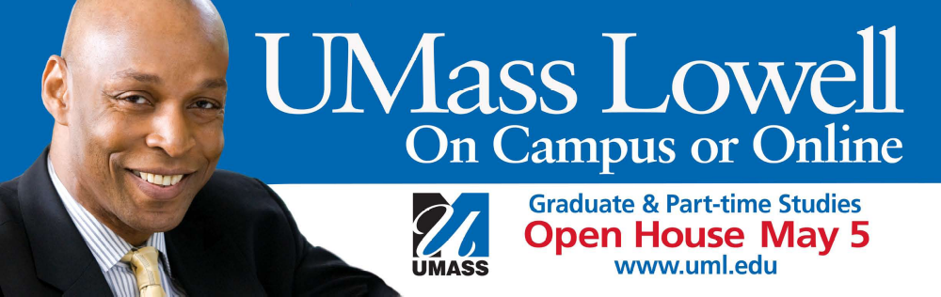

Graduate Open House
For All Bachelors to Master’s Programs

If you’re a qualifying UMass Lowell undergraduate, you may be eligible for the Bachelors to Master’s Program. If you do, the GRE and Application Fee may be waived. In addition, you may be able to save $3,000.

Let us show you how. Come to:

The UMass Lowell Inn & Conference Center, 50 Warren Street, Lowell
Wednesday, May 4 from 4-7 pm

Speak with Graduate Faculty! Registrar’s Office, Graduate Admissions, Financial Aid, International Students Office and Student Accounting Services staff will be available. Come investigate the opportunities! NO RSVP required.

For a complete list of Master’s Programs go to http://www.uml.edu/grad/Programs_of_Study/Masters_Programs.html

Refreshments will be available Entertainment Raffle Prizes

