Lecture 1: Patterns of Violent Offending and Victimization

What we will cover:
- We will examine the official statistics on the nature and extent of violence in America, focusing on four types of violent crime: murder, rape, robbery, and aggravated assault.
- We will compare these results to data compiled by the National Crime Victimization Survey, highlighting the recent decline in violence in the United States identified in both official, reported crime statistics and in the NCVS survey data.
- We will examine the likelihood of each type of violent crime occurring by both time and place.

Our Top 8 introductory lecture topics are organized as follows:
Topic 1: The nature and extent of violence in America
Topic 2: An Alternative View: the National Crime Victimization Survey
Topic 3: Murder in America
Topic 4: Rape in America
Topic 5: Robbery in America
Topic 6: Aggravated Assault in America
Topic 7: How often does violent crime really happen?
Topic 8: Where does violence occur?

Topic 1: the nature and extent of violence in America
Perhaps the best way to begin a discussion of our country’s violence problem is to define what we mean by violence and then take a quick look at the numbers. According to the FBI report, Crime in 2013,
Violent crime is composed of four offenses: murder and non-negligent manslaughter, forcible rape, robbery, and aggravated assault. Violent crimes are defined in the Uniform Crime Reporting (UCR) Program as those offenses which involve force or threat of force.
We will examine each of these crime types in detail, while also considering the situational context related to each type of violent behavior, which leads to an assessment of family, gang, workplace, school, community, and institutional violence.
The summary below from the FBI’s webpage provides the most recent data on the extent of this country’s violence problem, highlighting recent trends in each violent crime area. For more information, I suggest that you check out the following link from the FBI’s webpage:
https://www.fbi.gov/about-us/cjis/ucr/crime-in-the-u.s/2013/crime-in-the-u.s.-2013

Overview of key findings from the most recent FBI report on violence in the United States

Overview
- In 2013, an estimated 1,163,146 violent crimes occurred nationwide, a decrease of 4.4 percent from the 2012 estimate.
- When considering 5- and 10-year trends, the 2013 estimated violent crime total was 12.3 percent below the 2009 level and 14.5 percent below the 2004 level.
- There were an estimated 367.9 violent crimes per 100,000 inhabitants in 2013, a rate that declined 5.1 percent when compared with the 2012 estimated rate.
- Aggravated assaults accounted for 62.3 percent of violent crimes reported to law enforcement in 2013. Robbery offenses accounted for 29.7 percent of violent crime offenses; rape (legacy definition) accounted for 6.9 percent; and murder accounted for 1.2 percent.
- Information collected regarding types of weapons used in violent crime showed that firearms were used in 69.0 percent of the nation’s murders, 40.0 percent of robberies, and 21.6 percent of aggravated assaults.

As illustrated in the figures below, the past few years have been marked by significant fluctuations in the overall number of violent crimes reported in the United States ( compare increases in early 2000s to decreases in last few years). The longer term trend –comparing the eighties and nineties crime figures to these numbers is downward, which is a good sign.
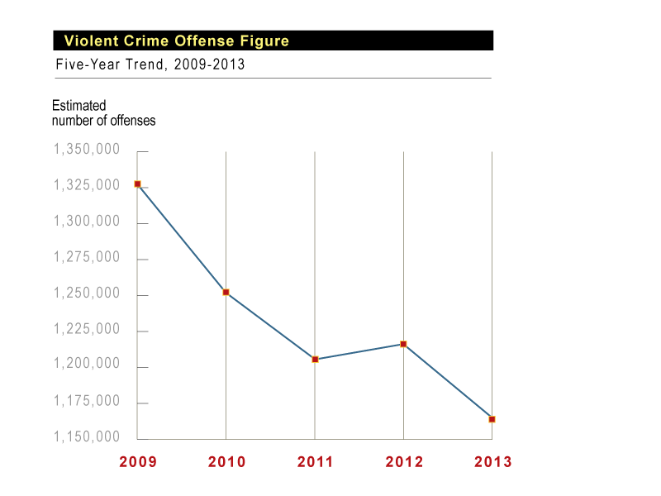

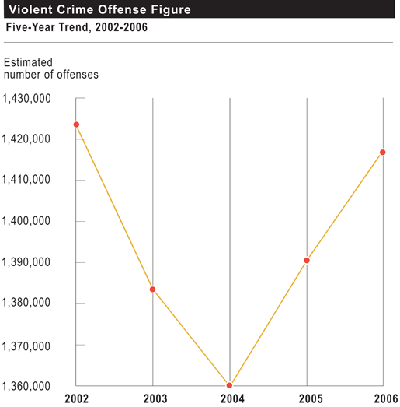

I would recommend that you go to the link below and explore these violence trends in more detail, including twenty-five year trends (1990-2015) in reported violence. What does your examination of these longer term trends suggest?
http://www.statista.com/statistics/191219/reported-violent-crime-rate-in-the-usa-since-1990/
Let me offer my perspective on these recent trends in violence.
Contrary to what many people believe, we have seen a decline in most categories of reported violent crime over the past decade (down 13.3% from the violent crime total in 1996), but we are likely to see an upsurge in the coming decade due to a variety of factors (the size of the young adult population, recent immigration shifts, downturn in the economy). At present, our rate of reported violence is about the same rate as 1972, the year we started to recognize that we had a serious crime problem in this country and crime became a major political issue in both political parties’ campaign platforms. Interestingly, what we now consider as a low crime rate (2006 vs 1996) was viewed then as an unacceptably HIGH crime rate (mid70’s vs mid 60’s) . Times change—and our perception of the extent/seriousness of this country’s violence problem changes over time—sometimes perception fits reality; sometimes it doesn’t.

Topic 2: an Alternative View: the National Crime Victimization Survey

In addition to crimes reported to police, we collect data on the extent of the violence problem by surveying the general public about their victimization experiences—if any—and asking them whether they reported these victimizations to the police. These data offer an alternative to official reported crime statistics. When both data sources agree, we can be more confident in using these estimates to measure crime. According to victimization surveys, we are experiencing the lowest violent victimization since we began collecting these data. Below are the HIGHLIGHTS from the 2014 National Crime Victimization Survey:
Violent Crime Victimization Trends
1. No significant change occurred in the rate of violent crime from 2013 (23.2 victimizations per 1,000) to 2014(20.1 per 1,000).
2. From 2013 to 2014, no statistically significant change was detected in the rate of serious violence, domestic violence, intimate partner violence,
violence resulting in an injury, and violence involving a firearm.
3. No significant change was found in the percentage of violent crime reported to police from 2013 to 2014 (46%).
4. About 12% of victims of serious violence and 28% of intimate partner violence victims received assistance from a victim service agency.
5. No change was observed in the percentage of violent crime victims who received assistance from a victim service agency from 2013 to 2014.

Prevalence of violent crime victimization:
1. In 2014, 1.1% of all persons age 12 or older (3 million persons) experienced at least one violent victimization.
2. An estimated 0.5% (1.2 million persons) experienced at least one serious violent victimization in 2014. (Source: National Crime Victimization Survey, 2014, Bureau of Justice Statistics)

It is important to consider that since violence rates vary over time, it matters which time period you select for comparison; we sometimes get too caught up in year to year—and even decade to decade-- changes in specific crime categories and miss the bigger, long term trends. I suspect that violence is a problem that will always be with us, but it is important to understand why it peaks when it peaks and why it drops when it drops. We will spend the semester exploring the answer to this critical public policy question .In the following section, I will provide a brief description of the four major crime categories we will study—murder, rape, robbery, and assault—including how each crime category is defined by the FBI, the federal agency responsible for collecting data on violent crime, and on the number of violent crimes reported to the police each year. As you examine these data, be sure to keep in mind that(1) a significant proportion of all violent crimes, close to 50 %, are never reported to the police( see figure below), and (2) the percentage of crimes reported to the police has been increasing, which will make interpreting the meaning of crime trends more difficult. We will be forced to consider whether the trend represents a change in the level/rate of violent crime or a change in reporting behavior. We will examine this reporting problem in a later lecture, but it’s important to keep in mind as you assess the seriousness/extent of the violence problem in this country.
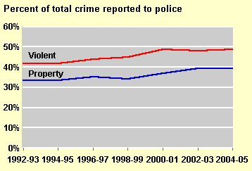

Percent of victimizations reported to police, by type of crime,
2005, 2013, and 2014
Type of crime 2005 2013 2014
Violent crime 45.8% 45.6% 46.0%
Rape/sexual assault 35.1 34.8 33.6
Robbery 55.4 68.0 60.9
Assault 44.9 43.4 44.6
Aggravated assault 65.0 64.3 58.4
Simple assault 39.4 38.5 40.0
Domestic violence 53.0 56.9 56.1
Intimate partner violence 56.9 57.0 57.9
Stranger violence 48.1 49.6 48.8
Violent crime involving injury 59.6 55.5 54.9
Serious violent crime 59.1 61.0% 55.8%
Serious domestic violence 61.4 65.3 60.0
Serious intimate partner violence 57.4 60.4 56.7
Serious stranger violence 53.4 ‡ 61.9 65.4
Serious violent crime involving weapons 64.0 65.7 57.6
Serious violent crime involving injury 64.5 66.2 61.0
For further information on national crime victimization trends, you can check out the following Bureau of Justice Statistics webpage:
http://www.bjs.gov/content/pub/pdf/cv14.pdf

Topic 3: Murder in America

We will examine the crime of murder in detail later in the term, but as an introduction to this topic, we will briefly examine data on short and long term homicide trends. There are a number of ways to talk about homicide, but I find it useful to begin by observing that most murderers know their victims; only a small percentage of murderers killed people that they did not know. The exceptions are the cases of mass murder and serial killers, but even here there is sometimes a connection. For example, the recent mass murder incident in San Bernardino California occurred at the workplace of one of the assailants, which indicates that he knew at least some of the murder victims. The school shootings at Columbine, Virginia Tech, and Newington Connecticut (2012) also represent examples of a prior relationship between offenders and victims of homicide. Of course, as horrific as these mass murders are to experience directly and indirectly, they represent only a fraction of the approximately 15,000 homicides that occurred on average each year for the past decade.
Defining Homicide:
The Uniform Crime Reporting (UCR) Program defines murder and non-negligent manslaughter as the willful (non-negligent) killing of one human being by another.The classification of this offense is based solely on police investigation as opposed to the determination of a court, medical examiner, coroner, jury, or other judicial body. The UCR Program does not include the following situations in this offense classification: deaths caused by negligence, suicide, or accident; justifiable homicides; and attempts to murder or assaults to murder, which are scored as aggravated assaults.

Overview: Murder in the United States
- In 2014, the estimated number of murders in the nation was 14,249. This was a 0.5 percent decrease from the 2013 estimate, a 3.2 percent decrease from the 2010 figure, and a 14.9 percent drop from the number in 2005.

- There were 4.5 murders per 100,000 people. The murder rate fell 1.2 percent in 2014 compared with the 2013 rate. The murder rate was down from the rates in 2010 (6.1 percent) and 2005 (20.8 percent).

- Of the estimated number of murders in the United States, 46.0 percent were reported in the South, 20.5 percent were reported in the Midwest, 20.5 percent were reported in the West, and 13.1 percent were reported in the Northeast.

Long term trends in Homicide

When we step back and take a historical look at homicide trends, we see that the last time the homicide rate approached its late 19880s/early 1990’s peak was during the final years of prohibition. From alcohol wars in the early 1930s to the drug wars of the early 1990’s, one pattern is clear: alcohol and drug prohibition has contributed to this country’s homicide problem.
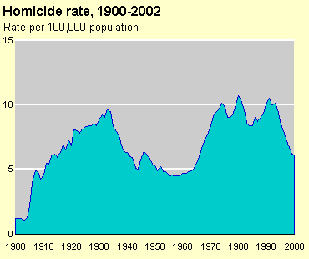

Other Facts to Consider about homicide:
Besides offender/victim relationship, a few other basic facts about the crime of homicide should be mentioned at the outset of our discussion of violence in the United States. First, the handgun is the weapon of choice in homicides: about half of all homicides each year are committed using a handgun. We also know that the regions of the country with the most guns per capita have the highest recorded rates of homicide (and other forms of violence). While the circumstances surrounding the homicide id unknown in about a third of all cases, we know that homicides often occur as the result of a fight or argument, in situations that often involve both victim precipitation and the use of drugs and/or alcohol by both the offender and the victim. Homicide is a crime that disproportionately affects youth, both in terms of offending and victimization; and in particular, it disproportionately affects young minority males, again as both victims and as offenders. We will explore the reasons behind these disturbing facts in a later lecture.
To review additional homicide data, you can go to the FBI’s website:
https://www.fbi.gov/about-us/cjis/ucr/crime-in-the-u.s/2013/crime-in-the-u.s.-2013/violent-crime/murder-topic-page/murdermain_final

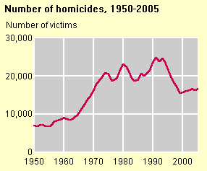
Source: FBI, Uniform Crime Reports, 1950-2005

Topic 4: Rape in America
Another form of violence covered in this course is the crime of rape. As the authors of our text, Mark Riedel and Wayne Welch have observed, “Rapes and sexual assaults take many different forms. Victims are young as well as old, male as well as female, and from various racial backgrounds and income levels”( 2011, 105). There were slightly more than 54,000 rapes reported to the police in 2013; of this total, approximately 40% of these rapes were cleared by arrest (or exceptional means). However, overall clearance rates for rape will vary by region, city size, and other factors that we discuss in detail in a later lecture.

Definition
Forcible rape, as defined in the Uniform Crime Reporting (UCR) Program, is the carnal knowledge of a female forcibly and against her will. Assaults and attempts to commit rape by force or threat of force are also included; however, statutory rape (without force) and other sex offenses are excluded.

Sexual Assault Official Reporting Practices
The UCR Program counts one offense for each female victim of a forcible rape, attempted forcible rape, or assault with intent to rape, regardless of the victim’s age. A rape by force involving a female victim and a familial offender is counted as a forcible rape not an act of incest. The Program collects only arrest statistics concerning all other crimes of a sexual nature. The offense of statutory rape, in which no force is used but the female victim is under the age of consent, is included in the arrest total for the sex offenses category. Sexual attacks on males are counted as aggravated assaults or sex offenses, depending on the circumstances and the extent of any injuries.

Overview: Rape in the United States
Like other crimes of violence, the number of reported rapes has dropped sharply over the past two decades, perhaps a sign of our country’s changing attitudes about violence generally and sexual assault in particular. In 1994, there were 102, 214 rapes reported in the United States. This number has dropped significantly over the past twenty years. There were an estimated 79,770 rapes reported to law enforcement in 2013. This estimate was 6.3 percent lower than the 2012 estimate, and 10.6 percent and 16.1 percent lower than the 2009 and 2004 estimates, respectively. The rate of rapes in 2013 was estimated at 25.2 per 100,000 females. Are we changing our attitudes and behaviors regarding sexual assault? The recent reports of the extent of sexual assault victimizations on our college campuses certainly challenge this interpretation of these data. Similarly, we are hearing more and more each year about the serious problem of sexual assault in the military, and about the long term problem of sexual assault in prison and jail settings. The recent reports of sexual assault via the internet and the increased arrests for sexual solicitation on the web challenge the notion that sexual assault is decreasing nationally. Perhaps it is simply changing its location. The movement of sex trafficking to the harder to detect darkweb is yet another facet of the sexual assault problem we will explore in this course.

Additional Facts to Consider about the Crime of Rape:

Expanded offense data provide details of the various sexual assault offenses. These details may include the type of weapons used in a crime, type or value of items stolen, and so forth. In addition, expanded data include trends (for example, 2-year comparisons) and rates per 100,000 inhabitants. Expanded information regarding forcible rape is available in the following tables found on the link below:
https://www.fbi.gov/about-us/cjis/ucr/crime-in-the-u.s/2013/crime-in-the-u.s.-2013/violent-crime/rape

Topic 5: Robbery in America
The third major crime type covered in this course is robbery.

Definition
The Uniform Crime Reporting (UCR) Program defines robbery as the taking or attempting to take anything of value from the care, custody, or control of a person or persons by force or threat of force or violence and/or by putting the victim in fear.

Overview: Robbery in the United States

Number of Robberies is decreasing: There were an estimated 345,031 robberies nationwide in 2013. The estimated number of robberies decreased 2.8 percent from the 2012 estimate and 15.6 percent from the 2009 estimate.

Rate of Robbery is decreasing: The estimated robbery rate of 109.1 per 100,000 inhabitants showed a decrease of 3.5 percent when compared to the 2012 rate.

Cost of Robbery: In 2013, the average dollar value of property stolen per reported robbery was $1,170. Robberies accounted for an estimated $404 million in losses. Banks experienced the highest average dollar loss at $3,542 per offense.

Methods of Robbery: Among the robberies for which the UCR Program received weapon information in 2013, strong-arm tactics were used in 43.6 percent, firearms in 40.0 percent, and knives or cutting instruments in 7.6 percent. Other dangerous weapons were used in 8.9 percent of robberies in 2013.

Guns and Robbery: Firearms were used in 42.2 percent of robberies for
which the UCR Program received supplementary data.

More details on Robbery
The FBI collects additional information about robbery, in an attempt to better understand the nature and scope of this crime.These details may include the type of weapons used in a crime, type or value of items stolen, and so forth. In addition, expanded data include trends (for example, 2-year comparisons) and rates per 100,000 inhabitants. It appears that street robbery is the most common type of robbery being committed in the United States.The figure below highlights where robberies occur. Why and how does location matter?
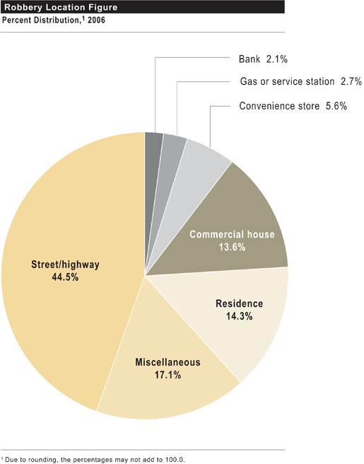

Browse by
Topic 6: Aggravated Assault in America
We will also examine the crime of physical assault in this course. Following the pattern of other violent crimes, aggravated assaults continue to decline across the country.

Definition
The Uniform Crime Reporting (UCR) Program defines aggravated assault as an unlawful attack by one person upon another for the purpose of inflicting severe or aggravated bodily injury. The Program further specifies that this type of assault is usually accompanied by the use of a weapon or by other means likely to produce death or great bodily harm. Attempted aggravated assault that involves the display of—or threat to use—a gun, knife, or other weapon is included in this crime category because serious personal injury would likely result if the assault were completed. When aggravated assault and larceny-theft occur together, the offense falls under the category of robbery.

Overview: Aggravated Assault in the United States
- In 2013, there were an estimated 724,149 aggravated assaults in the nation. The estimated number of aggravated assaults decreased 5 percent when compared with the 2012 estimate and 14.5 percent when compared with the 2004 estimate.

- The estimated rate of aggravated assaults in 2013 was 229.1 per 100,000 inhabitants. A 10-year comparison of estimated data from both 2004 and 2013 showed that the rate of aggravated assaults dropped 20.6 percent.

- Of the aggravated assault offenses in 2013 for which law enforcement provided expanded data, 27.0 percent were committed with personal weapons, such as hands, fists, or feet.

- Firearms were used in 21.6 percent of aggravated assaults, and knives or cutting instruments were used in 19.1 percent. Other weapons were used in 32.2 percent of aggravated assaults.

Topic 7: How often does violent crime really happen?
The media loves to tell the public about the likelihood of a violent crime and the risk of various types of violent victimization. The crime clock provides this information in summary form, but as you look at the crime clock, you should ask yourself: are some people more “at risk” than others? Are some places riskier places to live, work, or visit than others? And does risk—for individuals and or places—vary by the type of violent crime being examined? The answer to each of these questions is yes, which is why you should be careful when you examine violent crime at this level of analysis.

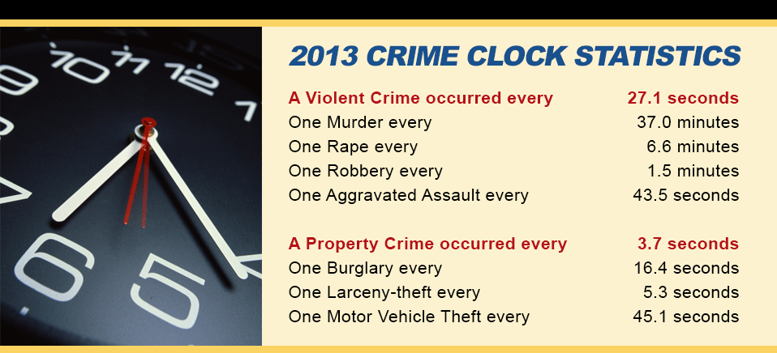

Crime Clock
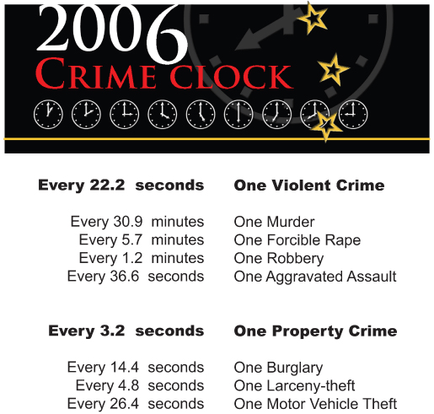

Topic 8: Where does violence occur?

As you can see from the figure below, some regions of the country are more violent than others. For crimes of violence, it is the South that has the highest rate of violence, followed—but not too closely—by the West.
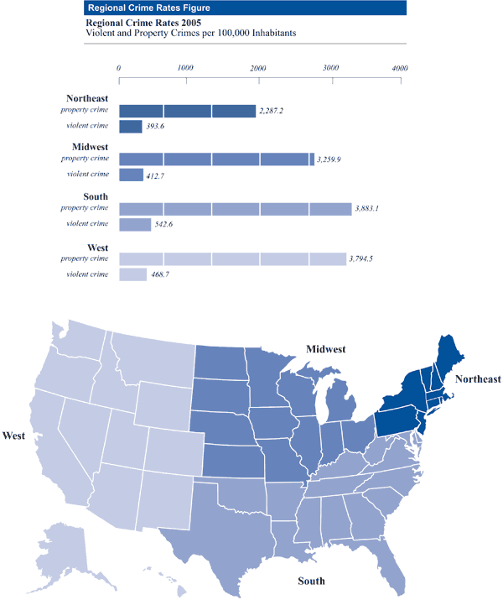

Concluding comments
We conclude our initial discussion of the violence problem in the United States by returning to the most recent official statistics available from the FBI on how many violent crimes are actually solved each year. Go to the link below and you will see the latest data on the clearance rates for each of the violent crimes mentioned here:
https://www.fbi.gov/about-us/cjis/ucr/crime-in-the-u.s/2013/crime-in-the-u.s.-2013/offenses-known-to-law-enforcement/clearances/13clearance.gif

Questions for our week 1 discussion:

I have presented a number of possible discussion questions for your consideration in this lecture, but I would like you to comment on one of the following:
1. What does your examination of long term trends in violence reveal?
https://www.fbi.gov/about-us/cjis/ucr/crime-in-the-u.s/2013/crime-in-the-u.s.-2013
2. How often does violent crime really happen? Are some people-- and places-- more likely to be victims of violent crime than others?
3. What do you think explains the higher rates of violence in the South?
4. Why do you believe that people appear to be reporting crime to the police more often than in the past?
5. Why do we solve so few violent crimes?

