GEOL3010L – Earth Materials II Laboratory
Metamorphic Rocks in Thin Section

In this exercise, using photomicrographs, you are going to investigate the textures and mineralogy of a variety of metamorphic rocks. You will also classify the rocks using the classification table found at the end of this handout.

Metamorphic rocks are classified on the basis of their texture and mineralogy.

Textures of metamorphic rocks fall into two broad groups, FOLIATED and NON-FOLIATED. Foliation is produced in a rock by the parallel alignment of platy minerals (e.g., muscovite, biotite, chlorite), needle-like minerals (e.g., hornblende), or tabular minerals (e.g., feldspars).

For the foliated rocks the textures are
- Slatey - parallel orientation of microscopic grains. The name for the rock with this texture is slate and the rock is characterized by a tendency to separate along parallel planes.
- Phyllitic - formed by the parallel arrangement of platy minerals, usually micas, that are barely macroscopic (visible to the naked eye). The parallelism is often silky, or crenulated. The predominance of micaceous minerals imparts a sheen to the hand specimens. A rock with a phyllitic texture is called a phyllite.
- Schistose - foliated texture resulting from the subparallel to parallel orientation of platy minerals such as chlorite or micas. A schistose texture lies between the parallel platy appearance of phyllite and the distinct banding of gneissic texture. The average grain size of the minerals is generally smaller than in a gneiss. A rock with schistose texture is called a schist.
- Gneissic - a coarsely foliated texture in which the minerals have been segregated into discontinuous hands, each of which is dominated by one or two minerals. These bands range in thickness from 1 mm to several centimeters. The individual mineral grains are macroscopic and impart a striped appearance to a hand specimen. Light-colored bands commonly contain quartz and feldspar and the dark hands are commonly composed of hornblende and biotite. A rock with a gneissic texture is called a gneiss.

Metamorphic rocks with no visible preferred orientation of mineral grains have a nonfoliated texture. Nonfoliated rocks commonly contain equidimensional grains of a single mineral such as quartz, calcite, or dolomite. Examples of such rocks are quartzite, formed from a quartz sandstone, and marble, formed from a limestone or dolomite.

A fine-grained (dense-textured), nonfoliated rock usually of contact metamorphic origin is hornfels. Hornfels has a nondescript appearance because it is usually some medium to dark shade of gray, is lacking in any structural characteristics, and contains few if any recognizable minerals in hand specimen.

Mineralogy – the major minerals found in the specimen.

When naming a metamorphic rock, textural terms are frequently given mineral prefixes based on the importance of a particular mineral or minerals in the rock. For example: staurolite-kyanite schist, Sillimanite-biotite hornfels, garnet-sillimanite gneiss. In the preceding examples the mineral names sillimanite and kyanite have been used as prefixes. Recalling the aluminum silicate polymorph phase diagram might help you understand why these mineral names were added to the textural terms.

The most abundant minerals found in the thin sections
Biotite | Quartz | Piemontite (one thin section) | Chloritoid (one thin section)
Chlorite | Feldspar | Andalusite | Calcite
Muscovite | Garnet | Sillimanite | Cordierite
Olivine | Pyroxene | Amphibole | Staurolite

In this laboratory you will examine 10 metamorphic rocks in thin section. The thin section images will be accessed using the links listed below. To access the thin sections, Ctrl-click on each of the hyperlinks.

The first page you see will look like this –

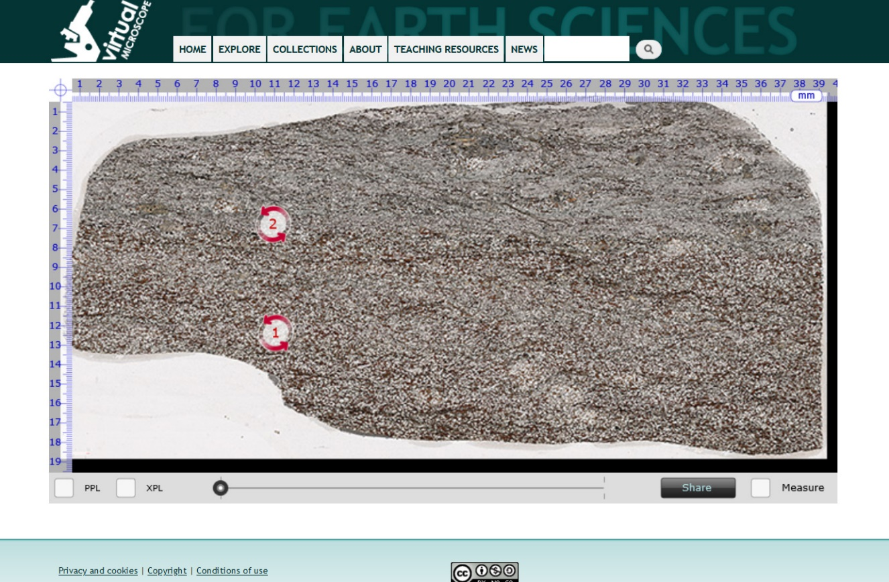

At the bottom left of the page are two check boxes – PPL (plane polarized light) and XPL (crossed polarized light). If you want to see the thin section in plane polarized light click PPL. If you want to see the thin section in crossed-polarize light click XPL.

On the thin section image are numbers inside of circles. Click on one of these, which will take you to the page shown below. The selected area on the thin section slide is shown in both plane polarized light and crossed polar. Put your mouse pointer inside of one of the circles. Dragging the pointer will cause both fields of view to rotate so you can observe the full range of optical properties in both plane polarized light and crossed polars. To return to the whole thin-section image click “Back”. This is a “really cool” website courtesy of our colleagues in the UK.
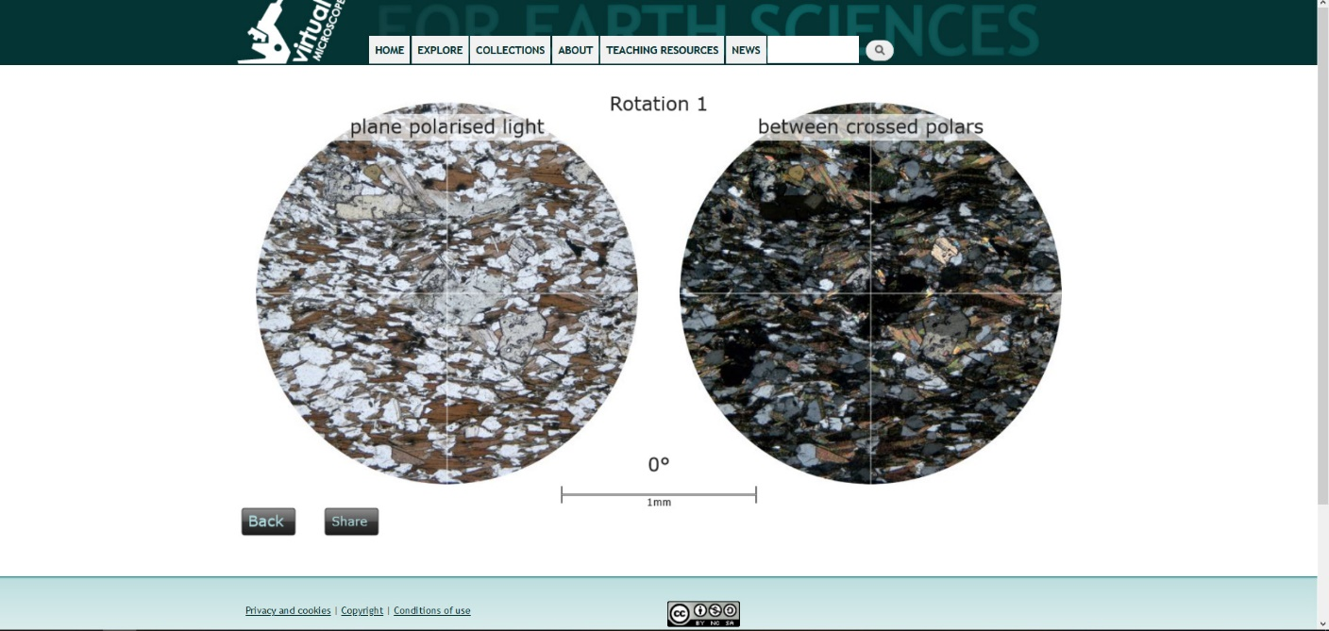

For each of the listed specimens, examine both the whole thin section and the individual areas. Then answer the questions.

Metamorphic Rock #1

- Describe the rock texture.
- Name the major minerals in the rock. Given a brief description of the optical appearance of the minerals in plane polarized light and crossed polars.
- Name the rock.

Metamorphic Rock #2

- Describe the rock texture
- Name the major minerals in the rock. Given a brief description of the optical appearance of the minerals in plane polarized light and crossed polars.
- Name the rock.

Metamorphic Rock #3

- Describe the rock texture
- Name the major minerals in the rock. Given a brief description of the optical appearance of the minerals in plane polarized light and crossed polars.
- Name the rock.

Metamorphic Rock #4

- Describe the rock texture
- Name the major minerals in the rock. Given a brief description of the optical appearance of the minerals in plane polarized light and crossed polars.
- Name the rock.

Metamorphic Rock #5

- Describe the rock texture
- Name the major minerals in the rock. Given a brief description of the optical appearance of the minerals in plane polarized light and crossed polars.
- Name the rock.

Metamorphic Rock #6

- Describe the rock texture
- Name the major minerals in the rock. Given a brief description of the optical appearance of the minerals in plane polarized light and crossed polars.
- Name the rock.

Metamorphic Rock #7

- Describe the rock texture
- Name the major minerals in the rock. Given a brief description of the optical appearance of the minerals in plane polarized light and crossed polars.
- Name the rock.

Metamorphic Rock #8

- Describe the rock texture
- Name the major minerals in the rock. Given a brief description of the optical appearance of the minerals in plane polarized light and crossed polars.
- Name the rock.

Metamorphic Rock #9

- Describe the rock texture
- Name the major minerals in the rock. Given a brief description of the optical appearance of the minerals in plane polarized light and crossed polars.
- Name the rock.

Metamorphic Rock #10

- Describe the rock texture
- Name the major minerals in the rock. Given a brief description of the optical appearance of the minerals in plane polarized light and crossed polars.
- Name the rock.

