6
277

Ocean storage

Coordinating Lead Authors
Ken Caldeira (United States), Makoto Akai (Japan)

Lead Authors
Peter Brewer (United States), Baixin Chen (China), Peter Haugan (Norway), Toru Iwama (Japan), Paul Johnston (United Kingdom), Haroon Kheshgi (United States), Qingquan Li (China), Takashi Ohsumi (Japan), Hans Pörtner (Germany), Chris Sabine (United States), Yoshihisa Shirayama (Japan), Jolyon Thomson (United Kingdom)

Contributing Authors
Jim Barry (United States), Lara Hansen (United States)

Review Editors
Brad De Young (Canada), Fortunat Joos (Switzerland)

Contents
ExECutivE SummARy 279 |  | 6.7 | Environmental impacts, risks, and risk
 |  |  | management | 298
6.1 introduction and background 279 |  | 6.7.1 | Introduction to biological impacts and risk | 298
6.1.1 Intentional storage of CO2 in the ocean 279 |  | 6.7.2 | Physiological effects of CO2 | 301
6.1.2 Relevant background in physical and chemical |  | 6.7.3 | From physiological mechanisms to ecosystems | 305
oceanography 281 |  | 6.7.4 | Biological consequences for water column release
 |  |  | scenarios | 306
- Approaches to release CO2 into the ocean 282  - Approaches to releasing CO2 that has been captured, |  | 6.7.5 | Biological consequences associated with CO2  lakes | 307
compressed, and transported into the ocean | 282 | 6.7.6 Contaminants in CO2 streams |  | 307
6.2.2 CO2 storage by dissolution of carbonate minerals | 290 | 6.7.7 Risk management |  | 307
6.2.3 Other ocean storage approaches | 291 | 6.7.8 Social aspects; public and stakeholder perception |  | 307
6.3 Capacity and fractions retained | 291 | 6.8 Legal issues |  | 308
6.3.1 Capacity | 291 | 6.8.1 International law |  | 308
6.3.2 Measures of fraction retained | 291 | 6.8.2 National laws |  | 309
6.3.3 Estimation of fraction retained from ocean
observations | 292 | 6.9 Costs |  | 310
6.3.4 Estimation of fraction retained from model results | 292 | 6.9.1 Introduction |  | 310
 |  | 6.9.2 Dispersion from ocean platform or moving ship |  | 310
6.4 Site selection | 292 | 6.9.3 Dispersion by pipeline extending from shore into
6.4.1 Background | 292 | shallow to deep water |  | 310
6.4.2 Water column release | 294 | 6.9.4 Cost of carbonate neutralization approach |  | 311
6.4.3 CO2 lakes on the sea floor | 295 | 6.9.5 Cost of monitoring and verification |  | 311
6.4.4 Limestone neutralization | 295
 |  | 6.10 Gaps |  | 311
6.5 injection technology and operations | 295
6.5.1 Background | 295 | References |  | 311
6.5.2 Water column release | 295
6.5.3 Production of a CO2 lake | 296
6.6 Monitoring and verification | 296
6.6.1 Background | 296
6.6.2 Monitoring amounts and distributions of materials
released | 296
6.6.3 Approaches and technologies for monitoring
environmental effects | 298

ExECutivE SummARy

Captured CO2 could be deliberately injected into the ocean at great depth, where most of it would remain isolated from the atmosphere for centuries. CO2 can be transported via pipeline or ship for release in the ocean or on the sea floor. There have been small-scale field experiments and 25 years of theoretical, laboratory, and modelling studies of intentional ocean storage of CO2, but ocean storage has not yet been deployed or thoroughly tested.
The increase in atmospheric CO2 concentrations due to anthropogenic emissions has resulted in the oceans taking
2
expected close to injection points or CO2 lakes. Chronic effects may set in with small degrees of long-term CO2 accumulation, such as might result far from an injection site, however, long-term chronic effects have not been studied in deep-sea organisms.
CO2 effects on marine organisms will have ecosystem consequences; however, no controlled ecosystem experiments have been performed in the deep ocean. Thus, only a preliminary assessment of potential ecosystem effects can be given. It is expected that ecosystem consequences will increase with

up CO2
at a rate of about 7 GtCO yr-1 (2 GtCyr-1). Over the
increasing CO2 concentration, but no environmental thresholds

past 200 years the oceans have taken up 500 GtCO2 from the
atmosphere out of 1300 GtCO2 total anthropogenic emissions. Anthropogenic CO2 resides primarily in the upper ocean and has thus far resulted in a decrease of pH of about 0.1 at the
ocean surface with virtually no change in pH deep in the oceans. Models predict that the oceans will take up most CO2 released to the atmosphere over several centuries as CO2 is dissolved at the ocean surface and mixed with deep ocean waters.
The Earth's oceans cover over 70% of the Earth's surface with an average depth of about 3,800 metres; hence, there is no practical physical limit to the amount of anthropogenic CO2 that could be placed in the ocean. However, the amount that is stored in the ocean on the millennial time scale depends on oceanic equilibration with the atmosphere. Over millennia, CO2 injected into the oceans at great depth will approach approximately the same equilibrium as if it were released to the atmosphere. Sustained atmospheric CO2 concentrations in the range of 350 to 1000 ppmv imply that 2,300 ± 260 to 10,700
± 1,000 Gt of anthropogenic CO will eventually reside in the ocean.
2
Analyses of ocean observations and models agree that injected CO2 will be isolated from the atmosphere for several hundreds of years and that the fraction retained tends to be
larger with deeper injection. Additional concepts to prolong CO2 retention include forming solid CO2 hydrates and liquid CO2 lakes on the sea floor, and increasing CO2 solubility by, for example, dissolving mineral carbonates. Over centuries, ocean mixing results in loss of isolation of injected CO2 and exchange with the atmosphere. This would be gradual from large regions of the ocean. There are no known mechanisms for sudden or catastrophic release of injected CO2.
Injection up to a few GtCO2 would produce a measurable change in ocean chemistry in the region of injection, whereas injection of hundreds of GtCO2 would eventually produce measurable change over the entire ocean volume.
Experiments show that added CO2 can harm marine organisms. Effects of elevated CO2 levels have mostly been studied on time scales up to several months in individual organisms that live near the ocean surface. Observed phenomena include reduced rates of calcification, reproduction, growth, circulatory oxygen supply and mobility as well as increased mortality over time. In some organisms these effects are seen in response to small additions of CO2. Immediate mortality is
have been identified. It is also presently unclear, how species
and ecosystems would adapt to sustained, elevated CO2 levels. Chemical and biological monitoring of an injection project, including observations of the spatial and temporal evolution of the resulting CO2 plume, would help evaluate the amount of materials released, the retention of CO2, and some of the
potential environmental effects.
For water column and sea floor release, capture and compression/liquefaction are thought to be the dominant cost factors. Transport (i.e., piping, and shipping) costs are expected to be the next largest cost component and scale with proximity to the deep ocean. The costs of monitoring, injection nozzles etc. are expected to be small in comparison.
Dissolving mineral carbonates, if found practical, could cause stored carbon to be retained in the ocean for 10,000 years, minimize changes in ocean pH and CO2 partial pressure, and
may avoid the need for prior separation of CO2. Large amounts
of limestone and materials handling would be required for this
approach.
Several different global and regional treaties on the law of the sea and marine environment could be relevant to intentional release of CO2 into the ocean but the legal status of intentional carbon storage in the ocean has not yet been adjudicated.
It is not known whether the public will accept the deliberate storage of CO2 in the ocean as part of a climate change mitigation strategy. Deep ocean storage could help reduce the impact of CO2 emissions on surface ocean biology but at the expense of effects on deep-ocean biology.

introduction and background

Intentional storage of CO2 in the ocean
This report assesses what is known about intentional storage of carbon dioxide in the ocean by inorganic strategies that could be applied at industrial scale. Various technologies have been envisioned to enable and increase ocean CO2 storage (Figure 6.1). One class of options involves storing a relatively pure stream of carbon dioxide that has been captured and compressed. This CO2 can be placed on a ship, injected directly into the ocean, or deposited on the sea floor. CO2 loaded on ships could either be dispersed from a towed pipe or transported to fixed platforms feeding a CO2 lake on the sea floor. Such CO2 lakes must be

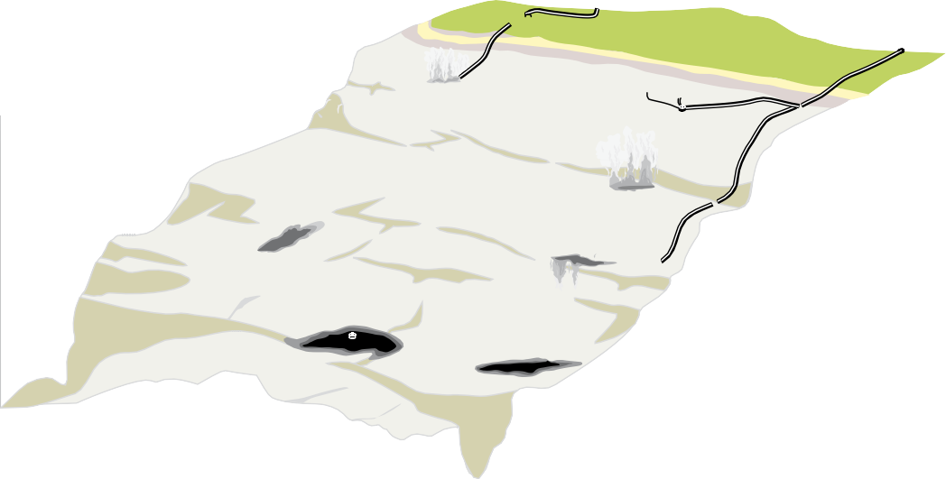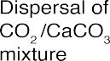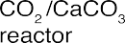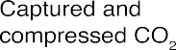
Figure 6.1 Illustration of some of the ocean storage strategies described in this chapter (Artwork courtesy Sean Goddard, University of Exeter.)

deeper than 3 km where CO2 is denser than sea water. Any of these approaches could in principle be used in conjunction with neutralization with carbonate minerals.
Research, development and analysis of ocean CO2 storage concepts has progressed to consider key questions and issues that could affect the prospects of ocean storage as a response option to climate change (Section 6.2). Accumulated understanding of the ocean carbon cycle is being used to estimate how long CO2 released into the oceans will remain isolated from the atmosphere. Such estimates are used to assess the effectiveness of ocean storage concepts (Section 6.3).
Numerical models of the ocean indicate that placing CO2 in the deep ocean would isolate most of the CO2 from the atmosphere for several centuries, but over longer times the ocean and atmosphere would equilibrate. Relative to atmospheric release, direct injection of CO2 into the ocean could reduce maximum amounts and rates of atmospheric CO2 increase over the next several centuries. Direct injection of CO2 in the ocean would not reduce atmospheric CO2 content on the millennial time scale (Table 6.1; Figures 6.2 and 6.3; Hoffert et al., 1979; Kheshgi et al., 1994).

table 6.1 Amount of additional CO2 residing in the ocean after atmosphere-ocean equilibration for different atmospheric stabilization concentrations. The uncertainty range represents the influence of climate sensitivity to a CO2 doubling in the range of 1.5 ºC to 4.5 ºC (Kheshgi et al., 2005; Kheshgi 2004a). This table considers the possibility of increased carbon storage in the terrestrial biosphere. Such an increase, if permanent, would allow a corresponding increase in total cumulative emissions. This table does not consider natural or engineered dissolution of carbonate minerals, which would increase ocean storage of anthropogenic carbon. The amount already in the oceans exceeds 500 GtCO2 (= 440 GtCO2 for 1994 (Sabine et al., 2004) plus CO2 absorption since that time). The long-term amount of CO2 stored in the deep ocean is independent of whether the CO2 is initially released to the atmosphere or the deep ocean.

Atmospheric CO2 stabilization concentration (ppmv) | total cumulative ocean + atmosphere CO2 release (GtCO2) | Amount of anthropogenic CO2 stored in the ocean in equilibrium (GtCO2)
350 | 2880 ± 260 | 2290 ± 260
450 | 5890 ± 480 | 4530 ± 480
550 | 8350 ± 640 | 6210 ± 640
650 | 10,460 ± 750 | 7540 ± 750
750 | 12,330 ± 840 | 8630 ± 840
1000 | 16,380 ± 1000 | 10,730 ± 1000

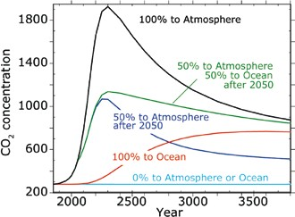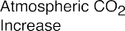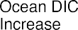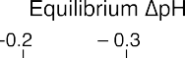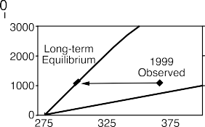

Figure 6.2 Simulated atmospheric CO2 resulting from CO2 release to the atmosphere or injection into the ocean at 3,000 m depth (Kheshgi and Archer, 2004). Emissions follow a logistic trajectory with cumulative emissions of 18,000 GtCO2. Illustrative cases include 100% of emissions released to the atmosphere leading to a peak in concentration, 100% of emissions injected into the ocean, and no emissions (i.e., other mitigation approaches are used). Additional cases include atmospheric emission to year 2050, followed by either
Figure 6.3 Equilibrium partitioning of CO2 between the ocean and atmosphere. On the time scale of millennia, complete mixing of the oceans leads to a partitioning of cumulative CO2 emissions between the oceans and atmosphere with the bulk of emissions eventually residing in the oceans as dissolved inorganic carbon. The ocean partition depends nonlinearly on CO2 concentration according to carbonate chemical equilibrium (Box 6.1) and has limited sensitivity to changes in surface water temperature (shown by the grey area for a range of climate

50% to atmosphere and 50% to ocean after 2050 or 50% to atmosphere and 50% by other mitigation approaches after 2050. Ocean injection results in lower peak concentrations than atmospheric release but higher than if other mitigation approaches are used (e.g., renewables
sensitivity of 1.5 to 4.5°C for CO2 doubling) (adapted from Kheshgi et al., 2005; Kheshgi, 2004a). ∆pH evaluated from pCO2 of 275 ppm. This calculation is relevant on the time scale of several centuries, and does not consider changes in ocean alkalinity that increase ocean CO2

or permanent storage). uptake over several millennia (Archer et al., 1997).

There has been limited experience with handling CO2 in the deep sea that could form a basis for the development of ocean CO2 storage technologies. Before they could be deployed, such technologies would require further development and field testing. Associated with the limited level of development, estimates of the costs of ocean CO2 storage technologies are at a primitive state, however, the costs of the actual dispersal technologies are expected to be low in comparison to the costs of CO2 capture and transport to the deep sea (but still non- negligible; Section 6.9). Proximity to the deep sea is a factor, as the deep oceans are remote to many sources of CO2 (Section 6.4). Ocean storage would require CO2 transport by ship or deep-sea pipelines. Pipelines and drilling platforms, especially in oil and gas applications, are reaching ever-greater depths, yet not on the scale or to the depth relevant for ocean CO2 storage (Chapter 4). No insurmountable technical barrier to storage of CO2 in the oceans is apparent.
Putting CO2 directly into the deep ocean means that the chemical environment of the deep ocean would be altered immediately, and in concepts where release is from a point, change in ocean chemistry would be greater proximate to the release location. Given only rudimentary understanding of deep-sea ecosystems, only a limited and preliminary assessment of potential ecosystem effects can be given (Section 6.7).
Technologies exist to monitor deep-sea activities (Section
6.6). Practices for monitoring and verification of ocean storage
would depend on which, as of yet undeveloped, ocean storage technology would potentially be deployed, and on environmental impacts to be avoided.
More carbon dioxide could be stored in the ocean with less of an effect on atmospheric CO2 and fewer adverse effects on the marine environment if the alkalinity of the ocean could
be increased, perhaps by dissolving carbonate minerals in sea water. Proposals based on this concept are discussed primarily in Section 6.2.
For ocean storage of CO2, issues remain regarding environmental consequences, public acceptance, implications of existing laws, safeguards and practices that would need to be
developed, and gaps in our understanding of ocean CO2 storage (Sections 6.7, 6.8, and 6.10).

Relevant background in physical and chemical oceanography

The oceans, atmosphere, and plants and soils are the primary components of the global carbon cycle and actively exchange carbon (Prentice et al., 2001). The oceans cover 71% of the Earth’s surface with an average depth of 3,800 m and contain roughly 50 times the quantity of carbon currently contained in the atmosphere and roughly 20 times the quantity of carbon currently contained in plants and soils. The ocean contains

so much CO2 because of its large volume and because CO2 dissolves in sea water to form various ionic species (Box 6.1).
The increase in atmospheric CO2 over the past few centuries has been driving CO2 from the atmosphere into the oceans. The oceans serve as an important sink of CO2 emitted to the atmosphere taking up on average about 7 GtCO yr-1 (2 GtC yr-1) over the 20 years from 1980 to 2000 with ocean uptake over the past 200 years estimated to be > 500 GtCO2 (135 GtC) (Prentice et al., 2001; Sabine et al., 2004). On average, the anthropogenic CO2 signal is detectable to about 1000 m depth; its near absence in the deep ocean is due to the slow exchange between ocean surface and deep –sea waters.
2
Ocean uptake of anthropogenic CO2 has led to a perturbation of the chemical environment primarily in ocean surface waters. Increasing ocean CO2 concentrationleadsto decreasing carbonate ion concentration and increasing hydrogen ion activity (Box 6.1). The increase in atmospheric CO2 from about 280 ppm in 1800 to 380 ppm in 2004 has caused an average decrease across
Most carbon dioxide released to either the atmosphere or the ocean will eventually reside in the ocean, as ocean chemistry equilibrates with the atmosphere. Thus, stabilization of atmospheric CO2 concentration at levels above the natural level of 280 ppm implies long-term addition of carbon dioxide to the ocean. In equilibrium, the fraction of an increment of CO2 released that will reside in the ocean depends on the atmospheric CO2 concentration (Table 6.1; Figure 6.3; Kheshgi et al., 2005; Kheshgi, 2004a).
The capacity of the oceans to absorb CO2 in equilibrium with the atmosphere is a function of the chemistry of sea water. The rate at which this capacity can be brought into play is a function of the rate of ocean mixing. Over time scales of decades to centuries, exchange of dissolved inorganic carbon between ocean surface waters and the deep ocean is the primary barrier limiting the rate of ocean uptake of increased atmospheric CO2. Over many centuries (Kheshgi, 2004a), changes in dissolved inorganic carbon will mix throughout the ocean volume with

the surface of the oceans of about 0.1 pH units (∆pH ≈ –0.1)
the oceans containing most of the cumulative CO2
emissions

from an initial average surface ocean pH of about 8.2. Further
increase in atmospheric CO2 will result in a further change in the chemistry of ocean surface waters that will eventually reach the deep ocean (Figure 6.4). The anthropogenic perturbation of ocean chemistry is greatest in the upper ocean where biological activity is high.
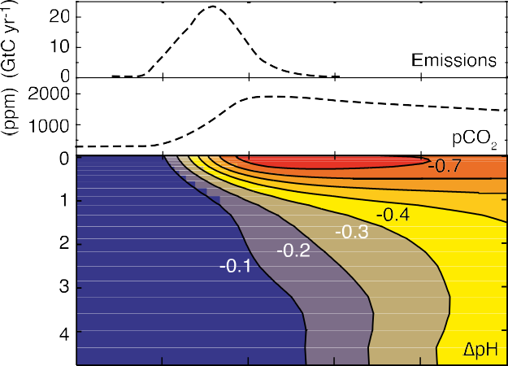

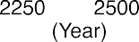
Figure 6.4 Simulated ocean pH changes from CO2 release to the atmosphere. Modelled atmospheric CO2 change and horizontally averaged ∆pH driven by a CO2 emissions scenario: historic atmospheric CO2 up to 2000, IS92a from 2000 to 2100, and logistic curve extending beyond 2100 with 18,000 GtCO2 (Moomaw et al., 2001) cumulative emissions from 2000 onward (comparable to estimates of fossil-fuel resources – predominantly coal; Caldeira and Wickett, 2003). Since year 1800, the pH of the surface of the oceans has decreased about
0.1 pH units (from an initial average surface ocean pH of about 8.2) and CO 2– has decreased about 40 µmol kg–1. There are a number of pH scales used by ocean chemists and biologists to characterize the hydrogen ion content of sea water, but ∆pH computed on different scales varies little from scale to scale (Brewer et al., 1995).
3
to the atmosphere/ocean system (Table 6.1; Figure 6.3). Over
longer times (millennia), dissolution of CaCO3 causes an even greater fraction of released CO2 (85–92%) to reside in the ocean (Archer et al., 1997).
Both biological and physical processes lead to the observed distribution of pH and its variability in the world ocean (Figure 6.6). As they transit from the Atlantic to Pacific Basins, deep ocean waters accumulate about 10% more dissolved inorganic carbon dioxide, primarily from the oxidation of sinking organic matter (Figure 6.7).

Approaches to release of CO2 into the ocean

Approaches to releasing CO2 that has been captured, compressed, and transported into the ocean

      - Basic approach
The basic concept of intentional CO2 storage in the ocean is to take a stream of CO2 that has been captured and compressed (Chapter 3), and transport it (Chapter 4) to the deep ocean for release at or above the sea floor. (Other ocean storage approaches are discussed in Sections 6.2.2 and 6.2.3.) Once released, the CO2 would dissolve into the surrounding sea water, disperse and become part of the ocean carbon cycle.
Marchetti (1977) first proposed injecting liquefied CO2 into the waters flowing over the Mediterranean sill into the mid- depth North Atlantic, where the CO2 would be isolated from the atmosphere for centuries. This concept relies on the slow exchange of deep ocean waters with the surface to isolate CO2 from the atmosphere. The effectiveness of ocean storage will depend on how long CO2 remains isolated from the atmosphere. Over the centuries and millennia, CO2 released to the deep ocean will mix throughout the oceans and affect atmospheric CO2 concentration. The object is to transfer the CO2 to deep waters because the degree of isolation from the atmosphere generally increases with depth in the ocean. Proposed methods

Box 6.1. Chemical properties of CO2

The oceans absorb large quantities of CO2 from the atmosphere principally because CO2 is a weakly acidic gas, and the minerals dissolved in sea water have created a mildly alkaline ocean. The exchange of atmospheric CO2 with ocean surface waters is determined by the chemical equilibrium between CO2 and carbonic acid H2CO3 in sea water, the partial pressure of CO2 (pCO2) in the atmosphere and the rate of air/ sea exchange. Carbonic acid dissociates into bicarbonate ion

which releases 2 mole-equivalents of Total Alkalinity and 1 mol of Dissolved Inorganic Carbon for each mole of CaCO3 dissolved. Increasing TAlk more than DIC leads to a decrease in the partial pressure of CO2 as seen in Figure 6.5. Because most Dissolved Inorganic Carbon is in the form of HCO –, the main effect of dissolving CaCO3 in surface waters is (see Kheshgi, 1995)
3

HCO –, carbonate ion CO 2–, and hydronium ion H+ by the
CaCO
(s) + CO
(g) + H O ↔ Ca2+ + 2HCO – (5)

3 3 3 2 2 3

reactions (see Annex AI.3):

CO (g) + H O ↔ H CO

(aq) ↔ HCO – + H+ ↔

thereby shifting CO2 from the atmosphere to the oceans in equilibrium, neutralizing the effect of CO on pH.

2 2 2 3 3 2

CO 2– + 2H+ (1)
3

Total dissolved inorganic carbon (DIC) is the sum of carbon contained in H CO , HCO –, and CO 2–. The atmospheric
Ocean surface waters are super-saturated with respect to
CaCO3, allowing the growth of corals and other organisms that produce shells or skeletons of carbonate minerals. In contrast, the deepest ocean waters have lower pH and lower

2 3 3 3

concentration of CO2
3
in equilibrium with surface water can
CO 2– concentrations, and are thus undersaturated with respect

be calculated from well-known chemical equilibria that
depend on ocean total dissolved inorganic carbon, alkalinity, temperature and salinity (Zeebe and Wolf-Gladrow, 2001). The partial pressure of CO2 in the ocean mixed layer equilibrates with the atmosphere on a time scale of about one year. The ocean is a highly buffered system, that is the concentration of the chemical species whose equilibrium controls pH is significantly higher than the concentrations of H+ or OH–. The pH of sea water is the base–10 log of activity of H+. Total Alkalinity (TAlk) is the excess of alkaline components, and is defined as the amount of strong acid required to bring sea water to the ‘equivalence point’ at which the HCO3– and
H2CO3 contributions are equal (Dickson, 1981).
The principal effect of adding CO2 to sea water is to form bicarbonate ion, for example,

CO + H O + CO 2– → 2HCO –. (2)
2 2 3 3

In addition, some CO2 undergoes simple reaction with water, for example,

CO + H O ↔ H+ + HCO –. (3)
2 2 3

In either case, Total Alkalinity does not change. The combined reactions lower both ocean pH, and carbonate ion concentration. For current ocean composition, CO2 that is added to sea water is partitioned primarily into HCO – with the net reaction resulting in the generation of H+ and thus decreasing pH and making sea water more acidic; adding CO
3
to CaCO3. Marine organisms produce calcium carbonate
particles in the surface ocean that settle and dissolve in
undersaturated regions of the deep oceans.

Figure 6.5 Composition diagram for ocean surface waters at 15°C (adapted from Baes, 1982). The white lines denote compositions with the same value of pCO2 (in ppm); the black lines denote compositions with the same pH. The tan shaded region is undersaturated and

thereby decreases the concentration of CO 2–.
3
2 the green shaded region is supersaturated with respect to calcite
at atmospheric pressure (calcite solubility increases with depth).

Total Alkalinity is increased when, for example, alkaline
minerals such as CaCO3 are dissolved in sea water through the reaction,
3
Surface water and average ocean compositions are also indicated. Adding CO2 increases Dissolved Inorganic Carbon (DIC) without changing Total Alkalinity (TAlk); dissolving CaCO3 increases both

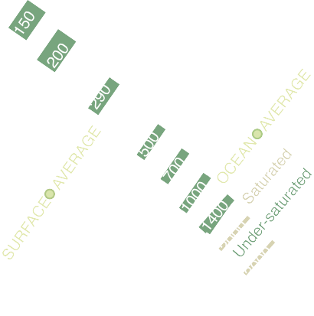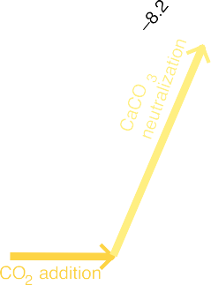CaCO3
(s) ↔ Ca2+ + CO 2– (4)
DIC and TAlk, with 2 moles of TAlk added for each mole of DIC
added.

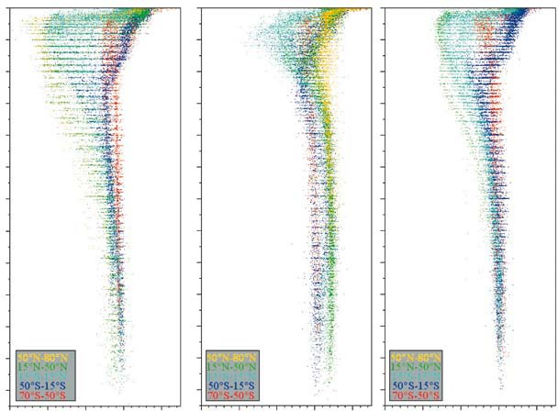
Figure 6.6 Observed variation in open ocean pH for the 1990s (shown on the total hydrogen scale; data from Key et al., 2004). In this figure the oceans are separated into separate panels. The three panels are on the same scale and coloured by latitude band to illustrate the large north-south changes in the pH of intermediate waters. Pre-industrial surface values would have been about 0.1 pH units greater than in the 1990s.
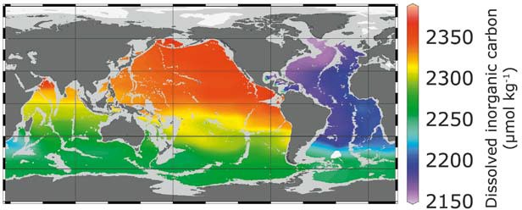
Figure 6.7 Natural variation in total dissolved inorganic carbon concentration at 3000 m depth (data from Key et al., 2004). Ocean carbon concentrations increase roughly 10% as deep ocean waters transit from the North Atlantic to the North Pacific due to the oxidation of organic carbon in the deep ocean.

would inject the CO2 storage.
below the thermocline1 for more effective
Authorities’ initial decision. After the public hearing procedure
and subsequent decision by the Authority to confirm their initial

Depending on the details of the release and local sea floor topography, the CO2 stream could be engineered to dissolve in the ocean or sink to form a lake on the sea floor. CO2, dissolved in sea water at high concentrations can form a dense plume or sinking current along an inclined sea floor. If release is at a great enough depth, CO2 liquid will sink and could accumulate on the sea floor as a pool containing a mixture of liquid and hydrate. In the short-term, fixed or towed pipes appear to be the most viable methods for oceanic CO2 release, relying on technology that is already largely commercially available.

      - Status of development
To date, injection of CO2 into sea water has only been investigated in the laboratory, in small-scale in-situ experiments, and in models. Larger-scale in-situ experiments have not yet been carried out.
An international consortium involving engineers, oceanographers and ecologists from 15 institutions in the United States, Norway, Japan and Canada proposed an in-situ experiment to help evaluate the feasibility of ocean carbon storage as a means of mitigating atmospheric increases. This was to be a collaborative study of the physical, chemical, and biological changes associated with direct injection of CO2 into the ocean (Adams et al., 2002). The proposed CO2 Ocean Sequestration Field Experiment was to inject less than 60 tonnes of pure liquid carbon dioxide (CO2) into the deep ocean near Keahole Point on the Kona coast of the Island of Hawaii. This would have been the largest intentional CO2 release into the ocean water column. The test was to have taken place in water about 800 m deep, over a period of about two weeks during the summer of 2001. Total project cost was to have been roughly US$ 5 million. A small steel pipeline, about 4 cm in diameter, was to have been deployed from a ship down to the injection depth, with a short section of pipeline resting on
permit, Brende said, ‘The possible future use of the sea as storage for CO2 is controversial. … Such a deposit could be in defiance of international marine laws and the ministry therefore had to reject the application.’ The Norwegian Environment ministry subsequently announced that the project would not go ahead (Giles, 2002).
Several smaller scale scientific experiments (less than 100 litres of CO2) have however been executed (Brewer et al., 1999, Brewer et al., 2005) and the necessary permits have also been issued for experiments within a marine sanctuary.

      - Basic behaviour of CO2 released in different forms The near-field behaviour of CO2 released into the ocean depends on the physical properties of CO2 (Box 6.2) and the method for CO2 release. Dissolved CO2 increases the density of sea water (e.g., Bradshaw, 1973; Song, et al., 2005) and this affects transport and mixing. The near field may be defined as that region in which it is important to take effects of CO2- induced density changes on the fluid dynamics of the ocean into consideration. The size of this region depends on the scale and design of CO2 release (Section 6.2.1.4).
CO2 plume dynamics depend on the way in which CO2 is released into the ocean water column. CO2 can be initially in the form of a gas, liquid, solid or solid hydrate. All of these forms of CO2 would dissolve in sea water, given enough time (Box 6.1). The dissolution rate of CO2 in sea water is quite variable and depends on the form (gas, liquid, solid, or hydrate), the depth and temperature of disposal, and the local water velocities. Higher flow rates increase the dissolution rate.
Gas. CO2 could potentially be released as a gas above roughly 500 m depth (Figure 6.8). Below this depth, pressures are too great for CO2 to exist as a gas. The gas bubbles would be less dense than the surrounding sea water so tend to rise towards the surface, dissolving at a radial speed of about 0.1

the sea floor to facilitate data collection. The liquid CO2
was
cm hr–1 (0.26 to 1.1 µmol cm–2 s–1; Teng et al., 1996). In waters

to have been dispersed through a nozzle, with CO2 droplets
briefly ascending from the injection point while dissolving into
the sea water. However, the project met with opposition from environmental organizations and was never able to acquire all of the necessary permits within the prescribed budget and schedule (de Figueiredo, 2002).
Following this experience, the group developed a plan to release 5.4 tonnes of liquefied CO2 at a depth of 800 metres off the coast of Norway, and monitor its dispersion in the
Norwegian Sea. The Norwegian Pollution Control Authority granted a permit for the experiment. The Conservative Party environment minister in Norway’s coalition government, Børge Brende, decided to review the Norwegian Pollution Control

1 The thermocline is the layer of the ocean between about 100 and 1000 m depth that is stably stratified by large temperature and density gradients, thus inhibiting vertical mixing. Vertical mixing rates in the thermocline can be about 1000 times less than those in the deep sea. This zone of slow mixing would act as a barrier to slow degassing of CO2 released in the deep ocean to the atmosphere.
colder than about 9°C, a CO2 hydrate film could form on the
bubble wall. CO2 diffusers could produce gaseous CO2 bubbles that are small enough to dissolve completely before reaching the surface.
Liquid. Below roughly 500 m depth, CO2 can exist in the ocean as a liquid. Above roughly 2500 m depth CO2 is less dense than sea water, so liquid CO2 released shallower than 2500 m would tend to rise towards the surface. Because most ocean water in this depth range is colder than 9°C, CO2 hydrate would tend to form on the droplet wall. Under these conditions, the radius of the droplet would diminish at a speed of about 0.5 cm hr–1 (= 3 µmol cm–2 s–1; Brewer et al., 2002). Under these conditions a 0.9 cm diameter droplet would rise about 400 m in an hour before dissolving completely; 90% of its mass would be lost in the first 200 m (Brewer et al., 2002). Thus, CO2 diffusers could be designed to produce droplets that will dissolve within roughly 100 m of the depth of release. If the droplet reached approximately 500 m depth, it would become a gas bubble.
CO2 is more compressible than sea water; below roughly

Box 6.2 Physical properties of CO2.

The properties of CO2 in sea water affect its fate upon release to the deep-sea environment. The conditions under which CO2 can exist in a gas, liquid, solid hydrate, or aqueous phase in sea water are given in Figure 6.8 (see Annex I).
At typical pressures and temperatures that exist in the ocean, pure CO2 would be a gas above approximately 500 m and a liquid below that depth. Between about 500 and 2700 m depth, liquid CO2 is lighter than sea water. Deeper than 3000 m, CO2 is denser than sea water. The buoyancy of CO2 released into the ocean determines whether released CO2 rises or falls in the ocean column (Figure 6.9). In the gas phase, CO2 is lighter than sea water and rises. In the liquid phase CO2 is a highly compressible fluid compared to sea water. A fully formed crystalline CO2 hydrate is denser than sea water and will form a sinking mass (Aya et al., 2003); hydrate formation can thus aid ocean CO2 storage by more rapid transport to depth, and by slowing dissolution. It may also create a nuisance by impeding flow in pipelines or at injectors.
The formation of a solid CO2 hydrate (Sloan, 1998) is a dynamic process (Figure 6.10; Brewer et al., 1998, 1999, 2000) and the nature of hydrate nucleation in such systems is imperfectly understood. Exposed to an excess of sea water, CO2 will eventually dissolve forming an aqueous phase with density higher than surrounding sea water. Release of dense or buoyant
CO2 – in a gas, liquid, hydrate or aqueous phase – would entrain surrounding sea water and form plumes that sink, or rise, until dispersed.

Figure 6.8 CO2 sea water phase diagram. CO2 is stable in the liquid phase when temperature and pressure (increasing with ocean depth) fall in the region below the blue curve; a gas phase is stable under conditions above the blue dashed line. In contact with sea water
and at temperature and pressure in the shaded region, CO2 reacts with sea water to from a solid ice-like hydrate CO2·6H2O. CO2 will dissolve in sea water that is not saturated with CO2. The red line shows how temperature varies with depth at a site off the coast of
California; liquid and hydrated CO2 can exist below about 400 m (Brewer et al., 2004).
Figure 6.9 Shallower than 2500 m, liquid CO2 is less dense than sea water, and thus tends to float upward. Deeper than 3000 m, liquid CO2 is denser than sea water, and thus tends to sink downwards. Between these two depths, the behaviour can vary with location (depending
mostly on temperature) and CO2 can be neutrally buoyant (neither rises nor falls). Conditions shown for the northwest Atlantic Ocean.

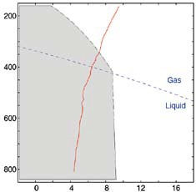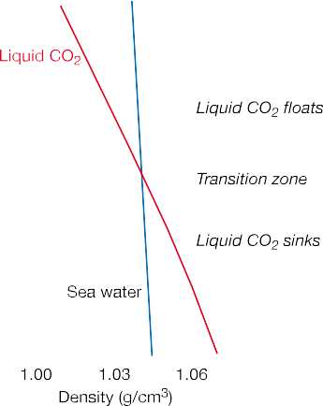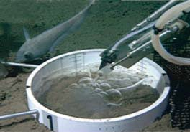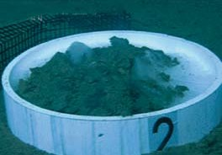

Figure 6.10 Liquid CO2 released at 3600 metres initially forms a liquid CO2 pool on the sea floor in a small deep ocean experiment
(upper picture). In time, released liquid CO2 reacts with sea water to form a solid CO2 hydrate in a similar pool (lower picture).

3000 m, liquid CO2 is denser than the surrounding sea water and sinks. CO2 nozzles could be engineered to produce large droplets that would sink to the sea floor or small droplets that would dissolve in the sea water before contacting the sea floor. Natural ocean mixing and droplet motion are expected to prevent concentrations of dissolved CO2 from approaching saturation, except near liquid CO2 that has been intentionally placed in topographic depressions on the sea floor.
Solid. Solid CO2 is denser than sea water and thus would tend to sink. Solid CO2 surfaces would dissolve in sea water at a speed of about 0.2 cm hr–1 (inferred from Aya et al., 1997). Thus small quantities of solid CO2 would dissolve completely before reaching the sea floor; large masses could potentially reach the sea floor before complete dissolution.
Hydrate. CO2 hydrate is a form of CO2 in which a cage of water molecules surrounds each molecule of CO2. It can form in average ocean waters below about 400 m depth. A fully formed crystalline CO2 hydrate is denser than sea water and will sink (Aya et al., 2003). The surface of this mass would dissolve at a speed similar to that of solid CO , about 0.2 cm hr–1 (0.47 to
2
0.60 µm s–1; Rehder et al., 2004; Teng et al., 1999), and thus droplets could be produced that either dissolve completely in the sea water or sink to the sea floor. Pure CO2 hydrate is a hard crystalline solid and will not flow through a pipe; however a paste-like composite of hydrate and sea water may be extruded (Tsouris et al., 2004), and this will have a dissolution rate intermediate between those of CO2 droplets and a pure CO2 hydrate.

      - Behaviour of injected CO2 in the near field:
CO2-rich plumes
As it leaves the near field, CO2 enriched water will reside at a depth determined by its density. The oceans are generally stably stratified with density increasing with depth. Parcels of water
tend to move upward or downward until they reach water of the same density, then there are no buoyancy forces to induce further motion.
The dynamics of CO2-rich plumes determine both the depth at which the CO2 leaves the near-field environment and the amount of initial dilution (and consequently the amount of pH change).
When CO2 is released in any form into seawater, the CO2 can move upward or downward depending on whether the CO2 is less or more dense than the surrounding seawater. Drag forces transfer momentum from the CO2 droplets to the surrounding water column producing motion in the adjacent water, initially in the direction of droplet motion. Simultaneously, the CO2 dissolves into the surrounding water, making the surrounding water denser and more likely to sink. As the CO2-enriched water moves, it mixes with surrounding water that is less enriched in CO2, leading to additional dilution and diminishing the density contrast between the CO2-enriched water and the surrounding water.
CO2 releases could be engineered to produce CO2 plumes with different characteristics (Chen et al., 2003; Sato and Sato, 2002; Alendal and Drange, 2001; Crounse et al., 2001; Drange et al., 2001; Figure 6.11). Modelling studies indicate that

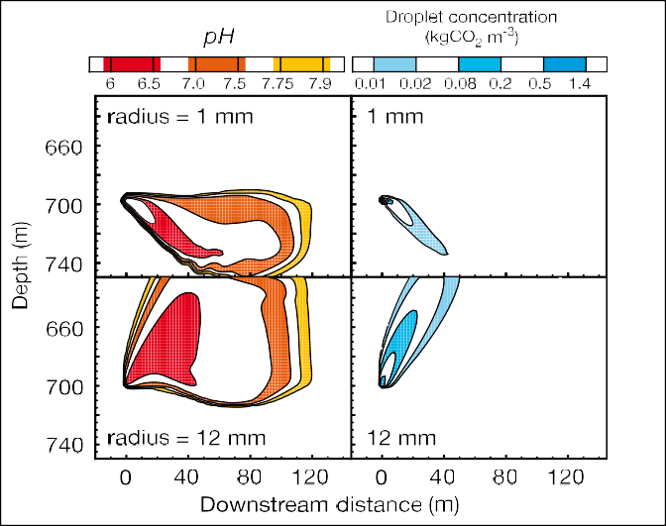
Figure 6.11 Simulated CO2 enriched sea water plumes (left panels; indicated by pH) and CO2 droplet plumes (right panels; indicated by kgCO m–3) created by injecting 1 cm and 12 cm liquid CO droplets (top and bottom panels, respectively) into the ocean from fixed nozzles (elapsed time is 30 min; injection rate is 1.0 kgCO s–1; ocean current speed is 5 cm s–1; Alendal and Drange, 2001). By varying droplet size, the plume can be made to sink (top panels) or rise (bottom panels).
2
2
2

releases of small droplets at slow rates produce smaller plumes than release of large droplets at rapid rates. Where CO2 is denser than seawater, larger droplet sizes would allow the CO2 to sink more deeply. CO2 injected at intermediate depths could increase the density of CO2-enriched sea water sufficiently to generate a sinking plume that would carry the CO2 into the deep ocean (Liro et al., 1992; Haugan and Drange, 1992). Apparent coriolis forces would operate on such a plume, turning it towards the right in the Northern Hemisphere and towards the left in the Southern Hemisphere (Alendal et al., 1994). The channelling effects of submarine canyons or other topographic features could help steer dense plumes to greater depth with minimal dilution (Adams et al., 1995).

      - Behaviour of injected CO2 in the far field
The far field is defined as the region in which the concentration
of added CO2 is low enough such that the resulting density increase does not significantly affect transport, and thus CO2 may be considered a passive tracer in the ocean. Typically, this would apply within a few kilometres of an injection point in midwater, but if CO2 is released at the sea floor and guided along topography, concentration may remain high and influence transport for several tens of kilometres. CO2 is transported by ocean currents and undergoes further mixing and dilution with other water masses (Alendal and Drange, 2001). Most of this mixing and transport occurs along surfaces of nearly constant density, because buoyancy forces inhibit vertical mixing in a stratified fluid. Over time, a release of CO2 becomes increasingly diluted but affects ever greater volumes of water.
The concept of ocean injection from a moving ship towing a trailing pipe was developed in order to minimize the local

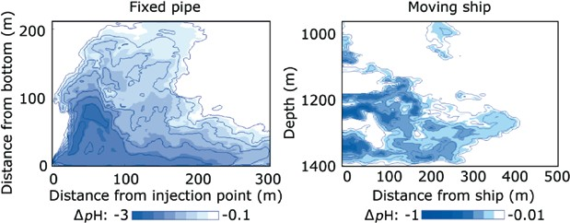
Figure 6.12 Simulated plumes (Chen et al., 2005) created by injecting liquid CO2 into the ocean from a fixed pipe (left panel) and a moving ship
(right panel) at a rate of 100 kg s–1 (roughly equal to the CO from a 500 MWe coal-fired power plant). Left panel: injection at 875 m depth (12
2
m from the sea floor) with an ocean current speed of 2.3 cm s–1. Right panel: injection at 1340 m depth from a ship moving at a speed of 3 m s–1. Note difference in pH scales; maximum pH perturbations are smaller in the moving ship simulation.

environmental impacts by accelerating the dissolution and dispersion of injected liquid CO2 (Ozaki, 1997; Minamiura et
injected CO2 for hypothetical examples of ocean storage (e.g., Orr, 2004). Wickett et al. (2003) estimated that injection into

al., 2004). A moving ship could be used to produce a sea water
the deep ocean at a rate of 0.37 GtCO2
yr–1 (= 0.1 GtC yr–1)

plume with relatively dilute initial CO2 concentrations (Figures
6.12 and 6.13). In the upper ocean where CO2is less dense than seawater, nozzles engineered to produce mm-scale droplets would generate CO2 plumes that would rise less than 100 m.
Ocean general circulation models have been used to predict
changes in ocean chemistry resulting from the dispersion of
for 100 years would produce a ∆pH < –0.3 over a volume of
sea water equivalent to 0.01% or less of total ocean volume (Figure 6.14). In this example, for each GtCO2 released to the deep ocean, less than about 0.0001%, 0.001% and 0.01% of

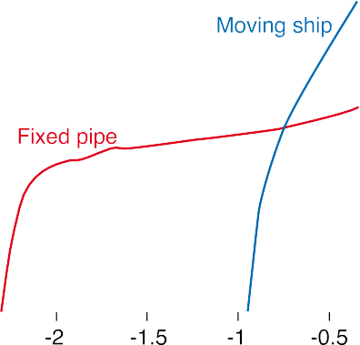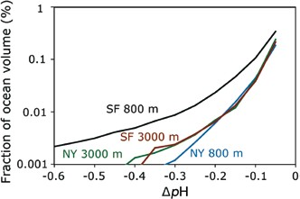Figure 6.14 Estimated volume of pH perturbations at basin scale (Wickett et al., 2003). Simulated fraction of global ocean volume with a ∆pH less than the amount shown on the horizontal axis, after 100

years of simulated injection at a rate of 0.37 GtCO2
yr–1 (= 0.1 GtC

Figure 6.13 Volume of water with a ∆pH less than the value shown on the horizontal axis for the simulations shown in Figure 6.12 corresponding to CO releases from a 500 MW power plant. The fixed
yr–1) at each of four different points (two different depths near New
York City and San Francisco). Model results indicate, for example, that injecting CO2 at this rate at a single location for 100 years could be expected to produce a volume of sea water with a ∆pH < –0.3 units in 0.01% or less of total ocean volume (0.01% of the ocean is roughly 105
2

2 e

pipe simulation produces a region with ∆pH < –1, however, the moving
km3). As with other simulations of direct CO
injection in the ocean,

ship disperses the CO2 more widely, largely avoiding pH changes of this magnitude.
results for the upper ocean (e.g., 800 m) tend to be more site-specific
than are results for the deep ocean (e.g., 3000 m).

the ocean volume has ∆pH of less than –0.3, –0.2, and –0.1 pH units respectively. Caldeira and Wickett (2005) predicted volumes of water undergoing a range of pH changes for several atmospheric emission and carbon stabilization pathways, including pathways in which direct injection of CO2 into the deep ocean was assumed to provide either 10% or 100% of the total atmospheric CO2 mitigation effort needed to stabilize atmospheric CO2 according to the WRE550 pathway. This assumed a CO2 production scenario in which all known fossil- fuel resources were ultimately combusted. Simulations in which ocean injection provided 10% of the total mitigation effort, resulted in significant changes in ocean pH in year 2100 over roughly 1% of the ocean volume (Figure 6.15). By year 2300, injection rates have slowed but previously injected carbon has spread through much of the ocean resulting in an additional 0.1 pH unit reduction in ocean pH over most of the ocean volume compared to WRE550.

      - Behaviour of CO2 lakes on the sea floor
Long-term storage of carbon dioxide might be more effective
if CO2 were stored on the sea floor in liquid or hydrate form below 3000 metres, where CO2 is denser than sea water (Box 6.2; Ohsumi, 1995; Shindo et al., 1995). Liquid carbon dioxide could be introduced at depth to form a lake of CO2 on the sea floor (Ohsumi, 1993). Alternatively, CO2 hydrate could be created in an apparatus designed to produce a hydrate pile or pool on the sea floor (Saji et al., 1992). To date, the concept of CO2 lakes on the sea floor has been investigated only in the laboratory, in small-scale (tens of litres) in-situ experiments and
in numerical models. Larger-scale in-situ experiments have not yet been carried out.
Liquid or hydrate deposition of CO2 on the sea floor could increase isolation, however in the absence of a physical barrier the CO2 would dissolve into the overlying water (Mori and
Mochizuki, 1998; Haugan and Alendal, 2005). In this aspect,
most sea floor deposition proposals can be viewed as a means of ‘time-delayed release’ of CO2 into the ocean. Thus, many issues relevant to sea floor options, especially the far-field behaviour, are discussed in sections relating to CO2 release into the water column (e.g., Section 6.2.1.5).
CO2 released onto the sea floor deeper than 3 km is denser than surrounding sea water and is expected to fill topographic depressions, accumulating as a lake of CO2 over which a thin hydrate layer would form. This hydrate layer would retard dissolution, but it would not insulate the lake from the overlying water. The hydrate would dissolve into the overlying water (or sink to the bottom of the CO2 lake), but the hydrate layer would be continuously renewed through the formation of new crystals (Mori, 1998). Laboratory experiments (Aya et al., 1995) and small deep ocean experiments (Brewer et al., 1999) show that deep-sea storage of CO2 would lead to CO2 hydrate formation (and subsequent dissolution).
Predictions of the fate of large-scale CO2 lakes rely on numerical simulations because no large-scale field experiments have yet been performed. For a CO2 lake with an initial depth of 50 m, the time of complete dissolution varies from 30 to 400 years depending on the local ocean and sea floor environment. The time to dissolve a CO2 lake depends on its depth, complex

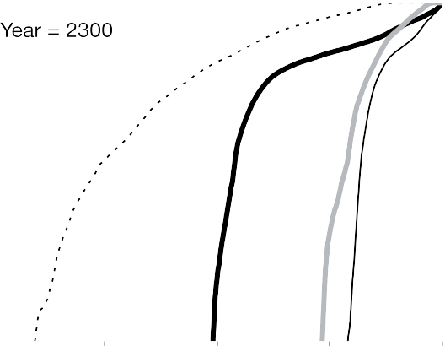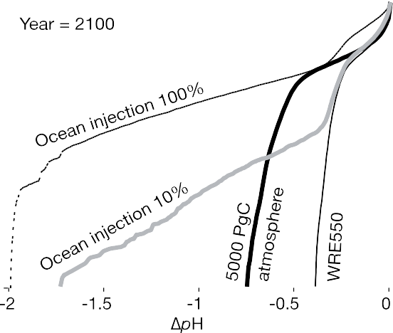

Figure 6.15 Estimated volume of pH perturbations at global scale for hypothetical examples in which injection of CO2 into the ocean interior provides 100% or 10% of the mitigation effort needed to move from a logistic emissions curve cumulatively releasing 18,000 GtCO2 (=5000 GtC) to emissions consistent with atmospheric CO2 stabilization at 550 ppm according to the WRE550 pathway (Wigley et al., 1996). The curves show the simulated fraction of ocean volume with a pH reduction greater than the amount shown on the horizontal axis. For the 10% case, in year 2100, injection rates are high and about1% of the ocean volume has significant pH reductions; in year 2300, injection rates are low, but previously injected CO2 has decreased ocean pH by about 0.1 unit below the value produced by a WRE550 atmospheric CO2 pathway in the absence of CO2 release directly to the ocean (Caldeira and Wickett, 2005).

dynamics of the ocean bottom boundary layer and its turbulence characteristics, mechanism of CO2 hydrate dissolution, and properties of CO2 in solution (Haugan and Alendal, 2005). The lifetime of a CO2 lake would be longest in relatively confined environments, such as might be found in some trenches or depressions with restricted flow (Ohgaki and Akano, 1992). Strong flows have been observed in trenches (Nakashiki, 1997). Nevertheless, simulation of CO2 storage in a deep trench (Kobayashi, 2003) indicates that the bottom topography can weaken vertical momentum and mass transfer, slowing the CO2 dissolution rate. In a quiescent environment, transport would be dominated by diffusion. Double-diffusion in the presence of strong stratification may produce long lake lifetimes. In contrast, the flow of sea water across the lake surface would increase mass transfer and dissolution. For example, CO2 lake lifetimes of >10,000 yr for a 50 m thick lake can be estimated
to the ocean would increase ocean carbon storage, both in the near term and on millennial time scales (Kheshgi, 1995). The duration of increased ocean carbon storage would be limited by eventual CaCO3 sedimentation, or reduced CaCO3 sediment dissolution, which is modelled to occur through natural processes on the time scale of about 6,000 years (Archer et al., 1997, 1998).
Carbonate minerals have been proposed as the primary source of alkalinity for neutralization of CO2 acidity (Kheshgi 1995; Rau and Caldeira, 1999). There have been many experiments and observations related to the kinetics of carbonate mineral dissolution and precipitation, both in fresh water and in sea water (Morse and Mackenzie, 1990; Morse and Arvidson, 2002). Carbonate minerals and other alkaline compounds that dissolve readily in surface sea water (such as Na2CO3), however, have not been found in sufficient quantities to store carbon in the

from the dissolution rate of 0.44 cm yr–1 for a quiescent, purely
ocean on scales comparable to fossil CO2
emissions (Kheshgi,

diffusive system (Ohsumi, 1997). Fer and Haugan (2003) found
that a mean horizontal velocity of 0.05 m s–1 would cause the
1995). Carbonate minerals that are abundant do not dissolve
in surface ocean waters. Surface ocean waters are typically

CO2
lake to dissolve >25 times more rapidly (12 cm yr–1).
oversaturated with respect to carbonate minerals (Broecker

Furthermore, they found that an ocean bottom storm with a
horizontal velocity of 0.20 m s–1 could increase the dissolution rate to 170 cm yr–1.

CO2 storage by dissolution of carbonate minerals
Over thousands of years, increased sea water acidity resulting from CO2 addition will be largely neutralized by the slow natural dissolution of carbonate minerals in sea-floor sediments and on land. This neutralization allows the ocean to absorb more CO2 from the atmosphere with less of a change in ocean pH, carbonate ion concentration, and pCO2 (Archer et al., 1997, 1998). Various approaches have been proposed to accelerate carbonate neutralization, and thereby store CO2 in the oceans
and Peng, 1982; Emerson and Archer, 1990; Archer, 1996), but
carbonate minerals typically do not precipitate in sea water due to kinetic inhibitions (Morse and Mackenzie, 1990).
To circumvent the problem of oversaturated surface waters, Kheshgi (1995) considered promoting reaction (5) by calcining limestone to form CaO, which is readily soluble. If the energy for the calcining step was provided by a CO2-emission-free source,
and the CO2 released from CaCO3 were captured and stored
(e.g., in a geologic formation), then this process would store 1.8
mole CO2 per mole CaO introduced into the ocean. If the CO2 from the calcining step were not stored, then a net 0.8 mole CO2 would be stored per mole CaO. However, if coal without CO2 capture were used to provide the energy for calcination, and the CO2 produced in calcining was not captured, only 0.4 mole

by promoting the dissolution of carbonate minerals2. These
CO2
would be stored net per mole lime (CaO) to the ocean,

approaches (e.g., Kheshgi, 1995; Rau and Caldeira, 1999) do not
entail initial separate CO2 capture and transport steps. However, no tests of these approaches have yet been performed at sea, so inferences about enhanced ocean CO2 storage, and effects on ocean pH are based on laboratory experiments (Morse and Mackenzie, 1990; Morse and Arvidson, 2002), calculations (Kheshgi, 1995), and models (Caldeira and Rau, 2000).
Carbonate neutralization approaches attempt to promote reaction (5) (in Box 6.1) in which limestone reacts with carbon dioxide and water to form calcium and bicarbonate ions in solution. Accounting for speciation of dissolved inorganic carbon in sea water (Kheshgi, 1995), for each mole of CaCO3 dissolved there would be 0.8 mole of additional CO2 stored in sea water in equilibrium with fixed CO2 partial pressure (i.e., about 2.8 tonnes of limestone per tonne CO2). Adding alkalinity

2 This approach is fundamentally different than the carbonate mineralization approach assessed in Chapter 7. In that approach CO2 is stored by reacting it with non-carbonate minerals to form carbonate minerals. In this approach, carbonate minerals are dissolved in the ocean, thereby increasing ocean alkalinity and increasing ocean storage of CO2. This approach could also make use of non- carbonate minerals, if their dissolution would increase ocean alkalinity.
assuming existing high-efficiency kilns (Kheshgi, 1995). This
approach would increase the ocean sink of CO2, and does not need to be connected to a concentrated CO2 source or require transport to the deep sea. Such a process would, however, need to avoid rapid re-precipitation of CaCO3, a critical issue yet to be addressed.
Rau and Caldeira (1999) proposed extraction of CO2 from flue gas via reaction with crushed limestone and seawater. Exhaust gases from coal-fired power plants typically have 15,000 ppmv of CO2 – over 400 times that of ambient air. A carbonic acid solution formed by contacting sea water with flue gases would accelerate the dissolution of calcite, aragonite, dolomite, limestone, and other carbonate-containing minerals, especially if minerals were crushed to increase reactive surface area. The solution of, for example, Ca2+ and dissolved inorganic carbon (primarily in the form of HCO –) in sea water could then be released back into the ocean, where it would be diluted by additional seawater. Caldeira and Rau (2000) estimate that dilution of one part effluent from a carbonate neutralization reactor with 100 parts ambient sea water would result, after equilibration with the atmosphere, in a 10% increase in the
3

calcite saturation state, which they contend would not induce precipitation. This approach does not rely on deep-sea release, avoiding the need for energy to separate, transport and inject CO2 into the deep ocean. The wastewater generated by this carbonate-neutralization approach has been conjectured to be relatively benign (Rau and Caldeira, 1999). For example, the addition of calcium bicarbonate, the primary constituent of the effluent, has been observed to promote coral growth (Marubini and Thake, 1999). This approach will not remove all the CO2 from a gas stream, because excess CO2 is required to produce a solution that is corrosive to carbonate minerals. If greater CO2 removal were required, this approach could be combined with other techniques of CO2 capture and storage.
Process wastewater could be engineered to contain different ratios of added carbon and calcium, and different ratios of flue gas CO2 to dissolved limestone (Caldeira and Wickett, 2005). Processes involving greater amounts of limestone dissolution per mole CO2 added lead to a greater CO2 fraction being retained. The effluent from a carbonate-dissolution reactor could have the same pH, pCO , or [CO 2–] as ambient seawater,
CO2 slurry is required for flow assurance (Tsouris et al., 2004). Water-CaCO3-CO2 emulsion. Mineral carbonate could be used to physically emulsify and entrain CO2 injected in sea water (Swett et al. 2005); a 1:1 CO2:CaCO3 emulsion of CO2 in water could be stabilized by pulverized limestone (CaCO3). The emulsion plume would have a bulk density of 40% greater than that of seawater. Because the emulsion plume is heavier than seawater, the CaCO3coated CO2 slurries may sink all the way to the ocean floor. It has been suggested that the emulsion plume would have a pH that is at least 2 units higher than would a plume of liquid CO2. Carbonate minerals could be mined on land, and then crushed, or fine-grained lime mud could be extracted from the sea floor. These fine-grain carbonate particles could be suspended in sea water upstream from the CO2-rich plume emanating from the direct CO2 injection site. The suspended carbonate minerals could then be transported with the ambient sea water into the plume, where the minerals could dissolve, increasing ocean CO2 storage effectiveness and
diminishing the pH impacts of direct injection.
Emplacement in carbonate sediments. Murray et al. (1997)

2 3

although processing costs may be reduced by allowing effluent
composition to vary from these values (Caldeira and Rau, 2000). Elevation in Ca2+ and bicarbonate content from this approach is anticipated to be small relative to the already existing concentrations in sea water (Caldeira and Rau, 2000), but effects of the new physicochemical equilibria on physiological performance are unknown. Neutralization of carbon acidity by dissolution of carbonate minerals could reduce impacts on marine ecosystems associated with pH and CO 2– decline (Section 6.7).
3
Carbonate neutralization approaches require large amounts of carbonate minerals. Sedimentary carbonates are abundant with estimates of 5 x 1017 tonnes (Berner et al., 1983), roughly 10,000 times greater than the mass of fossil-fuel carbon. Nevertheless, up to about 1.5 mole of carbonate mineral must be dissolved for each mole of anthropogenic CO2 permanently stored in the ocean (Caldeira and Rau, 2000); therefore, the mass of CaCO3 used would be up to 3.5 times the mass of CO2 stored. Worldwide, 3 Gt CaCO3 is mined annually (Kheshgi, 1995). Thus, large-scale deployment of carbonate neutralization approaches would require greatly expanded mining and transport of limestone and attendant environmental impacts. In addition, impurities in dissolved carbonate minerals may cause deleterious effects and have yet to be studied.

Other ocean storage approaches

Solid hydrate. Water reacts with concentrated CO2 to form a solid hydrate (CO2·6H2O) under typical ocean conditions at quite modest depths (Løken and Austvik, 1993; Holdren and Baldwin, 2001). Rehder et al. (2004) showed that the hydrate dissolves rapidly into the relatively dilute ocean waters. The density of pure CO2 hydrate is greater than seawater, and this has led to efforts to create a sinking plume of released CO2 in the ocean water column. Pure CO2 hydrate is a hard crystalline solid and thus will not flow through a pipe, and so some form of
have suggested emplacement of CO2 into carbonate sediments
on the sea floor. Insofar as this CO2 remained isolated from the ocean, this could be categorized as a form of geological storage (Chapter 5).
Dry ice torpedoes. CO2 could be released from a ship as dry ice at the ocean surface (Steinberg,1985). One costly method is to produce solid CO2 blocks (Murray et al., 1996). With a density of 1.5 t m–3, these blocks would sink rapidly to the sea floor and could potentially penetrate into the sea floor sediment. Direct flue-gas injection. Another proposal is to take a power plant flue gas, and pump it directly into the deep ocean without any separation of CO2 from the flue gas, however costs
of compression are likely to render this approach infeasible.

Capacity and fractions retained

Capacity

The physical capacity for storage of CO2 in the ocean is large relative to fossil-fuel resources. The degree to which this capacity will be utilized may be based on factors such as cost, equilibrium pCO2, and environmental consequences.
Storage capacity for CO2 in the ocean can be defined relative to an atmospheric CO2 stabilization concentration. For example, roughly 2,300 to 10,700 GtCO2 (above the natural pre-industrial background) would be added to the ocean in equilibrium with atmospheric CO2 stabilization concentrations, ranging from 350 ppmv to 1000 ppmv, regardless of whether the CO2 is initially released to the ocean or the atmosphere (Table 6.1, Figure 6.3; Kheshgi et al., 2005; Sorai and Ohsumi, 2005). The capacity of the ocean for CO2 storage could be increased with the addition of alkalinity to the ocean (e.g., dissolved limestone).

Measures of fraction retained

Effectiveness of ocean CO2 storage has been reported in a

variety of ways. These different ways of reporting result in very different numerical values (Box 6.3).
Over several centuries, CO2 released to the deep ocean would be transported to the ocean surface and interact with the atmosphere. The CO2-enriched water would then exchange CO2
with the atmosphere as it approaches chemical equilibrium. In
this chemical equilibrium, most of the injected CO2 remains in the ocean even though it is no longer isolated from the atmosphere (Table 6.1; Figure 6.3). CO2 that has interacted with the atmosphere is considered to be part of the natural carbon cycle, much in the way that CO2 released directly to the atmosphere is considered to be part of the natural carbon cycle. Such CO2 cannot be considered to be isolated from the atmosphere in a way that can be attributable to an ocean storage project.
Loss of isolation of injected CO2 does not mean loss of all of the injected CO2 to the atmosphere. In chemical equilibrium with an atmosphere containing 280 ppm CO2, about 85% of any carbon injected would remain the ocean. If atmospheric CO2 partial pressures were to approach 1000 ppm, about 66% of the
injected CO2 would remain in the ocean after equilibration with the atmosphere (Table 6.1). Thus, roughly 1/5 to 1/3 of the CO2 injected into the ocean will eventually reside in the atmosphere,
with this airborne fraction depending on the long-term atmosphere-ocean CO2 equilibrium (Kheshgi, 1995, 2004b). The airborne fraction is the appropriate measure to quantify the effect of ocean storage on atmospheric composition.

Estimation of fraction retained from ocean observations

Observations of radiocarbon, CFCs, and other tracers indicate the degree of isolation of the deep sea from the atmosphere (Prentice et al., 2001). Radiocarbon is absorbed by the oceans from the atmosphere and is transported to the deep-sea, undergoing radioactive decay as it ages. Radiocarbon age (Figure 6.16) is not a perfect indicator of time since a water
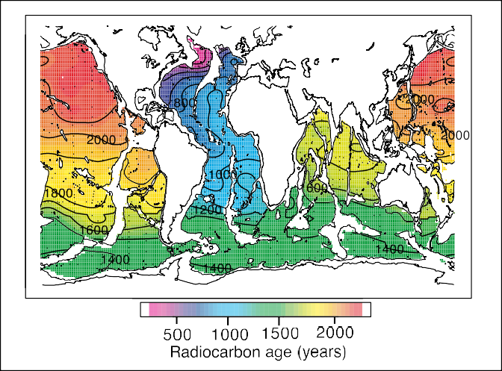
Figure 6.16 Map of radiocarbon (14C) age at 3500 m (Matsumoto and
Key, 2004).
parcel last contacted the atmosphere because of incomplete equilibration with the atmosphere (Orr, 2004). Taking this partial equilibration into account, the age of North Pacific deep water is estimated to be in the range of 700 to 1000 years. Other basins, such as the North Atlantic, have characteristic overturning times of 300 years or more. This data suggests that, generally, carbon injected in the deep ocean would equilibrate with the atmosphere over a time scale of 300 to 1000 years.

Estimation of fraction retained from model results

Ocean models have been used to predict the isolation of injected CO2 from the atmosphere. Many models are calibrated using ocean radiocarbon data, so model-based estimates of retention of injected CO2 are not completely independent of the estimates based more directly on observations (Section 6.3.3).
A wide number of studies have used three-dimensional ocean general circulation models to study retention of CO2 injected into the ocean water column (Bacastow and Stegen, 1991; Bacastow et al., 1997; Nakashiki and Ohsumi, 1997;
Dewey et al., 1997, 1999; Archer et al., 1998; Xu et al., 1999; Orr, 2004; Hill et al., 2004). These modelling studies generally confirm inferences based on simpler models and considerations of ocean chemistry and radiocarbon decay rates. In ocean general circulation simulations performed by seven modelling groups (Orr, 2004), CO2 was injected for 100 years at each of seven different locations and at three different depths. Model results indicate that deeper injections will be isolated from the atmosphere for longer durations. Figure 6.17 shows the effect of injection depth on retained fraction for the mean of seven ocean sites (Orr, 2004). Ranges of model results indicate some uncertainty in forecasts of isolation of CO2 released to the deep ocean, although for all models the time extent of CO2 isolation is longer for deeper CO2 release, and isolation is nearly complete for 100 years following CO2 release at 3000 m depth (Figure
6.18 and 6.19). However, present-day models disagree as to the degassing time scale for particular locations (Figure 6.19). There seems to be no simple and robust correlation of CO2 retention other than depth of injection (Caldeira et al., 2002), however, there is some indication that the mean fraction retained for stored carbon is greater in the Pacific Ocean than the Atlantic Ocean, but not all models agree on this. Model results indicate that for injection at 1500 m depth, the time scale of the partial CO2 degassing is sensitive to the location of the injection, but at 3000 m, results are relatively insensitive to injection location. Model results have been found to be sensitive to differences in numerical schemes and model parameterizations (Mignone et al., 2004).

Site selection

Background

There are no published papers specifically on site selection for intentional ocean storage of CO2; hence, we can discuss only general factors that might be considered when selecting sites for

Box 6.3 Measures of the fraction of CO2 retained in storage
Different measures have been used to describe how effective intentional storage of carbon dioxide in the ocean is to mitigate climate change (Mueller et al., 2004). Here, we illustrate several of these measures using schematic model results reported by Herzog et al. (2003) for injection of CO2 at three different depths (Figure 6.17).
Fraction retained (see Chapter 1) is the fraction of the cumulative amount of injected CO2 that is retained in the storage
reservoir over a specified period of time, and thereby does not have the opportunity to affect atmospheric CO2 concentration (Mignone et al., 2004). The retained fraction approaches zero (Figure 6.17) over long times, indicating that nearly all injected CO2 will interact with the atmosphere (although a small amount would interact first with carbonate sediments).
Airborne Fraction is the fraction of released CO2 that adds to atmospheric CO2 content (Kheshgi and Archer, 2004). For
atmospheric release, airborne fraction is initially one and decays to roughly 0.2 (depending on atmospheric CO2 concentration) as the added CO2 is mixed throughout the ocean, and decays further to about 0.08 as CO2 reacts with sediments (Archer et al., 1997). For deep-sea release, airborne fraction is initially zero and then approaches that of atmospheric release. Note that the
asymptotic airborne fraction depends on the concentration of CO2 of surface waters (Figure 6.3).
Fraction retained is used throughout this report to indicate
how long the CO2 is stored. In addition the following measures can be used to compare the effectiveness of ocean carbon storage with other options, for example:
      - The Net Present value (NPV) approach (Herzog et al., 2003) considers temporary storage to be equivalent to delayed emission of CO2 to the atmosphere. The value of delaying CO2 emissions depends on the future costs of CO2 emission and economic discount rates. There is economic value to temporary storage (i.e., delayed emission) if the cost of CO2 emissions increases at a rate that is less than the discount rate (Herzog et al., 2003).
      - The Global-Warming Potential (GWP) is a measure defined by the IPCC to compare the climatic effect of different greenhouse- gas emissions. It is computed by accumulating the radiative climate forcing of a greenhouse-gas emission over a specified time horizon. This measure has been applied to compare the radiative forcing from oceanic and atmospheric releases of carbon dioxide (Kheshgi

et al., 1994, Ramaswamy et al., 2001). Haugan and Joos (2004) propose a modification to the GWP approach that compares the climate effects of the airborne fraction of a CO2 release to the ocean
with those from a release to the atmosphere. Table 6.2 compares
these measures for results from a schematic model at three depths.
Figure 6.17 Fraction of carbon in the ocean from injection at three different depths and the atmosphere illustrated with results from a schematic model (Herzog et al., 2003). Calculations assume a background 280 ppm of CO2 in the atmosphere.

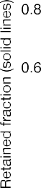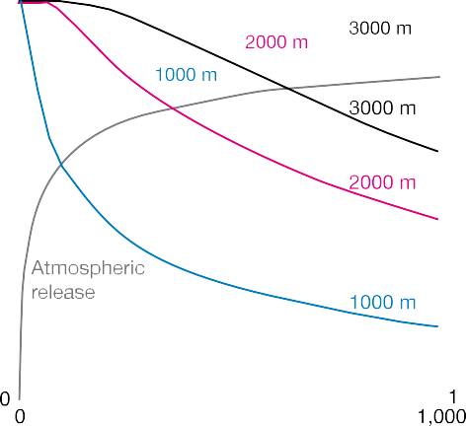table 6.2 Evaluation of measures described in the text illustrated using schematic model results shown in Figure 6.17. For the Net Present Value measure, the percentage represents the discount rate minus the rate of increase in the cost of CO2 emission. (If these are equal, the Net Present Value of temporary carbon storage is zero) Two significant digits shown for illustration exceed the accuracy of model results.
measure |  | Atmospheric release | injection depth
 |  |  | 1000 m | 2000 m | 3000 m
Effective | at 20 years | 0 | 0.96 | 1.00 | 1.00
Retained | at 100 years | 0 | 0.63 | 0.97 | 1.00
Fraction | at 500 years | 0 | 0.28 | 0.65 | 0.85
Airborne | at 20 years | 0.61 | 0.03 | 6×10-6 | 7×10-10
Fraction | at 100 years | 0.40 | 0.19 | 0.02 | 9×10-4
 | at 500 years | 0.24 | 0.20 | 0.12 | 0.06
Net Present | 5% per year | 0 | 0.95 | 1.00 | 1.00
Value (constant | 1% per year | 0 | 0.72 | 0.95 | 0.99
emissions cost) | 0.2% per year | 0 | 0.41 | 0.72 | 0.85
Global | 20 year horizon | 1 | 0.01 | 1×10-6 | 6×10-10
Warming | 100 year horizon | 1 | 0.21 | 0.01 | 4×10-4
Potential | 500 year horizon | 1 | 0.56 | 0.20 | 0.06

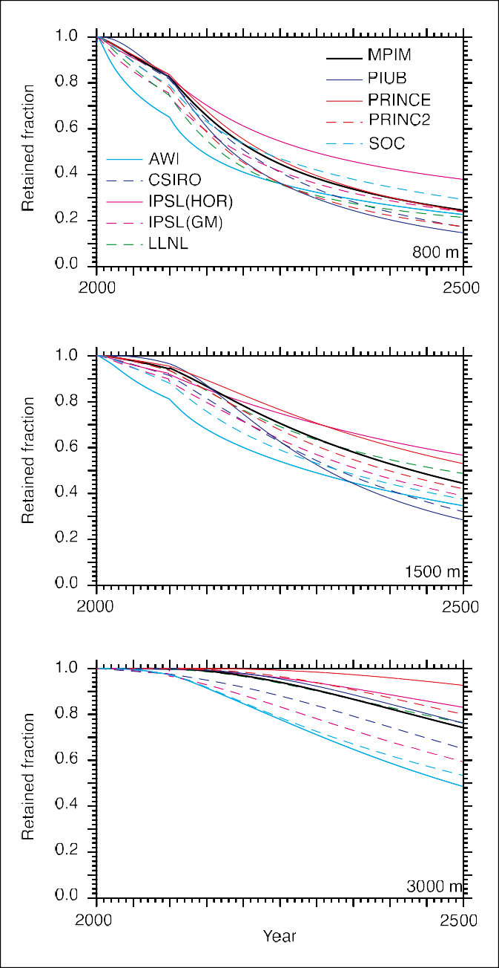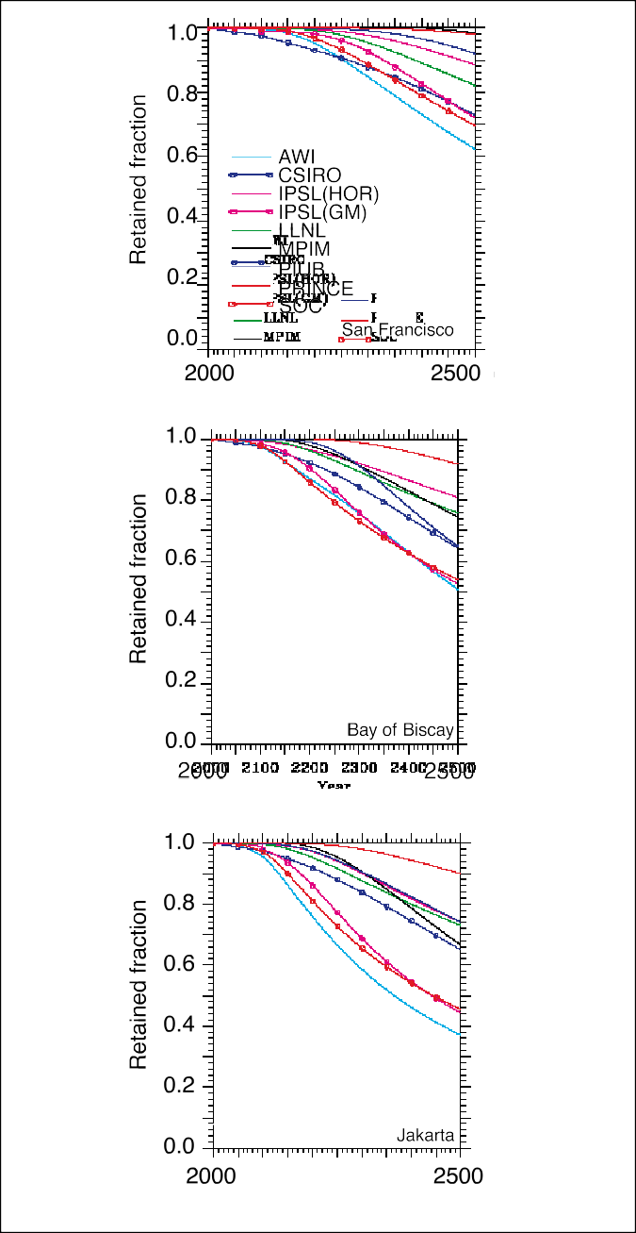

Figure 6.18 Results are shown for seven ocean general circulation models at three different depths averaged over seven injection
Figure 6.19 Comparison of storage results for three injection locations (at 3000 m depth) in ten ocean model simulations (Orr, 2004). Models

locations (Orr, 2004). The percentage efficiency shown is the retained
fraction for an injection at a constant rate from 2000 to 2100. Models agree that deeper injection isolates CO2 from the atmosphere longer than shallower injection. For release at 3000 m, most of the added carbon was still isolated from the atmosphere at the end of the 500
differ on predictions of CO2 oceans.
fraction retained for release in different

year simulations.

ocean storage. Among these considerations are environmental consequences, costs, safety, and international issues (including cross border transport). Because environmental consequences, costs, and social and political issues are addressed in other parts of this report, here we briefly consider site selection factors that enhance the fraction retained or reduce the costs.

Water column release

Large point sources of CO2 located near deep water would generally be the most cost effective settings in which to carry out direct CO2 injection (Figure 6.21; Section 6.9). While models indicate that site-specific differences exist, they do not yet agree on the ranking of potential sites for effectiveness of direct injection CO2 operations (Orr, 2004).

CO2 lakes on the sea floor

CO2 lakes must be on the sea floor at a depth below 3000 m (Figures 6.20 and 6.21), because the liquid CO2 must be denser than surrounding sea water (Box 6.2).
These ocean general circulation model calculations did not consider interactions with CaCO3 sediments or marine biota. Increased CO2 concentrations in the ocean promote dissolution of CaCO3 sediments, which would tend to increase predicted CO2 retention. This has been modelled for the deep sea with results of greater retention for release in the Atlantic because of high CaCO3 inventory in Atlantic sediments (Archer et al., 1998).
Preliminary numerical simulations of ocean CO2 injection predict increased oceanic retention of injected CO2 with concurrent global warming due to weaker overturning and a more stratified ocean (Jain and Cao, 2005). Some evidence indicates recent increases in stratification in all major ocean basins (e.g., Joos, 2003; McPhaden and Zhang, 2002; Palmer et al., 2004; Stramma et al., 2004).

Limestone neutralization

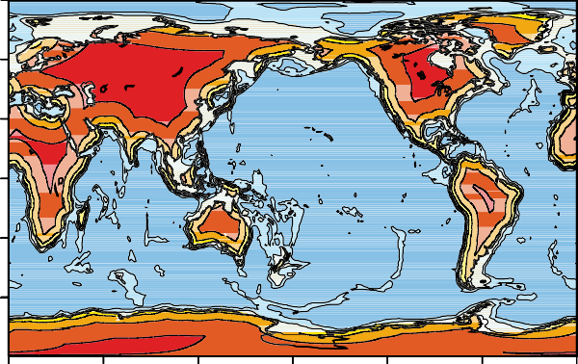
The amounts of sea water and limestone required to neutralize the acidity of added CO2 indicate that limestone neutralization would be most suitable for CO2 point sources located near both the ocean and large deposits of limestone (Rau and Caldeira, 1999).

Figure 6.20 Locations of ocean water at least 1 km and 3 km deep. Distance over land to water that is at least 3 km deep (Caldeira and Wickett, 2005). In general, land areas with the lightest colours would be the most-cost effective land-based settings for a CO2-injection operation. However, each potential site would need to be evaluated prior to deployment.

injection technology and operations

Background

The development of ocean storage technology is generally at a conceptual stage; thus, we will only discuss general principles. There has been limited engineering analysis and experimental studies of these conceptual technologies for ocean storage (Nihous, 1997), and no field-testing. No operational experience exists. Various technology concepts have been proposed to improve isolation from the atmosphere or diminish environmental consequences of CO2 injected into the ocean. Further research and development would be needed to make technologies available, but no major technical barriers are apparent.

Water column release

Dispersal of liquid CO2 at a depth of 1000 m or deeper is technologically feasible. Since liquid CO2 may be relatively easily transported to appropriate depths, the preferred release mode is thought at this time to be as a liquid or dense gas phase (achieved by compression beyond its critical point, 72.8 bar at 31°C). The pipes that would carry this CO2 to the deep ocean would be similar to the pipes that have been used commercially on land to transport CO2 for use in CO2 enhanced oil recovery projects (Ozaki et al., 1997). Models (Liro et al., 1992, Drange and Haugan, 1992) predict that, with a properly designed diffuser, nearly all the CO2 would dissolve in the ocean within a 100 m of the injection depth. Then, this CO2-rich water would be diluted as it disperses, primarily horizontally along surfaces of constant density.
Water column injection schemes typically envision minimizing local changes to ocean chemistry by producing a
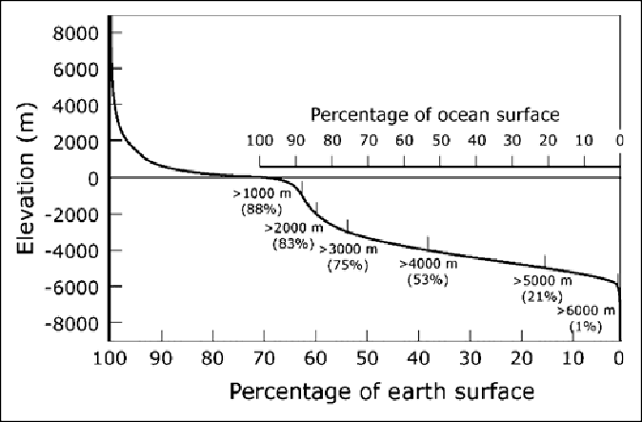
Figure 6.21 Relationship between depth and sea floor area. Flow in ocean bottom boundary layers would need to be taken into account when selecting a site for a CO2 lake. Bottom friction and turbulence can enhance the dissolution rate and vertical transport of dissolved CO2 and lead to a short lifetime for the lake (Section 6.2.1.6). It has been suggested that CO2 lakes would be preferentially sited in relatively restricted depressions or in trenches on sea floor (Ohsumi, 1995).

relatively dilute initial injection through a series of diffusers or by other means. Dilution would reduce exposure of organisms to very low pH (very high CO2) environments (Section 6.7).
One set of options for releasing CO2 to the ocean involves
transporting liquid CO2 from shore to the deep ocean in a pipeline. This would not present any major new problems in design, ‘according to petroleum engineers and naval architects
speaking at one of the IEA Greenhouse Gas R&D Programme ocean storage workshops’ (Ormerod et al., 2002). The oil industry has been making great advances in undersea offshore technology, with projects routinely working at depths greater than 1000 m. The oil and the gas industry already places pipes on the bottom of the sea in depths down to 1600 m, and design studies have shown 3000 m to be technically feasible (Ormerod et al., 2002). The 1 m diameter pipe would have the capacity to
2
to that from creation of a buoyant plume. Aya et al. (2004) have shown that a rapidly sinking plume of CO2 can be formed by release of a slurry combining cold liquid and solid CO2 with a hydrate skin. This would effectively transfer ship released CO2 at shallow ocean depth to the deep ocean without the cost of a long pipe. In all of these schemes the fate of the CO2 is to be dissolved into the ocean, with increased depth of dissolution, and thus increased retention.

Production of a CO2 lake
Nakashiki (1997) investigated several different kinds of discharge pipes that could be used from a liquid CO2 tanker to create a CO2 lake on the sea floor. They concluded that a ‘floating discharge pipe’ might be the best option because it is

transport 70,000 tCO2
day-1, enough for CO
captured from 3
simpler than the alternatives and less likely to be damaged by

GWe of a coal-fired electric power plant (Ormerod et al., 2002).
Liro et al. (1992) proposed injecting liquid CO2 at a depth of about 1000 m from a manifold lying near the ocean bottom to form a rising droplet plume. Nihous et al. (2002) proposed
injecting liquid CO2 at a depth of below 3000 m from a manifold lying near the ocean bottom and forming a sinking droplet plume. Engineering work would need to be done to assure that, below 500 m depth, hydrates do not form inside the discharged pipe and nozzles, as this could block pipe or nozzle flow.
CO2 could be transported by tanker for release from a stationary platform (Ozaki et al., 1995) or through a towed pipe (Ozaki et al., 2001). In either case, the design of CO2 tankers would be nearly identical to those that are now used to transport liquid petroleum gas (LPG). Cooling would be used, in order to reduce pressure requirements, with design conditions of –55 degrees C and 6 bar pressure (Ormerod et al., 2002). Producing a dispersed initial concentration would diminish the magnitude of the maximum pH excursion. This would probably involve designing for the size of the initial liquid CO2 droplet and the turbulent mixing behind the towed pipe (Tsushima et al., 2002). Diffusers could be designed so that CO2 droplets would dissolve completely before they reach the liquid-gas phase boundary.
CO2 hydrate is about 15% denser than sea water, so it tends to sink, dissolving into sea water over a broad depth horizon (Wannamaker and Adams, 2002). Kajishima et al. (1997) and Saito et al. (2001) investigated a proposal to create a dense CO2-seawater mixture at a depth of between 500 and 1000 m to form a current sinking along the sloping ocean bottom. Another proposal (Tsouris et al., 2004; West et al., 2003) envisions releasing a sinking CO2-hydrate/seawater slurry at between 1000 and 1500 m depth. This sinking plume would dissolve as it sinks, potentially distributing the CO2 over kilometres of vertical distance, and achieving some fraction of the CO2 retained in deep storage despite the initial release into intermediate waters. The production of a hydrate/seawater slurry has been experimentally demonstrated at sea (Tsouris et al., 2004). Tsouris et al. (2004) have carried out a field experiment at 1000 m ocean depth in which rapid mixing of sea water with CO2 in a capillary nozzle to a neutrally buoyant composite paste takes place. This would enhance ocean retention time compared
wind and waves in storm conditions.
Aya et al. (2003) proposed creating a slurry of liquid CO2 mixed with dry ice and releasing into the ocean at around 200 to 500 m depth. The dry ice is denser that the surrounding sea water and would cause the slurry to sink. An in situ experiment carried out off the coast of California found that a CO2 slurry and dry ice mass with initial diameter about 8.0 cm sank approximately 50 metres within two minutes before the dry ice melted (Aya et al., 2003). The initial size of CO2 slurry and dry ice is a critical factor making it possible to sink more than 3000 m to the sea floor. To meet performance criteria, the dry ice content would be controlled with a system consisting of a main power engine, a compressor, a condenser, and some pipe systems.

Monitoring and verification

Background

Monitoring (Figure 6.22) would be done for at least two different purposes: (1) to gain specific information relating to a particular CO2 storage operation and (2) to gain general scientific understanding. A monitoring program should attempt to quantify the mass and distribution of CO2 from each point source and could record related biological and geochemical parameters. These same issues may relate to monitoring of potential leakages from subsea geologic storage, or for verification that such leakage does not occur. Monitoring protocols for submarine sewage disposal for example are already well established, and experience may be drawn from that.

Monitoring amounts and distributions of materials released

      - Monitoring the near field
It appears that there is no serious impediment to verifying plant compliance with likely performance standards for flow through a pipe. Once CO2 is discharged from the pipe then the specific monitoring protocols will depend upon whether the plume is buoyant or sinking. Fixed location injections present fewer

verification difficulties than moving ship options.
For ocean injection from large point sources on land, verifying compliance involves above ground inspection of facilities for verification of flow and the CO2 purity being consistent with environmental regulations (e.g., trace metal concentrations, etc.). For a power plant, flue gases could be
conductivity sensors. Measurements of ocean pH and current profiles at sufficiently high temporal resolution could be used to evaluate the rate of CO2 release, local CO2 accumulation and net transport away from the site (Sundfjord et al., 2001). Undersea video cameras can monitor the point of release to observe CO2 flow. The very large sound velocity contrast between liquid CO2

monitored for flow rate and CO2
a full power plant carbon audit.
partial pressure, thus allowing
(about 300 m s–1) and sea water (about 1,500 m s–1) offers the
potential for very efficient monitoring of the liquid CO2 phase

There are a variety of strategies for monitoring release of
CO2 into the ocean from fixed locations. Brewer et al. (2005) observed a plume of CO2-rich sea water emanating from a small- scale experimental release at 4 km depth with an array of pH and
using acoustic techniques (e.g., sonar).
The placement of CO2 directly in a lake on the sea floor can be verified, and the quantity and loss rate determined by a combination of acoustic, pH, and velocity measurements, and by direct inspection with underwater vehicles. Undersea vehicles, tethered or autonomous, could play a prominent role in monitoring and verification. Autonomous vehicles have been developed that can be programmed to efficiently follow a variety of complex trajectories over large areas (Simonetti, 1998), but accurate pH sensing in a rapidly changing pressure and temperature field has yet to be demonstrated. Deep-sea pH monitoring from tethered vehicles has been shown to be very precise (Brewer et al., 2004), and these vehicles can routinely collect precisely located samples for later analysis.

      - Monitoring the far field
It will be possible to monitor the far field distributions of injected CO2 using a combination of shipboard measurements and modelling approaches. The ability to identify pH plumes in the ocean has been well demonstrated (Figure 6.23). Current analytical techniques for measuring total CO2 in the ocean are accurate to about ±0.05% (Johnson et al., 1998). Thus, measurable changes could be seen with the addition of approximately 90 tonnes of CO per km3. In other words,
2

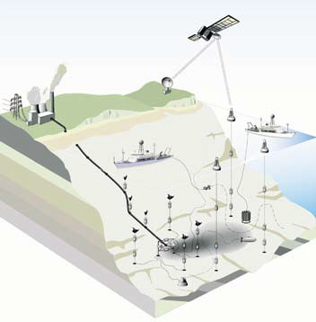Figure 6.22 Schematic of possible approaches for monitoring the injection of CO2 into the deep ocean via a pipeline. The grey region represents a plume of high CO2/low pH water extending from the end of the pipeline. Two sets of chemical, biological and current sensors and two underwater cameras are shown at the end of the pipeline. An array of moored sensors to monitor the direction and magnitude of the resulting plume can be seen around the pipe and are also located along the pipeline to monitor for possible leaks. A shore-based facility provides power to the sensors and for obtaining real-time data and an autonomous underwater vehicle maps the near-field distribution of the plume. A towed undulating pumping system monitors at distances of more than a few kilometres from the injection site. The towed system could provide much greater measurement accuracy and precision, but would also be able to provide measurements over large areas in a relatively short period of time. Moored systems are used to monitor the plume between mapping cruises. These moorings have surface buoys and make daily transmissions back to the monitoring facility via satellite. The very far-field distributions are monitored with hydrographic section cruises conducted every 2–5 years using standard discrete sampling approaches. These approaches provide the

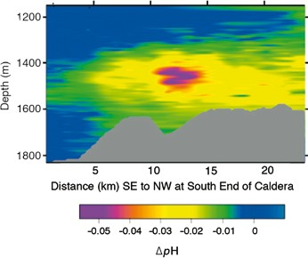Figure 6.23 Measurements showing the ability to measure chemical effects of a natural CO2 plume. Profiles for pH were taken in June 1999

accuracy and precision required to detect the small CO2
add to background variations.
signals that
near the Axial Volcano at 46ºN 130ºW, in the ocean near Portland,
Oregon, United States.

1 GtCO2
could be detected even if it were dispersed over 107

Environmental impacts, risks, and risk

km3 (i.e., 5000 km x 2000 km x 1 km), if the dissolved inorganic
carbon concentrations in the region were mapped out with high- density surveys before the injection began.
Variability in the upper ocean mixed layer would make it difficult to directly monitor small changes in CO2 in waters shallower than the annual maximum mixed-layer depth.
Seasonal mixing from the surface can extend as deep as 800 m in some places, but is less than 200 m in most regions of the ocean. Below the seasonal mixed layer, however, periodic ship- based surveys (every 2 to 5 years) could quantify the expansion of the injection plume.
We do not have a direct means of measuring the evasion of carbon stored in the ocean to the atmosphere. In most cases of practical interest the flux of stored CO2 from the ocean to
atmosphere will be small relative to natural variability and
the accuracy of our measurements. Operationally, it would be impossible to differentiate between carbon that has and has not interacted with the atmosphere. The use of prognostic models in evaluating the long-term fate of the injected CO2 is critical for properly attributing the net storage from a particular site.
Given the natural background variability in ocean carbon concentrations, it would be extremely difficult, if not impossible, to measure CO2 injected very far from the injection source. The attribution of a signal to a particular point source would become increasingly difficult if injection plumes from different locations began to overlap and mix. In some parts of the ocean it would be difficult to assign the rise in CO2 to intentional ocean storage as opposed to CO2 from atmospheric absorption.

6.6.3 Approaches and technologies for monitoring environmental effects

Techniques now being used for field experiments could be used to monitor some near field consequences of direct CO2 injection (Section 6.7). For example, researchers (Barry et al., 2004, 2005; Carman et al., 2004; Thistle et al., 2005) have been developing experimental means for observing the consequences of elevated CO2 on organisms in the deep ocean. However, such experiments and studies typically look for evidence of acute toxicity in a narrow range of species (Sato, 2004; Caulfield et al., 1997; Adams et al., 1997; Tamburri et al., 2000). Sub-lethal effects have been studied by Kurihara et al. (2004). Process studies, surveys of biogeochemical tracers, and ocean bottom studies could be used to evaluate changes in ecosystem structure and dynamics both before and after an injection.
It is less clear how best to monitor the health of broad reaches of the ocean interior (Sections 6.7.3 and 6.7.4). Ongoing long-term surveys of biogeochemical tracers and deep-sea biota could help to detect long-term changes in deep-sea ecology.

management

Introduction to biological impacts and risk

Overall, there is limited knowledge of deep-sea population and community structure and of deep-sea ecological interactions (Box 6.4). Thus the sensitivities of deep ocean ecosystems to intentional carbon storage and the effects on possibly unidentified goods and services that they may provide remain largely unknown.
Most ocean storage proposals seek to minimize the volume of water with high CO2 concentrations either by diluting the CO2 in a large volume of water or by isolating the CO2 in a small
volume (e.g., in CO2 lakes). Nevertheless, if deployed widely,
CO2 injection strategies ultimately will produce large volumes of water with somewhat elevated CO2 concentrations (Figure 6.15). Because large amounts of relatively pure CO2 have never been introduced to the deep ocean in a controlled experiment,
conclusions about environmental risk must be based primarily on laboratory and small-scale in-situ experiments and extrapolation from these experiments using conceptual and mathematical models. Natural analogues (Box 6.5) can be relevant, but differ significantly from proposed ocean engineering projects.
Compared to the surface, most of the deep sea is stable and varies little in its physiochemical factors over time (Box 6.4). The process of evolutionary selection has probably eliminated individuals apt to endure environmental perturbation. As a result, deep-sea organisms may be more sensitive to environmental disturbance than their shallow water cousins (Shirayama, 1997).
Ocean storage would occur deep in the ocean where there is virtually no light and photosynthesizing organisms are lacking, thus the following discussion primarily addresses CO2 effects on heterotrophic organisms, mostly animals. The diverse fauna that lives in the waters and sediments of the deep ocean can be affected by ocean CO2 storage, leading to change in ecosystem composition and functioning. Thus, the effects of CO2 need to be identified at the level of both the individual (physiological) and the ecosystem.
As described in Section 6.2, introduction of CO2 into the ocean either directly into sea water or as a lake on the sea floor would result in changes in dissolved CO2 near to and down current from a discharge point. Dissolving CO2 in sea water (Box 6.1; Table 6.3) increases the partial pressure of CO2 (pCO2, expressed as a ppm fraction of atmospheric pressure, equivalent to µatm), causes decreased pH (more acidic) and decreased CO 2– concentrations (less saturated). This can lead to dissolution of CaCO3 in sediments or in shells of organisms. Bicarbonate (HCO –) is then produced from carbonate (CO 2–).
3

3 3
The spatial extent of the waters with increased CO2 content
and decreased pH will depend on the amount of CO2 released and the technology and approach used to introduce that CO2 into the ocean. Table 6.3 shows the amount of sea water needed
to dilute each tonne of CO2 to a specified ∆pH reduction. Further dilution would reduce the fraction of ocean at one ∆pH

Box 6.4 Relevant background in biological oceanography.

Photosynthesis produces organic matter in the ocean almost exclusively in the upper 200 m where there is both light and nutrients (e.g., PO , NO , NH +, Fe). Photosynthesis forms the base of a marine food chain that recycles much of the carbon
4 3 4
and nutrients in the upper ocean. Some of this organic matter ultimately sinks to the deep ocean as particles and some of it is
mixed into the deep ocean as dissolved organic matter. The flux of organic matter from the surface ocean provides most of the energy and nutrients to support the heterotrophic ecosystems of the deep ocean (Gage and Tyler, 1991). With the exception of the oxygen minimum zone and near volcanic CO2 vents, most organisms living in the deep ocean live in low and more or less constant CO2 levels.
At low latitudes, oxygen consumption and CO2 release can produce a zone at around 1000 m depth characterized by low O2 and high CO2 concentrations, known as the ‘oxygen minimum zone’. Bacteria are the primary consumers of organic matter in the deep ocean. They obtain energy predominately by consuming dissolved oxygen in reactions that oxidize organic carbon into CO2. In the oxygen minimum layer, sea water pH may be less than 7.7, roughly 0.5 pH units lower than average pH of natural surface waters (Figure 6.6).
At some locations near the sea floor, especially near submarine volcanic CO2 sources, CO2 concentrations can fluctuate greatly. Near deep-sea hydrothermal vents CO2 partial pressures (pCO2, expressed as a ppm fraction of atmospheric pressure, equivalent to µatm) of up to 80,000 ppm have been observed. These are more than 100 times the typical value for deep- sea water. Typically, these vents are associated with fauna that have adapted to these conditions over evolutionary time. For example, tube worms can make use of high CO2 levels for chemosynthetic CO2 fixation in association with symbiotic bacteria (Childress et al., 1993). High CO2 levels (up to a pCO2 of 16,000 ppm; Knoll et al., 1996) have been observed in ocean bottom waters and marine sediments where there are high rates organic matter oxidation and low rates of mixing with the overlying seawater. Under these conditions, high CO2 concentrations are often accompanied by low O2 concentrations. Near the surface at night, respiratory fluxes in some relatively confined rock pools of the intertidal zone can produce high CO2 levels. These patterns suggest that in some environments, organisms have evolved to tolerate relatively wide pH oscillations and/or low pH values.
Deep-sea ecosystems generally depend on sinking particles of organic carbon made by photosynthesis near the ocean surface settling down through the water. Most species living in the deep sea display very low metabolic rates (Childress, 1995), especially in oxygen minimum layers (Seibel et al., 1997). Organisms living in the deep seawaters have adapted to the energy- limited environment by conserving energy stores and minimizing energy turnover. As a result of energy limitations and cold temperatures found in the deep sea, biological activities tend to be extremely low. For example, respiration rates of rat-tail fish are roughly 0.1% that of their shallow-water relatives. Community respiration declines exponentially with depth along the California margin, however, rapid turnover of large quantities of organic matter has been observed on the ocean floor (Mahaut et al., 1995; Smith and Demopoulos, 2003). Thus, biological activity of some animals living on the deep sea floor can be as great as is found in relatives living on the sea floor in shallow waters.
Deep-sea ecosystems may take a long time to recover from disturbances that reduce population size. Organisms have adapted to the energy-limited environment of the deep sea by limiting investment in reproduction, thus most deep-sea species produce few offspring. Deep-sea species tend to invest heavily in each of their eggs, making them large and rich in yolk to provide the offspring with the resources they will need for survival. Due to their low metabolic rates, deep-sea species tend to grow slowly and have much longer lifespans than their upper-ocean cousins. For example, on the deep-sea floor, a bivalve less than 1 cm across can be more than 100 years old (Gage, 1991). This means that populations of deep-sea species will be more greatly affected by the loss of individual larvae than would upper ocean species. Upon disturbance, recolonization and community recovery in the deep ocean follows similar patterns to those in shallow waters, but on much longer time scales (several years compared to weeks or months in shallow waters, Smith and Demopoulos, 2003).
The numbers of organisms living on the sea floor per unit area decreases exponentially with depth, probably associated with the diminishing flux of food with depth. On the sea floor of the deepest ocean and of the upper ocean, the fauna can be dominated by a few species. Between 2000 and 3000 m depth ecosystems tend to have high species diversity with a low number of individuals, meaning that each species has a low population size (Snelgrove and Smith, 2002). The fauna living in the water column appear to be less diverse than that on the sea floor, probably due to the relative uniformity of vast volumes of water in the deep ocean.

Box 6.5 Natural analogues and Earth history.

There are several examples of natural systems with strong CO2 sources in the ocean, and fluid pools toxic to marine life that
may be examined to better understand possible physical and biological effects of active CO2 injection.
Most natural environments that are heavily enriched in CO2 (or toxic substances) host life forms that have adapted to these special conditions on evolutionary time scales. During Earth history much of the oceans may have hosted life forms specialized on elevated pCO2, which are now extinct. This limits the use of natural analogues or Earth history to predict and generalize
effects of CO2 injection on most extant marine life.
      - Venting of carbon dioxide-rich fluids: Hydrothermal vents, often associated with mid-ocean-ridge systems, often release
CO2 rich fluids into the ocean and can be used to study CO2 behaviour and effects. For example, Sakai et al. (1990) observed buoyant hydrate forming fluids containing 86–91% CO2 (with H2S, and methane etc. making up the residual) released from the sea floor at 1335–1550 m depth from a hydrothermal vent field. These fluids would be similar to a heavily contaminated industrial CO2 source. These fluids arise from the reaction of sea water with acid and intermediate volcanic rocks at high temperature; they are released into sea water of 3.8°C. A buoyant hydrate-coated mass forms at the sea floor, which then floats upwards dissolving into the ocean water. Sea floor venting of aqueous fluids, rich in CO2 and low in pH (3.5–4.4), is also to be found in some hydrothermal systems (Massoth et al., 1989; Karl, 1995).
Near volcanic vents, deep-sea ecosystems can be sustained by a geochemical input of chemical energy and CO2. While there has been extensive investigation of these sites, and the plumes emanating from them, this has not yet been in the context of analogues for industrial CO2 storage effects. Such an investigation would show how a fauna has evolved to adapt to a high-CO2 environment; it would not show how biota adapted to normal ocean water would respond to increased CO2 concentrations.*
      - Deep saline brine pools: The ocean floor is known to have a large number of highly saline brine pools that are anoxic and toxic to marine life. The salty brines freely dissolve, but mixing into the overlying ocean waters is impeded by the stable stratification imparted by the high density of the dissolving brines. The Red Sea contains many such brine pools (Degens and Ross, 1969; Anschutz et al., 1999), some up to 60 km2 in area, filled with high-temperature hyper-saline, anoxic, brine. Animals cannot survive in these conditions, and the heat and salt that are transported across the brine-seawater interface form a plume into the surrounding bottom water. Hydrothermal sources resupply brine at the bottom of the brine pool (Anschutz and Blanc, 1996). The Gulf of Mexico contains numerous brine pools. The largest known is the Orca Basin, where a 90 km2 brine pool in 2250 m water depth is fed by drainage from exposed salt deposits. The salt is toxic to life, but biogeochemical cycles operate at the interface with the overlying ocean (van Cappellen et al., 1998). The Mediterranean also contains numerous large hypersaline basins (MEDRIFF Consortium, 1995).
Taken together these naturally occurring brine pools provide examples of vast volumes of soluble, dense, fluids, hostile to marine life, on the sea floor. The number, volume, and extent of these pools exceed those for scenarios for CO2 lake formation yet considered. There has been little study of the impact of the plumes emanating from these sources. These could be examined to yield information that may be relevant to environmental impacts of a lake of CO2 on the ocean floor.
      - Changes over geological time: In certain times in Earth’s geological past the oceans may have contained more dissolved inorganic carbon and/or have had a lower pH.
There is evidence of large-scale changes in calcifying organism distributions in the oceans in the geological record that may be related in changes in carbonate mineral saturation states in the surface ocean. For example, Barker and Elderfield (2002) demonstrated that glacial-interglacial changes in the shell weights of several species of planktonic foraminifera are negatively correlated with atmospheric CO2 concentrations, suggesting a causal relationship.
Cambrian CO2 levels (i.e., about 500 million years ago) were as high as 5000 ppm and mean values decreased progressively
thereafter (see. Dudley, 1998; Berner, 2002). Two to three times higher than extant ocean calcium levels ensured that
calcification of, for example, coral reefs was enabled in paleo-oceans despite high CO2 levels (Arp et al., 2001). High performance animal life appeared in the sea only after atmospheric CO2 began to diminish. The success of these creatures may have depended on the reduction of atmospheric CO2 levels (reviewed by Pörtner et al., 2004, 2005).
CO2 is also thought to have been a potential key factor in the late Permian/Triassic mass extinction, which affected corals,
articulate brachiopods, bryozoans, and echinoderms to a larger extent than molluscs, arthropods and chordates (Knoll et al.,
1996; Berner, 2002; Bambach et al., 2002). Pörtner et al. (2004) hypothesized that this may be due to the corrosive effect of CO2 on heavily calcified skeletons. CO2 excursions would have occurred in the context of large climate oscillations. Effects of temperature oscillations, hypoxia events and CO2 excursions probably contributed to extinctions (Pörtner et al., 2005, see section 6.7.3).

table 6.3 Relationships between ∆pH, changes in pCO2, and dissolved inorganic carbon concentration calculated for mean deep-sea conditions. Also shown are volumes of water needed to dilute 1 tCO2 to the specified ∆pH, and the amount of CO2 that, if uniformly distributed throughout the ocean, would produce this ∆pH.
pH change  ∆pH | increase in CO2 partial pressure  ∆pCO2 (ppm) | increase in dissolved inorganic carbon  ∆DIC (µmol kg–1) | Seawater volume to dilute 1 tCO2 to  ∆pH (m3) | GtCO2 to produce  ∆pH in entire  ocean volume
0 | 0 | 0 | - | -
-0.1 | 150 | 30 | 656,000 | 2000
-0.2 | 340 | 70 | 340,000 | 3800
-0.3 | 580 | 100 | 232,000 | 5600
-0.5 | 1260 | 160 | 141,000 | 9200
-1 | 5250 | 400 | 54,800 | 24,000
-2 | 57,800 | 3,260 | 6800 | 190,000
-3 | 586,000 | 31,900 | 700 | 1,850,000

while increasing the volume of water experiencing a lesser
∆pH. Further examples indicating the spatial extent of ocean chemistry change from added CO2 are represented in Figures 6.11, 6.12, 6.13, 6.14, and 6.15.
On evolutionary time scales most extant animal life has adapted to, on average, low ambient CO2 levels. Accordingly, extant animal life may rely on these low pCO2 values and it is unclear to what extent species would be able to adapt to permanently elevated CO2 levels. Exposure to high CO2 levels and extremely acidic water can cause acute mortality, but more limited shifts in CO2, pH, and carbonate levels can be tolerated at least temporarily. Studies of shallow water organisms have identified a variety of physiological mechanisms by which changes in the chemical environment can affect fauna. These mechanisms should also apply to organisms living in the deep ocean. However, knowing physiological mechanisms alone does not enable full assessment of impacts at ecosystem levels. Long-term effects, for intervals greater than the duration of the reproduction cycle or the lifespan of an individual, may be overlooked, yet may still drastically change an ecosystem.
Species living in the open ocean are exposed to low and relatively constant CO2 levels, and thus may be sensitive to CO2 exposure. In contrast, species dwelling in marine sediments, especially in the intertidal zone, are regularly exposed to CO2 fluctuations and thus may be better adapted to high and variable CO2 concentrations. Physiological mechanisms associated with CO2 adaptation have been studied mostly in these organisms. They respond to elevated CO2 concentrations by transiently diminishing energy turnover. However, such responses are likely become detrimental during long-term exposure, as reduced metabolism involves a reduction in physical activity, growth, and reproduction. Overall, marine invertebrates appear more sensitive than fish (Pörtner et al., 2005).
CO2 effects have been studied primarily in fish and invertebrates from shallow waters, although some of these cover wide depth ranges down to below 2000 m or are adapted to cold temperatures (e.g., Langenbuch and Pörtner, 2003, 2004). Some in situ biological experiments used CO2 in the deep ocean (See Box 6.6).

Physiological effects of CO2

      - Effects of CO2 on cold-blooded water breathing animals
Hypercapnia is the condition attained when an organism (or part thereof) is surrounded by high concentrations of CO2. Under these conditions, CO2 enters the organisms by diffusion across body and especially respiratory surfaces and equilibrates with all body compartments. This internal accumulation of CO2 will be responsible for most of the effects observed in animals (reviewed by Pörtner and Reipschläger, 1996, Seibel and Walsh, 2001, Ishimatsu et al., 2004, 2005; Pörtner et al., 2004, 2005). Respiratory distress, narcosis, and mortality are the most obvious short-term effects at high CO2 concentrations, but lower concentrations may have important effects on longer time scales. The CO2 level to which an organism has acclimated may affect its acute critical CO2 thresholds, however, the capacity to acclimate has not been investigated to date.

      - Effects of CO2 versus pH
Typically, tolerance limits to CO2 have been characterized by changes in ocean pH or pCO2 (see Shirayama, 1995; Auerbach et al., 1997). However, changes in molecular CO2, carbonate, and bicarbonate concentrations in ambient water and body
fluids may each have specific effects on marine organisms (Pörtner and Reipschläger, 1996). In water breathers like fish or invertebrates CO2 entry causes immediate disturbances in
acid-base status, which need to be compensated for by ion
exchange mechanisms. The acute effect of CO2 accumulation is more severe than that of the reduction in pH or carbonate- ion concentrations. For example, fish larvae are more sensitive to low pH and high CO2 than low pH and low CO2 (achieved by addition of HCl with pCO2 levels kept low by aeration; Ishimatsu et al., 2004).
CO2 added to sea water will change the hydrogen ion concentration (pH). This change in hydrogen ion concentration may affect marine life through mechanisms that do not directly involve CO2. Studies of effects of lowered pH (without concomitant CO2 accumulation) on aquatic organisms have a

Box 6.6 In-situ observations of the response of deep-sea biota to added CO2.

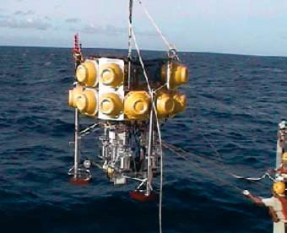In-situ experiments concerning the sensitivity of deep and shallow-living marine biota to elevated carbon dioxide levels have been limited in scope. Significant CO2 effects have been observed in experiments, consistent with the mechanisms of CO2 action reported in Section 6.7.2. Some animals avoid CO2 plumes, others do not.
Studies evaluating the behaviour and survival of deep- sea animals exposed to liquid CO2 or to CO2-rich sea water have been performed on the continental slope and rise off California. Experiments in which about 20–70 kg of liquid CO2 were released in small corrals on the sea floor at 3600 m depth were used to measure the response of animals that came in contact with liquid CO2, and to the dissolution plume emanating from CO2 pools (Barry et al., 2004). Larger bottom-living animals collected from the sea floor were held in cages and placed at distances of 1–50 m from CO2 pools. In addition, organisms living in the sediment were collected at a range of distances from CO2 pools, both before CO2 release and 1–3 months later.
The response of animals to direct contact with liquid CO2 varied among species. Sea cucumbers (holothurians like Scotoplanes sp.) and brittle stars (ophiuroids, unidentified
species) died immediately after contact with liquid CO2 (Barry et al., 2005). A few individuals (<5 individuals) of deep-sea fish (grenadiers, Coryphaenoides armatus) that approached CO2 pools and made contact with the fluid turned immediately and swam out of view. Other deep-sea experiments (Tamburri et al. 2000) evaluating the behavioural response of animals to a saturated CO2 / sea water solution have shown that some scavenger species (deep-sea hagfish) will not avoid acidic, CO2-rich seawater if chemical cues from decaying bait are also present. In fact, hagfish would maintain contact with the CO2-rich / bait-scented plume long enough to be apparently ‘narcotized’ by the CO2.
Survival rates of abyssal animals exposed to CO2 dissolution plumes in these experiments varied with the range of pH perturbation and the distance from the CO2 source. Abyssal animals held in cages or inhabiting sediments that were near (<1 m) CO2 pools, and which were exposed episodically to large pH reduction (1–1.5 pH units) experienced high rates of mortality (>80%). Animals affected included small (meio-
)fauna (flagellates, amoebae, nematodes; Barry et al., 2004) and larger (macro and mega-)fauna (Ampeliscid amphipod species, invertebrates like holothurians, echinoids, and fish like macrourids). Other fish like eelpout (zoarcids), however, all survived month-long exposure to episodic pH shifts of about –1.0 pH units. Animals held further (3–10 m) from CO2 pools were exposed to mild episodic pH reductions (about
0.1 – 0.2 pH units) exhibited mortality rates were (about 20–
50%) higher than at control sites (Barry et al., 2005).
It is unknown whether mortality was caused primarily by short-term exposure to large pH / CO2 shifts or by chronic, milder pH perturbations. Tidal variation in current direction resulted in a highly variable exposure to pH perturbations
with the most intense exposure to dissolution plumes when the current was flowing directly towards the study animals. During other tidal periods there was often no pH reduction, increasing the difficulty of interpreting these experiments.
Three controlled in-situ experiments were carried out at 2000 m in the Kumano Trough using a specially designed chamber (Figure 6.24; Ishida et al. 2005) to address the impact of 5,000 and 20,000 ppm rises in pCO2 (with resulting
pHs of 6.8 and 6.3) on the abundance and diversity of bacteria
and of small animals (nano- and meiobenthos). Significant impacts of elevated pCO2 on meiobenthic organisms could not be found except for one case where the abundance of foraminifera decreased significantly within 3 days at 20,000 ppm. The abundance of nanobenthos decreased significantly in most cases, whereas the abundance of bacteria increased at 20,000 ppm (Figure 6.25).
In-situ studies of short-term effects of elevated CO2 concentrations on deep-sea megafauna have been conducted using CO2 released naturally from the Loihi Seamount (Hawaii) at depths of 1200 to 1300 m (Vetter and Smith, 2005). A submersible was used to manipulate baited traps and bait parcels in Loihi’s CO2 plume to explore the effects of elevated CO2 on typical deep-sea scavengers. Vent-specialist shrimp were attracted to the bait and proved to be pre-adapted to the high CO2 levels found close to volcanic vents. Free swimming, amphipods, synaphobranchid eels, and hexanchid sharks avoided open bait parcels placed in the CO2 plumes

Figure 6.24 Experimental chamber going to the sea floor (Ishida et al. 2004). The bottom part houses a chamber that penetrates into the sediment. The top part houses electronics, pumps, valves, and water bags, that are used to control the CO2 concentration inside the chamber, and to sample sea water in the chamber at designated times. At the time of recovery, the bottom of the chamber is closed, weights are released, and the system returns to the surface of the ocean using buoyancy provided by the glass bulbs (yellow structures around the top).

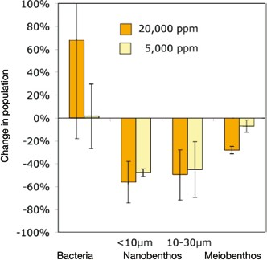

Figure 6.25 Preliminary investigations into the change of bacteria, nanobenthos and meiobenthos abundance after exposure to 20,000 and 5,000 ppm CO2 for 77 to 375 hr during three experiments carried out at 2,000 m depth in Nankai Trough, north-western Pacific. Error bars represent one standard deviation (Ishida et al. 2005).

long history, with an emphasis on freshwater organisms (Wolff et al., 1988). Observed consequences of lowered water pH (at constant pCO2) include changes in production/productivity patterns in algal and heterotrophic bacterial species, changes in biological calcification/ decalcification processes, and acute and sub-acute metabolic impacts on zooplankton species, ocean bottom species, and fish. Furthermore, changes in the pH of marine environments affect: (1) the carbonate system,
(2) nitrification (Huesemann et al., 2002) and speciation of nutrients such as phosphate, silicate and ammonia (Zeebe and Wolf-Gladrow, 2001), and (3) speciation and uptake of essential and toxic trace elements. Observations and chemical calculations show that low pH conditions generally decrease the association of metals with particles and increase the proportion of biologically available free metals (Sadiq, 1992; Salomons and Forstner, 1984). Aquatic invertebrates take up both essential and non-essential metals, but final body concentrations of metals vary widely across invertebrates. In the case of many trace metals, enhanced bioavailability is likely to have toxicological implications, since free forms of metals are of the greatest toxicological significance (Rainbow, 2002).

      - Acute CO2 sensitivity: oxygen transport in squid and
fish
CO2 accumulation and uptake can cause anaesthesia in many animal groups. This has been observed in deep-sea animals close to hydrothermal vents or experimental CO2 pools. A narcotic
effect of high, non-determined CO2 levels was observed in deep- sea hagfish after CO2 exposure in situ (Tamburri et al., 2000). Prior to anaesthesia high CO2 levels can exert rapid effects on oxygen transport processes and thereby contribute to acute CO2 effects including early mortality.
Among invertebrates, this type of CO2 sensitivity may be highest in highly complex, high performance organisms like squid (reviewed by Pörtner et al., 2004). Blue-blooded squid
do not possess red blood cells (erythrocytes) to protect their extracellular blood pigment (haemocyanin) from excessive pH fluctuations. Acute CO2 exposure causes acidification of the blood, will hamper oxygen uptake and binding at the gills and reduce the amount of oxygen carried in the blood, limiting performance, and at high concentrations could cause death. Less oxygen is bound to haemocyanin in squid than is bound to haemoglobin in bony fish (teleosts). Jet-propulsion swimming of squid demands a lot of oxygen. Oxygen supply is supported by enhanced oxygen binding with rising blood pH (and reduced binding of oxygen with falling pH – a large Bohr effect3). Maximizing of oxygen transport in squid thus occurs by means of extracellular pH oscillations between arterial and venous blood. Therefore, finely controlled extracellular pH changes are important for oxygen transport. At high CO2 concentrations, animals can asphyxiate because the blood cannot transport enough oxygen to support metabolic functions. In the most active open ocean squid (Illex illecebrosus), model calculations predict acute lethal effects with a rise in pCO2 by 6500 ppm and a 0.25 unit drop in blood pH. However, acute CO2 sensitivity varies between squid species. The less active coastal squid (Loligo pealei) is less sensitive to added CO2.
In comparison to squid and other invertebrates, fish (teleosts) appear to be less sensitive to added CO2, probably due to their lower metabolic rate, presence of red blood cells (erythrocytes containing haemoglobin) to carry oxygen, existence of a venous oxygen reserve, tighter epithelia, and more efficient acid-base regulation. Thus, adult teleosts (bony fish) exhibit a larger degree of independence from ambient CO2. A number of tested shallow-water fish have shown relatively high tolerance to added CO2, with short-term lethal limits of adult fish at a pCO2 of about 50,000 to 70,000 ppm. European eels (Anguilla anguilla) displayed exceptional tolerance of acute hypercapnia up to 104,000 ppm (for review see Ishimatsu et al., 2004, Pörtner et al., 2004). The cause of death in fish involves a depression of cardiac functions followed by a collapse of oxygen delivery to tissues (Ishimatsu et al., 2004). With mean lethal CO2 levels of 13,000 to 28,000 ppm, juveniles are more sensitive to acute CO2 stress than adults. In all of these cases, the immediate cause of death appears to be entry of CO2 into the organism (and not primarily some other pH-mediated effect).

3 The Bohr Effect is an adaptation in animals to release oxygen in the oxygen starved tissues in capillaries where respiratory carbon dioxide lowers blood pH. When blood pH decreases, the ability of the blood pigment to bind to oxygen decreases. This process helps the release of oxygen in the oxygen-poor environment of the tissues. Modified after ISCID Encyclopedia of Science and Philosophy. 2004. International Society for Complexity, Information, and Design. 12 October 2004 <http://www.iscid.org/encyclopedia/Bohr_Effect>.

Fish may be able to avoid contact to high CO2 exposure because they possess highly sensitive CO2 receptors that could be involved in behavioural responses to elevated CO2 levels (Yamashita et al., 1989). However, not all animals avoid low pH and high concentrations of CO2; they may actively swim into CO2-rich regions that carry the odour of potential food (e.g., bait; Tamburri et al., 2000, Box 6.6).
Direct effects of dissolved CO2 on diving marine air breathers (mammals, turtles) can likely be excluded since they possess higher pCO2 values in their body fluids than water breathers and gas exchange is minimized during diving. They may nonetheless be indirectly affected through potential CO2 effects on the food chain (see 6.7.5).

      - Deep compared with shallow acute CO2 sensitivity Deep-sea organisms may be less sensitive to high CO2 levels than their cousins in surface waters, but this is controversial. Fish (and cephalopods) lead a sluggish mode of life with reduced oxygen demand at depths below 300 to 400 m. Metabolic activity of pelagic animals, including fish and cephalopods, generally decreases with depth (Childress, 1995; Seibel et al., 1997). However, Seibel and Walsh (2001) postulated that deep-sea animals would experience serious problems in oxygen supply under conditions of increased CO2 concentrations. They refer to midwater organisms that may not be representative of deep-sea fauna; as residents of so-called ‘oxygen minimum layers’ they have special adaptations for efficient extraction of oxygen from low-oxygen waters (Sanders and Childress, 1990; Childress and Seibel, 1998).

      - Long-term CO2 sensitivity
Long-term impacts of elevated CO2 concentrations are more pronounced on early developmental than on adult stages of marine invertebrates and fish. Long-term depression of
physiological rates may, over time scales of several months, contribute to enhanced mortality rates in a population (Shirayama and Thornton, 2002, Langenbuch and Pörtner, 2004). Prediction of future changes in ecosystem dynamics, structure and functioning therefore requires data on sub-lethal effects over the entire life history of organisms.
The mechanisms limiting performance and long-term survival under moderately elevated CO2 levels are even less clear than those causing acute mortality. However, they
appear more important since they may generate impacts in larger ocean volumes during widespread distribution of CO2 at moderate levels on long time scales. In animals relying on calcareous exoskeletons, physical damage may occur under permanent CO2 exposure through reduced calcification and even dissolution of the skeleton, however, effects of CO2 on calcification processes in the deep ocean have not been studied to date. Numerous studies have demonstrated the sensitivity of calcifying organisms living in surface waters to elevated CO2 levels on longer time scales (Gattuso et al. 1999, Reynaud et al., 2003, Feeley et al., 2004 and refs. therein). At least a dozen laboratory and field studies of corals and coralline algae have suggested reductions in calcification rates by 15–85% with
a doubling of CO2 (to 560 ppmv) from pre-industrial levels. Shirayama and Thornton (2002) demonstrated that increases in dissolved CO2 levels to 560 ppm cause a reduction in growth rate and survival of shelled animals like echinoderms and gastropods. These findings indicate that previous atmospheric CO2 accumulation may already be affecting the growth of calcifying organisms, with the potential for large-scale changes in surface-ocean ecosystem structure. Due to atmospheric CO2 accumulation, global calcification rates could decrease by 50% over the next century (Zondervan et al., 2001), and there could be significant shifts in global biogeochemical cycles. Despite the potential importance of biogeochemical feedback induced by global change, our understanding of these processes is still in its infancy even in surface waters (Riebesell, 2004). Much less can be said about potential ecosystem shifts in the deep sea (Omori et al., 1998).
Long-term effects of CO2 elevations identified in individual animal species affects processes in addition to calcification (reviewed by Ishimatsu et al., 2004, Pörtner and Reipschläger, 1996, Pörtner et al., 2004, 2005). In these cases, CO2 entry into the organism as well as decreased water pH values are likely to have been the cause. Major effects occur through a disturbance in acid-base regulation of several body compartments. Falling pH values result and these affect many metabolic functions, since enzymes and ion transporters are only active over a narrow pH range. pH decreases from CO2 accumulation are counteracted over time by an accumulation of bicarbonate anions in the affected body compartments (Heisler, 1986; Wheatly and Henry, 1992, Pörtner et al., 1998; Ishimatsu et al. 2004), but compensation is not always complete. Acid-base relevant ion transfer may disturb osmoregulation due to the required uptake of appropriate counter ions, which leads to an additional NaCl load of up to 10% in marine fish in high CO2 environments (Evans, 1984; Ishimatsu et al., 2004). Long-term disturbances in ion equilibria could be involved in mortality of fish over long time scales despite more or less complete compensation of acidification.
Elevated CO2 levels may cause a depression of aerobic energy metabolism, due to incomplete compensation of the acidosis, as observed in several invertebrate examples (reviewed by Pörtner et al. 2004, 2005). In one model organism, the peanut worm Sipunculus nudus, high CO2 levels caused metabolic depression of up to 35% at 20,000 ppm pCO2. A central nervous mechanism also contributed, indicated by the accumulation of adenosine in the nervous tissue under 10,000 ppm pCO2. Adenosine caused metabolic depression linked to reduced ventilatory activity even more so when high CO2 was combined with oxygen deficiency (anoxia; Lutz and Nilsson, 1997). Studies addressing the specific role of adenosine or other neurotransmitters at lower CO2 levels or in marine fish during hypercapnia are not yet available.
The depression of metabolism observed under high CO2 concentrations in marine invertebrates also includes inhibition of protein synthesis – a process that is fundamental to growth
and reproduction. A CO2 induced reduction of water pH to 7.3 caused a 55% reduction in growth of Mediterranean mussels (Michaelidis et al. 2005; for review see Pörtner et al. 2004,

2005). Fish may also grow slowly in high CO2 waters. Reduced growth was observed in juvenile white sturgeon (Crocker and Cech, 1996). In this case, the stimulation of ventilation and the associated increase in oxygen consumption indicated a shift in energy budget towards maintenance metabolism, which occurred at the expense of growth. This effect was associated with reductions in foraging activity. A harmful influence of CO2 on reproductive performance was found in two species of marine copepods (Acartia steuri, Acartia erythrea) and sea urchins (Hemicentrotus purcherrimus, Echinometra mathaei). While survival rates of adult copepods were not affected during 8 days at pCO2 up to 10,000 ppm, egg production and hatching rates of eggs were significantly reduced concomitant to an increased mortality of young-stage larvae seen at water pH 7.0 (Kurihara et al., 2004). In both sea urchin species tested, fertilization rates decreased with pCO2 rising above1000 ppm (below water pH 7.6; Kurihara et al., 2004). Hatching and survival of fish larvae also declined with water pCO2 and exposure time in all examined species (Ishimatsu et al., 2004).

From physiological mechanisms to ecosystems

CO2 effects propagate from molecules via cells and tissues to whole animals and ecosystems (Figure 6.26; Table 6.4). Organisms are affected by chemistry changes that modulate crucial physiological functions. The success of a species can depend on effects on the most sensitive stages of its life cycle (e.g., egg, larvae, adult). Effects on molecules, cells, and tissues thus integrate into whole animal effects (Pörtner et al., 2004), affecting growth, behaviour, reproduction, and development of eggs and larvae. These processes then determine the ecological success (fitness) of a species, which can also depend on complex interaction among species. Differential effects of chemistry changes on the various species thus affect the entire ecosystem. Studies of CO2 susceptibility and affected mechanisms in individual species (Figure 6.26) support development of a cause and effect understanding for an entire ecosystem’s response to changes in ocean chemistry, but need to be complemented by field studies of ecosystem consequences.

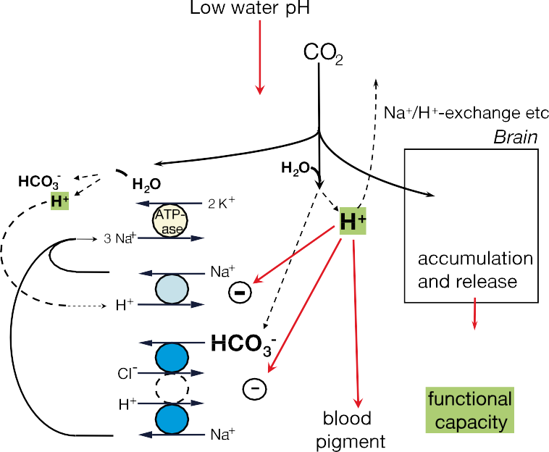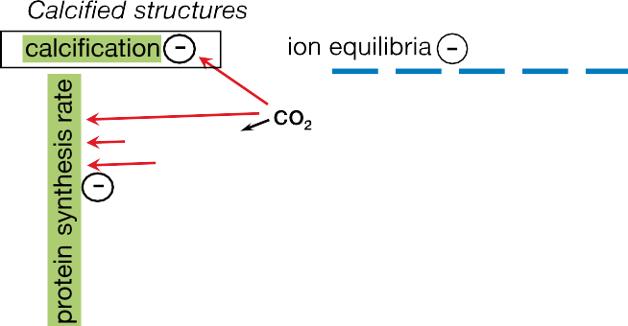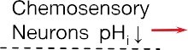

Figure 6.26 Effects of added CO at the scale of molecule to organism and associated changes in proton (H+), bicarbonate (HCO –) and carbonate
2 3
(CO 2–) levels in a generalized and simplified marine invertebrate or fish. The blue region on top refers to open water; the tan region represents
3
the organism. Generalized cellular processes are depicted on the left and occur in various tissues like brain, heart or muscle; depression of these processes has consequences (depicted on the right and top). Under CO2 stress, whole animal functions, like growth, behaviours or reproduction are depressed (adopted from Pörtner et al., 2005, – or + denotes a depression or stimulation of the respective function). Black arrows reflect diffusive movement of CO2 between compartments. Red arrows reflect effective factors, CO2, H+, HCO3– that modulate functions. Shaded areas indicate processes relevant for growth and energy budget.

table 6.4 Physiological and ecological processes affected by CO2 (note that listed effects on phytoplankton are not relevant in the deep sea, but may become operative during large-scale mixing of CO2). Based on reviews by Heisler, 1986, Wheatly and Henry, 1992, Claiborne et al., 2002, Langdon et al., 2003 Shirayama, 2002,
Kurihara et al., 2004, Ishimatsu et al., 2004, 2005, Pörtner et al. 2004, 2005, Riebesell, 2004, Feeley et al., 2004 and references therein.

It could also reduce the capacity to attack or escape predation, which would have consequences for the organism’s food supply and thus overall fitness with consequences for the rest of the ecosystem.
Complex organisms like animals proved to be more sensitive to changing environmental conditions like temperature extremes than are simpler, especially unicellular, organisms (Pörtner, 2002). It is not known whether animals are also more

sensitive to extremes in CO2. CO2
Affected processes | Organisms tested
Calcification | - Corals  - Calcareous benthos and plankton
Acid-base regulation | - Fish  - Sipunculids  - Crustaceans
Mortality | - Scallops  - Fish  - Copepods  - Echinoderms/gastropods  - Sipunculids
N-metabolism | - Sipunculids
Protein biosynthesis | - Fish  - Sipunculids  - Crustaceans
Ion homeostasis | - Fish, crustaceans  - Sipunculids
Growth | - Crustaceans  - Scallops  - Mussels  - Fish  - Echinoderms/gastropods
Reproductive performance | - Echinoderms  - Fish  - Copepods
Cardio-respiratory functions | - Fish
Photosynthesis | - Phytoplankton
Growth and calcification
Ecosystem structure
Feedback on biogeo- chemical cycles
(elemental stoichiometry C: N:P, DOC exudation)

affects many physiological

mechanisms that are also affected by temperature and hypoxia

(Figure 6.26). Challenges presented by added CO2
could

lower long-term resistance to temperature extremes and thus
narrow zoogeographical distribution ranges of affected species (Reynaud et al., 2003, Pörtner et al., 2005).
At the ecosystem level, few studies carried out in surface oceans report that species may benefit under elevated CO2 levels. Riebesell (2004) summarized observations in surface
ocean mesocosms under glacial (190 ppm) and increased CO2 concentrations (790 ppm). High CO2 concentrations caused higher net community production of phytoplankton. Diatoms dominated under glacial and elevated CO2 conditions, whereas Emiliania huxleyi dominated under present CO2 conditions. This example illustrates how species that are less sensitive to added CO2 could become dominant in a high CO2 environment, in this case due to stimulation of photosynthesis in resource limited phytoplankton species (Riebesell 2004). These conclusions have limited applicability to the deep sea, where animals and bacteria dominate. In animals, most processes are expected to be depressed by high CO2 and low pH levels (Table 6.4).

Biological consequences for water column release scenarios

Tolerance thresholds likely vary between species and
phyla, but still await quantification for most organisms. Due
Overall, extrapolation from knowledge mostly available for surface oceans indicates that acute CO2 effects (e.g., narcosis, mortality) will only occur in areas where pCO2 plumes reach significantly above 5000 ppm of atmospheric pressure (in the most sensitive squid) or above 13,000 or 40,000 ppm for juvenile or adult fish, respectively. Such effects are thus expected at CO2 increases with ∆pH < –1.0 for squid. According to the example presented in Figure 6.12, a towed pipe could avoid pH changes of this magnitude, however a fixed pipe without design optimization would produce a volume of several km3 with this pH change for an injection rate of 100 kg s–1. Depending on the scale of injection such immediate effects may thus be chosen to be confined to a small region of the ocean (Figures 6.13 and

to differential sensitivities among and within organisms, a continuum of impacts on ecosystems is more likely than the existence of a well-defined threshold beyond which CO2 cannot be tolerated. Many species may be able to tolerate transient CO2 fluctuations, but may not be able to settle and thrive in areas where CO2 levels remain permanently elevated. At concentrations that do not cause acute mortality, limited
6.14).
Available knowledge of CO2 effects and underlying mechanisms indicate that effects on marine fauna and their ecosystems will likely set in during long-term exposure to pCO2 of more than 400 to 500 ppm or associated moderate pH changes (by about 0.1–0.3 units), primarily in marine invertebrates (Pörtner et al. 2005) and, possibly, unicellular organisms. For

tolerance may include reduced capacities of higher functions,
injection at a rate of 0.37 GtCO2
yr–1 for 100 years (Figure

that is added CO2 could reduce the capacity of growth and
reproduction, or hamper resistance to infection (Burnett, 1997).
6.14), such critical pH shifts would occur in less than 1% of
the total ocean volume by the end of this period. However,

baseline pH shifts by 0.2 to 0.4 pH-units expected from the WRE550 stabilization scenario already reach that magnitude of change. Additional long-term repeated large-scale global injection of 10% of the CO2 originating from 18,000 GtCO2 fossil fuel would cause an extension of these pH shifts from the surface ocean to significantly larger (deeper) fractions of the ocean by 2100 to 2300 (Figure 6.15). Finally, large-scale ocean disposal of all of the CO2 would lead to pH decreases of more than 0.3 and associated long-term effects in most of the ocean. Expected effects will include a reduction in the productivity of calcifying organisms leading to higher ratios of non-calcifiers over calcifiers (Pörtner et al., 2005).
Reduced capacities for growth, productivity, behaviours, and reduced lifespan imply a reduction in population densities and productivities of some species, if not reduced biodiversity. Food chain length and composition may be reduced associated with reduced food availability for high trophic levels. This may diminish resources for local or global fisheries. The suggested scenarios of functional depression also include a CO2 induced reduction in tolerance to thermal extremes, which may go hand in hand with reduced distribution ranges as well as enhanced geographical distribution shifts. All of these expectations result from extrapolations of current physiological and ecological knowledge and require verification in experimental field studies. The capacity of ecosystems to compensate or adjust to such CO2 induced shifts is also unknown. Continued research efforts could identify critical mechanisms and address the potential for adaptation on evolutionary time scales.

Biological consequences associated with CO2 lakes
Strategies that release liquid CO2 close to the sea floor will be affecting two ecosystems: the ecosystem living on the sea floor, and deep-sea ecosystem living in the overlying water. Storage as a topographically confined ‘CO2 lake’ would limit immediate large-scale effects of CO2 addition, but result in the mortality of most organisms under the lake that are not able to flee and of organisms that wander into the lake. CO2 will dissolve from the lake into the bottom water, and this will disperse around the lake, with effects similar to direct release of CO2 into the overlying water. According to the scenarios depicted in Figures
6.11 and 6.12 for CO2 releases near the sea floor, pH reductions expected in the near field are well within the scope of those expected to exert significant effect on marine biota, depending on the length of exposure.

Contaminants in CO2 streams
The injection of large quantities of CO2 into the deep ocean will itself be the topic of environmental concern, so the matter of possible small quantities of contaminants in the injected material is of additional but secondary concern. In general there are already stringent limits on contaminants in CO2 streams due to human population concerns, and technical pipeline considerations. The setting of any additional limits for ocean disposal cannot be addressed with any certainty at this time.
There are prohibitions in general against ocean disposal; historical concerns have generally focused on heavy metals, petroleum products, and toxic industrial chemicals and their breakdown products.
A common contaminant in CO2 streams is H2S. There are very large sources of H2S naturally occurring in the ocean: many marine sediments are anoxic and contain large quantities
of sulphides; some large ocean basins (the Black Sea, the Cariaco Trench etc.) are anoxic and sulphidic. As a result ocean ecosystems that have adapted to deal with sulphide and sulphur- oxidizing bacteria are common throughout the worlds oceans. Nonetheless the presence of H2S in the disposal stream would result in a lowering of local dissolved oxygen levels, and have an impact on respiration and performance of higher marine organisms.

Risk management

There is no peer-reviewed literature directly addressing risk management for intentional ocean carbon storage; however, there have been risk management studies related to other uses of the ocean. Oceanic CO2 release carries no expectation of risk of catastrophic atmospheric degassing such as occurred at Lake Nyos (Box 6.7). Risks associated with transporting CO2 to depth are discussed in Chapter 4 (Transport).
It may be possible to recover liquid CO2 from a lake on the ocean floor. The potential reversibility of the production of CO2 lakes might be considered a factor that diminishes risk associated with this option.

Social aspects; public and stakeholder perception

The study of public perceptions and perceived acceptability of intentional CO2 storage in the ocean is at an early stage and comprises only a handful of studies (Curry et al., 2005; Gough et al., 2002; Itaoka et al., 2004; Palmgren et al., 2004). Issues crosscutting public perception of both geological and ocean storage are discussed in Section 5.8.5.
All studies addressing ocean storage published to date have shown that the public is largely uninformed about ocean carbon storage and thus holds no well-developed opinion. There is very little awareness among the public regarding intentional or unintentional ocean carbon storage. For example, Curry et al. (2005) found that the public was largely unaware of the role of the oceans in absorbing anthropogenic carbon dioxide released to the atmosphere. In the few relevant studies conducted thus far, the public has expressed more reservations regarding ocean carbon CO2 storage than for geological CO2 storage.
Education can affect the acceptance of ocean storage
options. In a study conducted in Tokyo and Sapporo, Japan (Iatoka et al, 2004), when members of the public, after receiving some basic information, were asked to rate ocean and geologic storage options on a 1 to 5 scale (1 = no, 5 = yes) the mean rating for dilution-type ocean storage was 2.24, lake-type ocean storage was rated at 2.47, onshore geological storage was rated at 2.57, and offshore geological storage was rated at

Box 6.7 Lake Nyos and deep-sea carbon dioxide storage.
About 2 million tonnes of CO2 gas produced by volcanic activity were released in one night in 1986 by Lake Nyos, Cameroon, causing the death of at least 1700 people (Kling et al., 1994). Could CO2 released in the deep sea produce similar catastrophic release at the ocean surface?
Such a catastrophic degassing involves the conversion of dissolved CO2 into the gas phase. In the gas phase, CO2 is buoyant and rises rapidly, entraining the surrounding water into the rising plume. As the water rises, CO2 bubbles form more readily. These processes can result in the rapid release of CO2 that has accumulated in the lake over a prolonged period of magmatic activity.
Bubbles of CO2 gas can only form in sea water shallower than about 500 m when the partial pressure of CO2 in sea water exceeds the ambient total pressure. Most release schemes envision CO2 release deeper than this. CO2 released below 3000 m would tend to sink and then dissolve into the surrounding seawater. CO2 droplets released more shallowly generally dissolve within a few 100 vertical metres of release.
The resulting waters are too dilute in CO2 to produce partial CO2 pressures exceeding total ambient pressure, thus CO2 bubbles would not form. Nevertheless, if somehow large volumes of liquid CO2 were suddenly transported above the liquid- gas phase boundary, there is a possibility of a self-accelerating regime of fluid motion that could lead to rapid degassing at
the surface. The disaster at Lake Nyos was exacerbated because the volcanic crater confined the CO2 released by the lake; the open ocean surface does not provide such topographic confinement. Thus, there is no known mechanism that could produce an unstable volume of water containing 2 MtCO2 at depths shallower than 500 m, and thus no mechanism known by which ocean carbon storage could produce a disaster like that at Lake Nyos.

2.75. After receiving additional information from researchers, the mean rating for dilution-type and lake-type ocean storage increased to 2.42 and 2.72, respectively, while the mean ratings for onshore and offshore geologic storage increased to 2.65 and 2.82, respectively. In a similar conducted study in Pittsburgh, USA, Palmgren et al. (2004) found that when asked to rate ocean and geologic storage on a 1 to 7 scale (1 = completely oppose, 7 = completely favour) respondents’ mean rating was about 3.2 for ocean storage and about 3.5 for geological storage. After receiving information selected by the researchers, the respondents changed their ratings to about 2.4 for ocean storage and 3.0 for geological storage. Thus, in the Itaoka et al. (2004) study the information provided by the researchers increased the acceptance of all options considered whereas in the Study of Palmgren et al. (2004) the information provided by the researchers decreased the acceptance of all options considered. The differences could be due to many causes, nevertheless, they suggest that the way information is provided by researchers could affect whether the added information increases or decreases the acceptability of ocean storage options.
Gough et al. (2002) reported results from discussions of carbon storage from two unrepresentative focus groups comprising a total of 19 people. These focus groups also preferred geological storage to ocean storage; this preference appeared to be based, ‘not primarily upon concerns for the deep-sea ecological environment’, but on ‘the lack of a visible barrier to prevent CO2 escaping’ from the oceans. Gough et al. (2002) notes that ‘significant opposition’ developed around a proposed ocean CO2 release experiment in the Pacific Ocean (see Section 6.2.1.2).

Legal issues

International law

Please refer to Sections 5.8.1.1 (Sources and nature of international obligations) and 5.8.1.2 (Key issues in the application of the treaties to CO2 storage) for the general position of both geological and ocean storage of CO2 under international law. It is necessary to look at and interpret the primary sources, the treaty provisions themselves, to determine the permissibility or otherwise of ocean storage. Some secondary sources, principally the 2004 OSPAR Jurists Linguists’ paper containing the States Parties’ interpretation of the Convention (considered in detail in Section 5.8.1.3) and conference papers prepared for the IEA workshop in 1996, contain their authors’ individual interpretations of the treaties.
McCullagh (1996) considered the international legal control of ocean storage, and found that, whilst the UN Framework Convention on Climate Change (UNFCCC) encourages the use of the oceans as a reservoir for CO2, the UN Convention on the Law of the Sea (UNCLOS) is ambiguous in its application to ocean storage. Whilst ocean storage will reduce CO2 emissions and combat climate change, to constitute an active use of sinks and reservoirs as required by the UNFCCC, ocean storage would need to be the most cost-effective mitigation option. As for UNCLOS, it is unclear whether ocean storage will be allowable in all areas of the ocean, but provisions on protecting and preserving the marine environment will be applicable if CO2 is deemed to be ‘pollution’ under the Convention (which will be so, as the large quantity of CO2 introduced is likely to cause harm to living marine resources). In fulfilling their obligation to prevent, reduce and control pollution of the marine environment, states must act so as not to transfer damage or hazards from one area to another or transform one type of pollution into another,

a requirement that could be relied upon by proponents and opponents alike.
Churchill (1996) also focuses on UNCLOS in his assessment of the international legal issues, and finds that the consent of the coastal state would be required if ocean storage occurred in that state’s territorial sea (up to12 miles from the coast). In that state’s Exclusive Economic Zone (up to 200 miles), the storage of CO2 via a vessel or platform (assuming it constituted
‘dumping’ under the Convention) would again require the
consent of that state. Its discretion is limited by its obligation to have due regard to the rights and duties of other states in the Exclusive Economic Zone under the Convention, by other treaty obligations (London and OSPAR) and the Convention’s general duty on parties not to cause damage by pollution to other states’ territories or areas beyond their national jurisdiction. He finds that it is uncertain whether the definition of ‘dumping’ would apply to use of a pipeline system from land for ocean storage, but, in any event, concludes that the discharge of CO2 from a pipeline will, in many circumstances, constitute pollution and thus require the coastal state to prevent, reduce and control such pollution from land-based sources. But ocean storage by a pipeline from land into the Exclusive Economic Zone will not fall within the rights of a coastal or any other state and any conflict between them will be resolved on the basis of equity and in the light of all the relevant circumstances, taking into account the respective importance of the interests involved to the parties as well as to the international community as a whole. He finds that coastal states do have the power to regulate and control research in their Exclusive Economic Zones, although such consent is not normally withheld except in some cases.
As for the permissibility of discharge of CO2 into the high seas (the area beyond the Exclusive Economic Zone open to all states), Churchill (1996) concludes that this will depend upon whether the activity is a freedom of the high sea and is thus not prohibited under international law, and finds that the other marine treaties will be relevant in this regard.
Finally, the London Convention is considered by Campbell (1996), who focuses particularly on the ‘industrial waste’ definition contained in Annex I list of prohibited substances, but does not provide an opinion upon whether CO2 is covered by that definition ‘waste materials generated by manufacturing or processing operations’, or indeed the so-called reverse list exceptions to this prohibition, or to the general prohibition under the 1996 Protocol.

National laws

      - Introduction
CO2 ocean storage, excluding injection from vessels, platforms or other human-made structures into the subseabed to which the Assessment made in Section 5.8 applies, is categorized into the following two types according to the source of injection of the CO2 (land or sea) and its destination (sea): (1) injection from land (via pipe) into the seawater; (2) injection from vessels, platforms or other human-made structures into sea water (water column, ocean floor).
States are obliged to comply with the provisions of international law mentioned above in Section 6.8.1, in particular treaty law to which they are parties. States have to implement their international obligations regarding CO2 ocean storage either by enacting relevant national laws or revising existing ones. There have been a few commentaries and papers on the assessment of the legal position of ocean storage at national level. However, the number of countries covered has been quite limited. Summaries of the assessment of the national legal issues having regard to each type of storage mentioned above to be considered when implementing either experimental or fully- fledged ocean storage of CO2 are provided below.
With regard to the United States, insofar as CO2 from a fossil-fuel power plant is considered industrial waste, it would be proscribed under the Ocean Dumping Ban Act of 1988. The Marine Protection, Research, and Sanctuaries Act of 1972 (codified as 33 U.S.C. 1401–1445, 16 U.S.C. 1431–1447f, 33
U.S.C. 2801–2805), including the amendments known as the Ocean Dumping Ban Act of 1988, has the aim of regulating intentional ocean disposal of materials, while authorizing related research. The Ocean Dumping Ban Act of 1988 placed a ban on ocean disposal of sewage sludge and industrial wastes after 31 December 1991.
The US Environmental Protection Agency (US EPA) specified protective criteria for marine waters, which held pH to a value between 6.5 and 8.5, with a limit on overall excursion of no more than 0.2 pH units outside the naturally occurring range (see: Train, 1979). Much of the early work on marine organisms reflected concerns about the dumping of industrial acid wastes (e.g., acid iron wastes from TiO2 manufacture) into
marine waters. For the most part, however, these studies failed
to differentiate between true pH effects and the effects due to CO2 liberated by the introduction of acid into the test systems.
      - Injection from land (via pipe) into seawater
States can regulate the activity of injection within their jurisdiction in accordance with their own national rules and regulations. Such rules and regulations would be provided by, if any, the laws relating to the treatment of high-pressure gases, labour health and safety, control of water pollution, dumping at sea, waste disposal, biological diversity, environmental impact assessment etc. It is, therefore, necessary to check whether planned activities of injection fall under the control of relevant existing rules and regulations.

      - Injection from vessels, platforms or other humanmade
structures into sea water (water column, ocean floor) It is necessary to check whether the ocean storage of CO2 is interpreted as ‘dumping’ of ‘industrial waste’ by relevant national laws, such as those on dumping at sea or waste disposal, because this could determine the applicability of the London Convention and London Protocol (see Section 6.8.1). Even if ocean storage is not prohibited, it is also necessary to check whether planned activities will comply with the existing relevant classes of rules and regulations, if any, mentioned above.

table 6.5 Ocean storage cost estimate for CO2 transport and injection at 3000 m depth from a floating platform. Scenario assumes three pulverized

coal fired power plants with a net generation capacity of 600 MWe each transported either 100 or 500 km by a CO2
tanker ship of 80,000 m3

capacity to a single floating discharge platform.

Ship transport distance | 100 km | 500 km
Onshore CO2 Storage (US$/tCO2 shipped) | 3.3 | 3.3
Ship transport to injection platform (US$/tCO2 shipped) | 2.9 | 4.2
Injection platform, pipe and nozzle (US$/tCO2 shipped) | 5.3 | 5.3
Ocean storage cost (US$/tCO2 shipped) | 11.5 | 12.8
Ocean storage cost (US$/tCO2 net stored) | 11.9 | 13.2

Costs

Introduction

Studies on the engineering cost of ocean CO2 storage have been published for cases where CO2 is transported from a power plant located at the shore by either ship to an offshore injection platform or injection ship (Section 6.9.2), or pipeline running on the sea floor to an injection nozzle (Section 6.9.3). Costs considered in this section include those specific to ocean storage described below and include the costs of handling of CO2 and transport of CO2 offshore, but not costs of onshore transport (Chapter 4).

Dispersion from ocean platform or moving ship

Costs have been estimated for ship transport of CO2 to an injection platform, with CO2 injection from a vertical pipe into mid- to deep ocean water, or a ship trailing an injection pipe (Akai et al., 2004; IEA-GHG, 1999; Ozaki, 1997; Akai et al., 1995; Ozaki et al., 1995). In these cases, the tanker ship transports liquid CO2 at low temperature (–55 to –50ºC) and high pressure (0.6 to 0.7 MPa).
Table 6.5 shows storage costs for cases (Akai et al., 2004) of ocean storage using an injection platform. In these cases, CO2 captured from three power plants is transported by a CO2 tanker ship to a single floating discharge platform for injection at a depth of 3000 m. The cost of ocean storage is the sum of three major components: tank storage of CO2 onshore awaiting shipping; shipping of CO2; and the injection platform pipe and nozzle. The sum of these three components is 11.5 to 12.8 US$/ tCO2 shipped 100 to 500 km. Assuming an emission equal to 3% of shipped CO2 from boil-off and fuel consumption, the estimated cost is 11.9 to 13.2 US$/tCO2 net stored.
Liquid CO2 could be delivered by a CO2 transport ship to the injection area and then transferred to a CO2 injection ship, which would tow a pipe injecting the CO2 into the ocean at a depth of 2,000 to 2,500 m. Estimated cost of ocean storage (Table 6.6) is again the sum of three major components: tank storage of CO2 onshore awaiting shipping; shipping of CO2; and the injection ship, pipe and nozzle (Table 6.6; Akai et al., 2004). The sum of these three components is 13.8 to 15.2 US$/tCO2 shipped 100 to 500 km. Assuming an emission equal to 3% of shipped CO2 from boil-off and fuel consumption, the estimated cost is 14.2 to 15.7 US$/tCO2 net stored.

Dispersion by pipeline extending from shore into shallow to deep water

Compared with the ship transport option (6.9.2), pipeline transport of CO2 is estimated to cost less for transport over shorter distances (e.g., 100 km) and more for longer distances (e.g., 500 km), since the cost of ocean storage via pipeline scales with pipeline length.
The cost for transporting CO2 from a power plant located at the shore through a pipeline running on the sea floor to an injection nozzle has been estimated by IEA-GHG (1994) and Akai et al. (2004). In the recent estimate of Akai et al. (2004), CO2 captured from a pulverized coal fired power plant with a net generation capacity of 600 MWe is transported either 100 or 500 km by a CO2 pipeline for injection at a depth of 3000 m at a cost of 6.2 US$/tCO2 net stored (100 km case) to 31.1 US$/ tCO2 net stored (500 km case).
There are no published cost estimates specific to the production of a CO2 lake on the sea floor; however, it might be reasonable to assume that there is no significant difference between the cost of CO2 lake production and the cost of water column injection given this dominance of pipeline costs.

table 6.6 Ocean storage cost estimate for CO2 transport and injection at 2000-2500 m depth from a moving ship.

Ship transport distance | 100 km | 500 km
Onshore CO2 Storage (US$/tCO2 shipped) | 2.2 | 2.2
Ship transport to injection ship(US$/tCO2 shipped) | 3.9 | 5.3
Injection ship, pipe and nozzle (US$/tCO2 shipped) | 7.7 | 7.7
Ocean storage cost (US$/tCO2 shipped) | 13.8 | 15.2
Ocean storage cost (US$/tCO2 net stored) | 14.2 | 15.7

Cost of carbonate neutralization approach

Large-scale deployment of carbonate neutralization would require a substantial infrastructure to mine, transport, crush, and dissolve these minerals, as well as substantial pumping of seawater, presenting advantages for coastal power plants near carbonate mineral sources.
There are many trade-offs to be analyzed in the design of an economically optimal carbonate-neutralization reactor along the lines of that described by Rau and Caldeira (1999). Factors to be considered in reactor design include water flow rate, gas flow rate, particle size, pressure, temperature, hydrodynamic conditions, purity of reactants, gas-water contact area, etc. Consideration of these factors has led to preliminary cost estimates for this concept, including capture, transport, and energy penalties, of 10 to 110 US$/tCO2 net stored (Rau and
Caldeira, 1999).

Cost of monitoring and verification

The cost of a monitoring and verification program could involve deploying and maintaining a large array of sensors in the ocean. Technology exists to conduct such monitoring, but a significant fraction of the instrument development and production is limited to research level activities. No estimate of costs for near-field monitoring for ocean storage have been published, but the costs of limited near-field monitoring would be small compared to the costs of ocean storage in cases of the scale considered in 6.9.2 and 6.9.3. Far field monitoring can benefit from international research programs that are developing global monitoring networks.

6.10 Gaps in knowledge

The science and technology of ocean carbon storage could move forward by addressing the following major gaps:

- Biology and ecology: Studies of the response of biological systems in the deep sea to added CO2, including studies that are longer in duration and larger in scale than yet performed.

- Research facilities: Research facilities where ocean storage concepts (e.g., release of CO2 from a fixed pipe or ship, or carbonate-neutralization approaches) can be applied and their effectiveness and impacts assessed in situ at small-scale on a continuing basis for the purposes of both scientific research and technology development.

- Engineering: Investigation and development of technology for working in the deep sea, and the development of pipes, nozzles, diffusers, etc., which can be deployed in the deep sea with assured flow and be operated and maintained cost-effectively.

- Monitoring: Development of techniques and sensors to detect CO2 plumes and their biological and geochemical consequences.
References
Adams, E., D. Golomb, X. Zhang, and H.J. Herzog, 1995: Confined release of CO2 into shallow seawater. Direct Ocean Disposal of Carbon Dioxide. N. Handa, (ed.), Terra Scientific Publishing Company, Tokyo, pp. 153-161.
Adams, E., J. Caulfield, H.J. Herzog, and D.I. Auerbach, 1997: Impacts of reduced pH from ocean CO2 disposal: Sensitivity of zooplankton mortality to model parameters. Waste Management, 17(5-6), 375-380.
Adams, E., M. Akai, G. Alendal, L. Golmen, P. Haugan, H.J. Herzog,
S. Matsutani, S. Murai, G. Nihous, T. Ohsumi, Y. Shirayama,
C. Smith, E. Vetter, and C.S. Wong, 2002: International Field Experiment on Ocean Carbon Sequestration (Letter). Environmental Science and Technology, 36(21), 399A.
Akai, M., N. Nishio, M. Iijima, M. Ozaki, J. Minamiura, and T. Tanaka, 2004: Performance and Economic Evaluation of CO2
Capture and Sequestration Technologies. Proceedings of the
Seventh International Conference on Greenhouse Gas Control Technologies.
Akai, M., T. Kagajo, and M. Inoue, 1995: Performance Evaluation of
Fossil Power Plant with CO2 Recovery and Sequestering System.
Energy Conversion and Management, 36(6-9), 801-804.
Alendal, G. and H. Drange, 2001: Two-phase, near field modelling of purposefully released CO2 in the ocean. Journal of Geophysical Research-Oceans, 106(C1), 1085-1096.
Alendal, G., H. Drange, and P.M. Haugan, 1994: Modelling of deep- sea gravity currents using an integrated plume model. The Polar Oceans and Their Role in Shaping the Global Environment: The Nansen Centennial Volume, O.M. Johannessen, R.D. Muench, and
J.E. Overland (eds.) AGU Geophysical Monograph, 85, American
Geophysical Union, pp. 237-246.
Anschutz, P. and G. Blanc, 1996: Heat and salt fluxes in the Atlantis II deep (Red Sea). Earth and Planetary Science Letters, 142, 147-159.
Anschutz, P., G. Blanc, F. Chatin, M. Geiller, and M.-C. Pierret, 1999: Hydrographic changes during 20 years in the brine-filled basins of the Red Sea. Deep-Sea Research Part I 46(10) 1779-1792.
Archer, D.E., 1996: An atlas of the distribution of calcium carbonate in sediments of the deep-sea. Global Biogeochemical Cycles, 10(1), 159-174.
Archer, D.E., H. Kheshgi, and E. Maier-Reimer, 1997: Multiple timescales for neutralization of fossil fuel CO2. Geophysical
Research Letters, 24(4), 405-408.
Archer, D.E., H. Kheshgi, and E. Maier-Reimer, 1998: Dynamics of fossil fuel neutralization by Marine CaCO3. Global Biogeochemical Cycles, 12(2), 259-276.
Arp, G., A. Reimer, and J. Reitner, 2001: Photosynthesis-induced biofilm calcification and calcium concentrations in Phanerozoic oceans. Science, 292, 1701-1704.
Auerbach, D.I., J.A. Caulfield, E.E. Adams, and H.J. Herzog, 1997:
Impacts of Ocean CO2 Disposal on Marine Life: I. A toxicological assessment integrating constant-concentration laboratory assay data with variable-concentration field exposure. Environmental Modelling and Assessment, 2(4), 333-343.

Aya, I., K. Yamane, and N. Yamada, 1995: Simulation experiment of CO2 storage in the basin of deep-ocean. Energy Conversion and Management, 36(6-9), 485-488.
Aya, I, R. Kojima, K. Yamane, P. G. Brewer, and E. T. Peltzer, 2004: In situ experiments of cold CO2 release in mid-depth. Energy, 29(9- 10), 1499-1509.
Aya, I., K. Yamane, and H. Nariai, 1997: Solubility of CO2 and density of CO2 hydrate at 30MPa. Energy, 22(2-3), 263-271.
Aya, I., R. Kojima, K. Yamane, P. G. Brewer, and E. T. Pelter, III, 2003: In situ experiments of cold CO2 release in mid-depth.
Proceedings of the International Conference on Greenhouse Gas
Control Technologies, 30th September-4th October, Kyoto, Japan. Bacastow, R.B. and G.R. Stegen, 1991: Estimating the potential for CO2 sequestration in the ocean using a carbon cycle model. Proceedings of OCEANS ‘91. Ocean Technologies and Opportunities in the Pacific for the 90’s, 1-3 Oct. 1991, Honolulu,
USA, 1654-1657.
Bacastow, R.B., R.K. Dewey, and G.R. Stegen, 1997: Effectiveness of CO2 sequestration in the pre- and post-industrial oceans. Waste Management, 17(5-6), 315-322.
Baes, C. F., 1982: Effects of ocean chemistry and biology on atmospheric carbon dioxide. Carbon Dioxide Review. W.C. Clark (ed.), Oxford University Press, New York, pp. 187-211.
Bambach, R.K., A.H. Knoll, and J.J. Sepkowski, jr., 2002: Anatomical and ecological constraints on Phanerozoic animal diversity in the marine realm. Proceedings of the National Academy of Sciences, 99(10), 6845-6859.
Barker, S. and H. Elderfield, 2002: Foraminiferal calcification
response to glacial-interglacial changes in atmospheric CO2.
Science, 297, 833-836.
Barry, J.P., K.R. Buck, C.F. Lovera, L.Kuhnz, P.J. Whaling, E.T. Peltzer, P. Walz, and P.G. Brewer, 2004: Effects of direct ocean CO2 injection on deep-sea meiofauna. Journal of Oceanography, 60(4), 759-766.
Barry, J.P. K.R. Buck, C.F. Lovera, L.Kuhnz, and P.J. Whaling, 2005: Utility of deep-sea CO2 release experiments in understanding the biology of a high CO2 ocean: effects of hypercapnia on deep-sea meiofauna. Journal of Geophysical Research-Oceans, in press.
Berner, R. A., A. C. Lasaga, and R. M. Garrels, 1983: The carbonate- silicate geochemical cycle and its effect on atmospheric carbon dioxide over the past 100 million years. American Journal of Science 283, 641-683.
Berner, R.A., 2002: Examination of hypotheses for the Permo-Triassic boundary extinction by carbon cycle modeling. Proceedings of the National Academy of Sciences, 99(7), 4172-4177.
Bradshaw, A., 1973: The effect of carbon dioxide on the specific volume of seawater. Limnology and Oceanography, 18(1), 95-105.
Brewer, P.G., D.M. Glover, C. Goyet, and D.K. Shafer, 1995: The pH of the North-Atlantic Ocean - improvements to the global- model for sound-absorption in seawater. Journal of Geophysical Research-Oceans, 100(C5), 8761-8776.
Brewer, P.G., E. Peltzer, I. Aya, P. Haugan, R. Bellerby, K. Yamane, R. Kojima, P. Walz, and Y. Nakajima, 2004: Small scale field study of an ocean CO2 plume. Journal of Oceanography, 60(4), 751-758.
Brewer, P.G., E.T. Peltzer, G. Friederich, and G. Rehder, 2002: Experimental determination of the fate of a CO2 plume in seawater. Environmental Science and Technology, 36(24), 5441-5446.
Brewer, P.G., E.T. Peltzer, G. Friederich, I. Aya, and K. Yamane, 2000: Experiments on the ocean sequestration of fossil fuel CO2: pH measurements and hydrate formation. Marine Chemistry, 72(2- 4), 83-93.
Brewer, P.G., F.M. Orr, Jr., G. Friederich, K.A. Kvenvolden, and D.L. Orange, 1998: Gas hydrate formation in the deep-sea: In situ experiments with controlled release of methane, natural gas and carbon dioxide. Energy and Fuels, 12(1), 183-188.
Brewer, P.G., G. Friederich, E.T. Peltzer, and F.M. Orr, Jr., 1999: Direct experiments on the ocean disposal of fossil fuel CO2.
Science, 284, 943-945.
Brewer, P.G., E.T. Peltzer, P. Walz, I. Aya, K. Yamane, R. Kojima, Y. Nakajima, N. Nakayama, P. Haugan, and T. Johannessen, 2005: Deep ocean experiments with fossil fuel carbon dioxide: creation and sensing of a controlled plume at 4 km depth. Journal of Marine Research, 63(1), 9-33.
Broecker, W.S. and T.-H. Peng, 1982: Tracers in the Sea. Eldigio Press, Columbia University, Palisades, New York, 690 pp.
Burnett, L.E., 1997: The challenges of living in hypoxic and hypercapnic aquatic environments. American Zoologist, 37(6), 633-640.
Caldeira, K. and G.H. Rau, 2000: Accelerating carbonate dissolution to sequester carbon dioxide in the ocean: Geochemical implications. Geophysical Research Letters, 27(2), 225-228.
Caldeira, K. and M.E. Wickett, 2003: Anthropogenic carbon and ocean pH. Nature, 425, 365-365.
Caldeira, K. and M.E. Wickett, 2005: Ocean chemical effects of atmospheric and oceanic release of carbon dioxide. Journal of Geophysical Research-Oceans, 110.
Caldeira, K., M.E. Wickett, and P.B. Duffy, 2002: Depth, radiocarbon and the effectiveness of direct CO2 injection as an ocean carbon
sequestration strategy. Geophysical Research Letters, 29(16),
1766.
Campbell, J.A., 1996: Legal, jurisdictional and policy issues - 1972 London Convention. Ocean Storage of CO2, Workshop 3, International links and Concerns, IEA Greenhouse Gas R&D Programme, Cheltenham, UK, pp.127-131.
Carman, K.R., D. Thistle, J. Fleeger, and J. P. Barry, 2004: The influence of introduced CO2 on deep-sea metazoan meiofauna. Journal of Oceanography, 60(4), 767-772.
Caulfield, J.A., E.E. Adams, D.I. Auerbach, and H.J. Herzog, 1997: Impacts of Ocean CO2 Disposal on Marine Life: II. Probabilistic plume exposure model used with a time-varying dose-response model, Environmental Modelling and Assessment, 2(4), 345-353.
Chen, B., Y. Song, M. Nishio, and M. Akai, 2003: Large-eddy simulation on double-plume formation induced by CO2 Dissolution in the ocean. Tellus (B), 55(2), 723-730.
Chen, B., Y. Song, M. Nishio, and M. Akai, 2005: Modelling of CO2 dispersion from direct injection of CO2 in the water column. Journal of Geophysical Research - Oceans, 110.

Childress, J.J. and B.A. Seibel, 1998: Life at stable low oxygen levels: adaptations of animals to oceanic oxygen minimum layers. Journal of Experimental Biology, 201(8), 1223-1232.
Childress, J.J., 1995: Are there physiological and biochemical adaptations of metabolism in deep-sea animals? Trends in Ecology and Evolution, 10(1), 30-36.
Childress, J.J., R. Lee, N.K. Sanders, H. Felbeck, D. Oros, A. Toulmond, M.C.K. Desbruyeres II, and J. Brooks, 1993: Inorganic carbon uptake in hydrothermal vent tubeworms facilitated by high environmental pCO2. Nature, 362, 147-149.
Churchill, R., 1996: International legal issues relating to ocean
Storage of CO2: A focus on the UN Convention on the Law of the Sea. Ocean Storage of CO2, Workshop 3, International links and Concerns, IEA Greenhouse Gas R&D Programme, Cheltenham, UK, pp. 117-126.
Claiborne, J.B., S.L. Edwards, and A.I. Morrison-Shetlar, 2002: Acid- base regulation in fishes: Cellular and molecular mechanisms. Journal of Experimental Zoology, 293(3), 302-319.
Crocker, C.E., and J.J. Cech, 1996: The effects of hypercapnia on the growth of juvenile white sturgeon, Acipenser transmontanus. Aquaculture, 147(3-4), 293-299.
Crounse, B., E. Adams, S. Socolofsky, and T. Harrison, 2001: Application of a double plume model to compute near field mixing for the international field experiment of CO2 ocean
sequestration. Proceedings of the 5th International Conference
on Greenhouse Gas Control Technologies, August 13th -16th 2000, Cairns Australia, CSIRO pp. 411-416.
Curry, T., D. Reiner, S. Ansolabehere, and H. Herzog, 2005: How
aware is the public of carbon capture and storage? E.S. Rubin,
D.W. Keith and C.F. Gilboy (eds.), Proceedings of 7th International Conference on Greenhouse Gas Control Technologies (GHGT-7), September 5-9, 2004, Vancouver, Canada.
De Figueiredo, M.A., D.M. Reiner, and H.J. Herzog, 2002: Ocean carbon sequestration: A case study in public and institutional perceptions. Proceedings of the Sixth International Conference on Greenhouse Gas Control Technologies, September 30th-October 4th Kyoto, Japan.
Degens, E.T. and D.A. Ross, 1969: Hot Brines and Recent Heavy Metal Deposits in the Red Sea. Springer-Verlag, New York, 600 pp.
Dewey, R.K., G.R. Stegen and R. Bacastow, 1997: Far-field impacts
associated with ocean disposal of CO2. Energy and Management,
38 (Supplement1), S349-S354.
Dewey, R., and G. Stegen, 1999: The dispersion of CO2 in the ocean: consequences of basin-scale variations in turbulence levels. Greenhouse Gas Control Technologies. Eliasson, B., P. Riemer,
A. Wokaun, (eds.), Elsevier Science Ltd., Oxford, pp. 299-304.
Dickson, A.G., 1981: An exact definition of total alkalinity and a procedure for the estimation of alkalinity and total CO2 from titration data. Deep-Sea Research Part A 28(6), 609-623.
Drange, H., and P.M. Haugan, 1992: Disposal of CO2 in sea-water.
Nature, 357, 547.
Drange, H., G. Alendal, and O.M. Johannessen, 2001: Ocean release of fossil fuel CO2: A case study. Geophysical Research Letters, 28(13), 2637-2640.
Dudley, R., 1998: Atmospheric oxygen, giant Palaeozoic insects and the evolution of aerial locomotor performance. Journal of Experimental Biology, 201(8), 1043-1050.
Emerson, S. and D. Archer, 1990: Calcium carbonate preservation in the ocean. Philosophical Transactions of the Royal Society of London (Series A), 331, 29-41.
Evans, D.H., 1984: The roles of gill permeability and transport mechanisms in euryhalinity. Fish Physiology. W.S. Haar and D.J. Randall (eds.), Academic Press, New York, pp. 239-283.
Feely, R.A., C.L. Sabine, K. Lee, W. Berelson, J. Kleypas, V.J. Fabry, and F.J. Millero, 2004: Impact of anthropogenic CO2 on the
CaCO3 system in the oceans. Science, 305, 362-366.
Fer, I. and P. M. Haugan, 2003: Dissolution from a liquid CO2 lake disposed in the deep ocean. Limnology and Oceanography, 48(2),
872-883.
Gage, J.D. and P.A. Tyler, 1991: Deep-Sea Biology: A Natural History of Organisms at the Deep-sea Floor. Cambridge University Press, Cambridge, 504 pp.
Gattuso J.-P., D. Allemand and M. Frankignoulle, 1999: Interactions between the carbon and carbonate cycles at organism and community levels in coral reefs: a review on processes and control by the carbonate chemistry. Am. Zool., 39(1): 160-183.
Giles, J., 2002. Norway sinks ocean carbon study. Nature 419, page 6.
Gough, C., I. Taylor, and S. Shackley, 2002: Burying carbon under the sea: an initial exploration of public opinion. Energy & Environment, 13(6), 883-900.
Haugan, P.M. and F. Joos, 2004: Metrics to assess the mitigation of global warming by carbon capture and storage in the ocean and in geological reservoirs. Geophysical Research Letters, 31, L18202, doi:10.1029/2004GL020295.
Haugan, P.M. and G. Alendal, 2005: Turbulent diffusion and transport
from a CO2 lake in the deep ocean. Journal of Geophysical Research-Oceans, 110.
Haugan, P.M. and H. Drange, 1992: Sequestration of CO2 in the deep ocean by shallow injection. Nature, 357, 318-320.
Heisler, N. (ed.), 1986: Acid-base Regulation in Animals. Elsevier Biomedical Press, Amsterdam, 491 pp.
Herzog, H., K. Caldeira, and J. Reilly, 2003: An issue of permanence: assessing the effectiveness of ocean carbon sequestration. Climatic Change, 59(3), 293-310.
Hill, C., V. Bognion, M. Follows, and J. Marshall, 2004: Evaluating carbon sequestration efficiency in an ocean model using adjoint sensitivity analysis. Journal of Geophysical Research-Oceans, 109, C11005, doi:10.1029/2002JC001598.
Hoffert, M.I., Y.-C. Wey, A.J. Callegari, and W.S. Broecker, 1979: Atmospheric response to deep-sea injections of fossil-fuel carbon dioxide. Climatic Change, 2(1), 53-68.
Holdren, J.P., and S.F. Baldwin, 2001: The PCAST energy studies: toward a national consensus on energy research, development, demonstration, and deployment policy. Annual Review of Energy and the Environment, 26, 391-434.
Huesemann, M.H., A.D. Skillman, and E.A. Crecelius, 2002: The inhibition of marine nitrification by ocean disposal of carbon dioxide. Marine Pollution Bulletin, 44(2), 142-148.

ishida, H., Y. Watanabe, T. Fukuhara, S. Kaneko, K. Firisawa, and Y. Shirayama, 2005: In situ enclosure experiment using a benthic chamber system to assess the effect of high concentration of CO2 on deep-sea benthic communities. Journal of Oceanography, in press.
ishimatsu, A., M. Hayashi, K.-S. Lee, T. Kikkawa, and J. Kita, 2005: Physiological effects on fishes in a high-CO2 world. Journal of Geophysical Research - Oceans, 110.
ishimatsu, A., T. Kikkawa, M. Hayashi, K.-S. Lee, and J. Kita, 2004: Effects of CO2 on marine fish: larvae and adults. Journal of Oceanography, 60(4), 731-742.
itaoka, K., A. Saito, and M. Akai, 2004: Public Acceptance of CO2 capture and storage technology: A survey of public opinion to explore influential factors. Proceedings of the 7th International Conference on Greenhouse Gas Control Technologies (GHGT-7), September 5-9, 2004, Vancouver, Canada.
Jain, A.K. and L. Cao, 2005: Assessing the effectiveness of direct injection for ocean carbon sequestration under the influence of climate change, Geophysical Research Letters, 32.
Johnson, K.M., A.G. Dickson, G. Eischeid, C. Goyet, P. Guenther,
F.J. Millero, D. Purkerson, C.L. Sabine, R.G. Schottle, D.W.R. Wallace, R.J. Wilke, and C.D. Winn, 1998: Coulometric total carbon dioxide analysis for marine studies: Assessment of the quality of total inorganic carbon measurements made during the US Indian Ocean CO2 Survey 1994-1996. Marine Chemistry, 63(1-2), 21-37.
Joos, F., G.K. Plattner, T.F. Stocker, A. Körtzinger, and D.W.R. Wallace, 2003: Trends in marine dissolved oxygen: implications for ocean circulation changes and the carbon budget. EOS Transactions, American Geophysical Union, 84 (21), 197, 201.
Kajishima, T., T. Saito, R. Nagaosa, and S. Kosugi, 1997: GLAD: A gas-lift method for CO2 disposal into the ocean. Energy, 22(2-3),
257-262.
Karl, D.M., 1995: Ecology of free-living, hydrothermal vent microbial communities. In: The Microbiology of Deep-Sea Hydrothermal Vents, D.M. Karl, (ed.), CRC Press, Boca Raton, pp. 35-125.
Key, R.M., A. Kozyr, C.L. Sabine, K. Lee, R. Wanninkhof, J. Bullister,
R.A. Feely, F. Millero, C. Mordy, and T.-H. Peng. 2004: A global ocean carbon climatology: Results from GLODAP. Global Biogeochemical Cycles, 18, GB4031.
Kheshgi, H.S. and D. Archer, 2004: A nonlinear convolution model for the evasion of CO2 injected into the deep ocean. Journal of
Geophysical Research-Oceans, 109.
Kheshgi, H.S., 1995: Sequestering atmospheric carbon dioxide by
increasing ocean alkalinity. Energy, 20(9), 915-922.
Kheshgi, H.S., 2004a: Ocean carbon sink duration under stabilization of atmospheric CO2: a 1,000-year time-scale. Geophysical Research Letters, 31, L20204.
Kheshgi, H.S., 2004b: Evasion of CO2 injected into the ocean in the context of CO2 stabilization. Energy, 29 (9-10), 1479-1486.
Kheshgi, H.S., B.P. Flannery, M.I. Hoffert, and A.G. Lapenis, 1994: The effectiveness of marine CO2 disposal. Energy, 19(9),
967-975.
Kheshgi, H.S., S.J. Smith, and J.A. Edmonds, 2005: Emissions and Atmospheric CO2 Stabilization: Long-term Limits and Paths, Mitigation and Adaptation. Strategies for Global Change, 10(2), pp. 213-220.
Kling, G.W., W.C. Evans, M.L. Tuttle, and G. Tanyileke, 1994: Degassing of Lake Nyos. Nature, 368, 405-406.
Knoll, A.K., R.K. Bambach, D.E. Canfield, and J.P. Grotzinger, 1996: Comparative Earth history and late Permian mass extinction. Science, 273, 452-457.
Kobayashi, Y., 2003: BFC analysis of flow dynamics and diffusion
from the CO2 storage in the actual sea bottom topography. Transactions of the West-Japan Society of Naval Architects, 106, 19-31.
Kurihara, H., S. Shimode, and Y. Shirayama, 2004: Sub-lethal effects of elevated concentration of CO2 on planktonic copepods and sea urchins. Journal of Oceanography, 60(4), 743-750.
Langdon, C., W.S. Broecker, D.E. Hammond, E. Glenn, K. Fitzsimmons, S.G. Nelson, T.H. Peng, I. Hajdas, and G. Bonani, 2003: Effect of elevated CO2 on the community metabolism of an experimental coral reef. Global Biogeochemical Cycles, 17.
Langenbuch, M. and H.O. Pörtner, 2003: Energy budget of Antarctic fish hepatocytes (Pachycara brachycephalum and Lepidonotothen kempi) as a function of ambient CO2: pH dependent limitations of cellular protein biosynthesis? Journal of Experimental Biology, 206 (22), 3895-3903.
Langenbuch, M. and H.O. Pörtner, 2004: High sensitivity to chronically elevated CO2 levels in a eurybathic marine sipunculid. Aquatic Toxicology, 70 (1), 55-61.
Liro, C., E. Adams, and H. Herzog, 1992: Modelling the releases of CO2 in the deep ocean. Energy Conversion and Management, 33(5-8), 667-674.
Løken, K.P., and T. Austvik, 1993: Deposition of CO2 on the seabed in the form of hydrates, Part-II. Energy Conversion and Management, 34(9-11), 1081-1087.
Lutz, P.L. and G.E. Nilsson, 1997: Contrasting strategies for anoxic brain survival - glycolysis up or down. Journal of Experimental Biology, 200(2), 411-419.
mahaut, M.-L., M. Sibuet, and Y. Shirayama, 1995: Weight-dependent respiration rates in deep-sea organisms. Deep-Sea Research (Part I), 42 (9), 1575-1582.
marchetti, C., 1977: On geoengineering and the CO2 problem. Climate Change, 1(1), 59-68.
marubini, F. and B. Thake, 1999: Bicarbonate addition promotes coral growth. Limnol. Oceanog. 44(3a): 716-720.
massoth, G.J., D.A. Butterfield, J.E. Lupton, R E. McDuff, M.D. Lilley, and I.R. Jonasson, 1989: Submarine venting of phase- separated hydrothermal fluids at axial volcano, Juan de Fuca Ridge. Nature, 340, 702-705.
matsumoto, K. and R.M. Key, 2004: Natural radiocarbon distribution in the deep ocean. Global environmental change in the ocean and on land, edited by M. Shiyomi, H. Kawahata and others, Terra Publishing Company, Tokyo, Japan, pp. 45-58,
mcCullagh, J., 1996: International legal control over accelerating
ocean storage of carbon dioxide. Ocean Storage of C02, Workshop 3, International links and Concerns. IEA Greenhouse Gas R&D Programme, Cheltenham, UK, pp. 85-115.

mcPhaden, M.J., and D. Zhang, 2002: Slowdown of the meridional overturning circulation in the upper Pacific Ocean. Nature, 415, 603-608.
MEDRIFF Consortium, 1995: Three brine lakes discovered in the seafloor of the eastern Mediterranean. EOS Transactions, American Geophysical Union 76, 313-318.
michaelidis, B., C. Ouzounis, A. Paleras, and H.O. Pörtner, 2005: Effects of long-term moderate hypercapnia on acid-base balance and growth rate in marine mussels (Mytilus galloprovincialis). Marine Ecology Progress Series 293, 109-118.
mignone, B.K., J.L. Sarmiento, R.D. Slater, and A. Gnanadesikan, 2004: Sensitivity of sequestration efficiency to mixing processes in the global ocean, Energy, 29(9-10), 1467-1478.
minamiura, J., H. Suzuki, B. Chen, M. Nishio, and M. Ozaki, 2004:
CO2 Release in Deep Ocean by Moving Ship. Proceedings of the 7th International Conference on Greenhouse Gas Control Technologies, 5th-9th September 2004, Vancouver, Canada.
moomaw, W., J.R. Moreira, K. Blok, D.L. Greene, K. Gregory,
T. Jaszay, T. Kashiwagi, M. Levine, M. McFarland, N. Siva Prasad, L. Price, H.-H. Rogner, R. Sims, F. Zhou, and P. Zhou, 2001: Technological and Economic Potential of Greenhouse Gas Emission Reduction. B. Metz et al. (eds.), Climate Change 2001: Mitigation, Contribution of Working Group III to the Third Assessment Report of the Intergovernmental Panel on Climate Change, Cambridge University Press, Cambridge, UK, 2001, pp 167-277.
mori, Y.H. and T. Mochizuki, 1998: Dissolution of liquid CO2 into water at high pressures: a search for the mechanism of dissolution
being retarded through hydrate-film formation. Energy Conversion and Management, 39(7), 567-578.
mori, Y.H., 1998: Formation of CO2 hydrate on the surface of liquid CO2 droplets in water - some comments on a previous paper. Energy Conversion and Management, 39(5-6) 369-373.
morse, J.W. and F.T. Mackenzie, 1990: Geochemistry of Sedimentary Carbonates. Elsevier, Amsterdam, 707 pp.
morse, J.W. and R.S. Arvidson, 2002: Dissolution kinetics of major sedimentary carbonate minerals. Earth Science Reviews, 58 (1-2), 51-84.
mueller, K., L. Cao, K. Caldeira, and A. Jain, 2004: Differing methods of accounting ocean carbon sequestration efficiency. Journal of Geophysical Research-Oceans, 109, C12018, doi:10.1029/2003JC002252.
murray, C.N., and T.R.S. Wilson, 1997: Marine carbonate formations: their role in mediating long-term ocean-atmosphere carbon dioxide fluxes - A review. Energy Conversion and Management, 38 (Supplement 1), S287-S294.
murray, C.N., L. Visintini, G. Bidoglio, and B. Henry, 1996: Permanent storage of carbon dioxide in the marine environment:
The solid CO2 penetrator. Energy Conversion and Management, 37(6-8), 1067-1072.
Nakashiki, N., 1997: Lake-type storage concepts for CO2 disposal option. Waste Management, 17(5-6), 361-367.
Nakashiki, N., and T. Ohsumi, 1997: Dispersion of CO2 injected into the ocean at the intermediate depth. Energy Conversion and Management, 38 (Supplement 1) S355-S360.
Nihous, G.C., 1997: Technological challenges associated with the sequestration of CO2 in the ocean. Waste Management, 17(5-6), 337-341.
Nihous, G.C., L. Tang, and S.M. Masutani, 2002: A sinking plume model for deep CO2 discharge, In Proceedings of the 6th International Conference on Greenhouse Gas Control Technologies, 30th September-4th October, Kyoto, Japan.
Ohgaki, K. and T. Akano, 1992: CO2 Storage in the Japan deep trench and utilization of gas hydrate. Energy and Resources, 13(4), 69-77.
Ohsumi, T., 1993: Prediction of solute carbon dioxide behaviour around a liquid carbon dioxide pool on deep ocean basin. Energy Conversion and Management, 33(5-8), 685-690.
Ohsumi, T., 1995: CO2 storage options in the deep sea. Marine Technology Society Journal, 29(3), 58-66.
Ohsumi, T., 1997: CO2 Storage Options in the Deep-sea, Marine Tech.
Soc. J., 29(3), 58-66.
Omori, M., C.P., Norman, and T. Ikeda, 1998: Oceanic disposal of CO2: potential effects on deep-sea plankton and micronekton- A review. Plankton Biology and Ecology, 45(2), 87-99.
Ormerod, W.G., P. Freund, A. Smith, and J. Davison, 2002: Ocean Storage of CO2, International Energy Agency, Greenhouse Gas R&D Programme, ISBN 1 898373 30 2.
Orr, J.C., 2004: Modelling of ocean storage of CO2---The GOSAC study, Report PH4/37, International Energy Agency, Greenhouse Gas R&D Programme, Cheltenham, UK, 96 pp.
Ozaki, M., 1997: CO2 injection and dispersion in mid-ocean by moving ship. Waste Management, 17(5-6), 369-373.
Ozaki, M., J. Minamiura, Y. Kitajima, S. Mizokami, K. Takeuchi, and
K. Hatakenka, 2001: CO2 ocean sequestration by moving ships.
Journal of Marine Science and Technology, 6, 51-58.
Ozaki, M., K. Sonoda, Y.Fujioka, O. Tsukamoto, and M. Komatsu, 1995: Sending CO2 into deep ocean with a hanging pipe from floating platform. Energy Conversion and Management, 36(6-9), 475-478.
Ozaki, M., K. Takeuchi, K. Sonoda, and O. Tsukamoto, 1997: Length of vertical pipes for deep-ocean sequestration of CO2 in rough seas. Energy, 22(2-3), 229-237.
Palmer, M.D., H.L. Bryden, J.L. Hirschi, and J. Marotzke, 2004: Observed changes in the South Indian Ocean gyre circulation, 1987-2002. Geophysical Research Letters, 31(15) L15303, doi:10.1029/2004GL020506.
Palmgren, C., M. Granger Morgan, W. Bruine de Bruin and D. Keith, 2004: Initial public perceptions of deep geological and oceanic disposal of CO2. Environmental Science and Technology, 38(24),
6441-6450.

Pörtner, H.O. and A. Reipschläger, 1996: Ocean disposal of anthropogenic CO2: physiological effects on tolerant and intolerant animals. Ocean Storage of CO2- Environmental Impact. B. Ormerod, M. Angel (eds.), Massachusetts Institute of Technology and International Energy Agency, Greenhouse Gas R&D Programme, Boston/Cheltenham, pp. 57-81.
Pörtner, H.O., 2002: Climate change and temperature dependent biogeography: systemic to molecular hierarchies of thermal tolerance in animals. Comparative Biochemistry and Physiology(A), 132(4), 739-761.
Pörtner, H.O., A. Reipschläger, and N. Heisler, 1998: Metabolism and acid-base regulation in Sipunculus nudus as a function of ambient carbon dioxide. Journal of Experimental Biology, 201(1), 43-55. Pörtner, H.O., M. Langenbuch, and A. Reipschläger, 2004: Biological impact of elevated ocean CO2 concentrations: lessons from animal
physiology and Earth history? Journal of Oceanography, 60(4):
705-718.
Pörtner, H.O., M. Langenbuch, and B. Michaelidis, 2005: Effects of CO2 on marine animals: Interactions with temperature and hypoxia regimes. Journal of Geophysical Research - Oceans, 110, doi:10.1029/2004JC002561.
Prentice, C., G. Farquhar, M. Fasham, M. Goulden, M. Heimann, V. Jaramillo, H. Kheshgi, C.L. Quéré, R. Scholes, and D. Wallace, 2001: The carbon cycle and atmospheric CO2. Climate Change 2001: The Scientific Basis: Contribution of WGI to the Third Assessment Report of the IPCC. J.T. Houghton et al., (eds.), Cambridge University Press, New York, pp. 183-237.
Rainbow, P.S., 2002: Trace metal concentrations in aquatic invertebrates: why and so what? Environmental Pollution, 120(3), 497-507.
Ramaswamy, V., O. Boucher, J. Haigh, D. Hauglustaine, J. Haywood,
G. Myhre, T. Nakajima, G. Y. Shi, and S. Solomon, 2001: Radiative forcing of climate change. In Climate Change 2001: The Scientific Basis: Contribution of WGI to the Third Assessment Report of the IPCC. J.T. Houghton et al., (eds.), Cambridge University Press, New York, pp. 349-416.
Rau, G. H. and K. Caldeira, 1999: Enhanced carbonate dissolution: A means of sequestering waste CO2 as ocean bicarbonate. Energy
Conversion and Management, 40(17), 1803-1813.
Rehder, G., S.H. Kirby, W.B. Durham, L.A. Stern, E.T. Peltzer,
J. Pinkston, and P.G. Brewer, 2004: Dissolution rates of pure methane hydrate and carbon dioxide hydrate in under-saturated sea water at 1000 m depth. Geochimica et Cosmochimica Acta, 68(2), 285-292.
Reynaud, S., N. Leclercq, S. Romaine-Lioud, C. Ferrier-Pagès, J. Jaubert, and J.P. Gattuso, 2003: Interacting effects of CO2 partial
pressure and temperature on photosynthesis and calcification in a
scleratinian coral. Global Change Biology, 9(1) 1-9.
Riebesell, U., 2004: Effects of CO2 enrichment on marine plankton.
Journal of Oceanography, 60(4), 719-729.
Sabine, C.L., R.A. Feely, N. Gruber, R.M. Key, K. Lee, J.L. Bullister,
R. Wanninkhof, C.S. Wong, D.W.R. Wallace, B. Tilbrook, F.J. Millero, T.H. Peng, A. Kozyr, T. Ono, and A.F. Rios, 2004: The oceanic sink for anthropogenic CO2. Science, 305, 367-371.
Sadiq, M., 1992: Toxic Metal Chemistry in Marine Environments.
Marcel Dekker Inc., New York, 390 pp.
Saito, T., S. Kosugi, T. Kajishima, and K. Tsuchiya, 2001: Characteristics and performance of a deep-ocean disposal system for low-purity CO2 gas via gas lift effect. Energy and Fuels, 15(2), 285-292.
Saji, A., H. Yoshida, M. Sakai, T. Tanii, T. Kamata, and H. Kitamura, 1992: Fixation of carbon dioxide by hydrate-hydrate. Energy Conversion and Management, 33(5-8), 634-649.
Sakai, H., T. Gamo, E-S. Kim, M. Tsutsumi, T. Tanaka, J. Ishibashi,
H. Wakita, M. Yamano, and T. Omori, 1990: Venting of carbon dioxide-rich fluid and hydrate formation in mid-Okinawa trough backarc basin. Science, 248, 1093-1096.
Salomons, W. and U. Forstner, 1984: Metals in the Hydrocycle.
Springer-Verlag, Heidelberg, 349 pp.
Sanders, N.K. and J.J. Childress, 1990: A comparison of the respiratory function of the hemocyanins of vertically migrating and non- migrating oplophorid shrimps. Journal of Experimental Biology, 152(1), 167-187.
Sato, T., 2004: Numerical Simulation of Biological Impact Caused by Direct Injection of Carbon Dioxide in the ocean. Journal of Oceanography, 60, 807-816.
Sato, T., and K. Sato, 2002: Numerical Prediction of the Dilution Process and its Biological Impacts in CO2 Ocean Sequestration.
Journal of Marine Science and Technology, 6(4), 169-180.
Seibel, B.A. and P.J. Walsh, 2001: Potential impacts of CO2 injections on deep-sea biota. Science, 294, 319-320.
Seibel, B.A., E.V. Thuesen, J.J. Childress, and L.A. Gorodezky, 1997: Decline in pelagic cephalopod metabolism with habitat depth reflects differences in locomotory efficiency. Biological Bulletin, 192, (2) 262-278.
Shindo, Y., Y. Fujioka, and H. Komiyama, 1995: Dissolution and
dispersion of CO2 from a liquid CO2 pool in the deep ocean.
International Journal of Chemical Kinetics, 27(11), 1089-1095.
Shirayama, Y. and H. Thornton, 2005: Effect of increased atmospheric CO2 on shallow-water marine benthos. Journal of Geophysical Research-Oceans, 110.
Shirayama, Y., 1995: Current status of deep-sea biology in relation to the CO2 disposal. Direct Ocean Disposal of Carbon Dioxide. N. Handa, T. Ohsumi, (eds.), Terra Scientific Publishing Company, Tokyo, pp. 253-264.
Shirayama, Y., 1997: Biodiversity and biological impact of ocean disposal of carbon dioxide. Waste Management, 17(5-6), 381-384.
Simonetti, P., 1998: Low-cost, endurance ocean profiler. Sea Technology, 39(2), 17-21.
Sloan, E.D., 1998. Clathrate Hydrates of Natural Gases. 2nd ed.
Marcel Dekker Inc., New York, 705 pp.
Smith, C.R., and A.W. Demopoulos, 2003: Ecology of the deep Pacific Ocean floor. In Ecosystems of the World, Volume 28: Ecosystems of the Deep Ocean. P.A. Tyler, (ed.), Elsevier, Amsterdam, pp. 179-218.
Snelgrove, P.V.R. and C.R. Smith, 2002: A riot of species in an environmental calm: The paradox of the species-rich deep-sea floor. Oceanography and Marine Biology: An Annual Review, 40, 311-342.

Song, Y., B. Chen, M. Nishio, and M. Akai, 2005: The study on density change of carbon dioxide seawater solution at high pressure and low temperature. Energy, 30(11-12) 2298-2307.
Sorai, M. and T. Ohsumi, 2005: Ocean uptake potential for carbon
dioxide sequestration. Geochemical Journal, 39(1) 29-45.
Steinberg, M., 1985: Recovery, disposal, and reuse of CO2 for atmospheric control. Environmental Progress, 4, 69-77.
Stramma, L., D. Kieke, M. Rhein, F. Schott, I. Yashayaev, and K. P. Koltermann, 2004: Deep water changes at the western boundary of the subpolar North Atlantic during 1996 to 2001. Deep-Sea Research Part I, 51(8), 1033-1056.
Sundfjord, A., A. Guttorm, P.M. Haugan, and L. Golmen, 2001: Oceanographic criteria for selecting future sites for CO2
sequestration. Proceedings of the 5th International Conference
on Greenhouse Gas Control Technologies, August 13th-16th 2000,
Cairns Australia, CSIRO pp. 505-510.
Swett, P., D. Golumn, E. Barry, D. Ryan and C. Lawton, 2005: Liquid carbon dioxide/pulverized limestone globulsion delivery system for deep ocean storage. Proceedings, Seventh International Conference on Greenhouse Gas Control Technologies.
tamburri, M.N., E.T. Peltzer, G.E. Friederich, I. Aya, K. Yamane,
and P.G. Brewer, 2000: A field study of the effects of CO2 ocean disposal on mobile deep-sea animals. Marine Chemistry, 72(2-4), 95-101.
teng, H., A. Yamasaki, and Y. Shindo, 1996: The fate of liquid CO2 disposed in the ocean. International Energy, 21(9), 765-774.
teng, H., A. Yamasaki, and Y. Shindo, 1999: The fate of CO2 hydrate released in the ocean. International Journal of Energy Research, 23(4), 295-302.
thistle, D., K.R. Carman, L. Sedlacek, P.G. Brewer, J.W. Fleeger, and J.P. Barry, 2005: Deep-ocean, sediment-dwelling animals are sensitive to sequestered carbon dioxide. Marine Ecology Progress Series, 289, 1-4.
train, R.E., 1979: Quality criteria for water, Publ Castlehouse
Publications Ltd. UK. 256pp
tsouris, C., P.G. Brewer, E. Peltzer, P. Walz, D. Riestenberg, L. Liang, and O.R. West, 2004: Hydrate composite particles for ocean carbon sequestration: field verification. Environmental Science and Technology, 38(8), 2470-2475.
tsushima, S., S. Hirai, H. Sanda, and S. Terada, 2002: Experimental
studies on liquid CO2 injection with hydrate film and highly turbulent flows behind the releasing pipe, In Proceedings of the Sixth International Conference on Greenhouse Gas Control Technologies, Kyoto, pp. 137.
van Cappellen, P., E. Viollier, A. Roychoudhury, L. Clark, E. Ingall,
K. Lowe, and T. Dichristina, 1998: Biogeochemical cycles of manganese and iron at the oxic-anoxic transition of a stratified marine basin (Orca Basin, Gulf of Mexico). Environmental Science and Technology, 32(19), 2931-2939.
vetter, E.W. and C.R. Smith, 2005: Ecological effects of deep-ocean
CO2 enrichment: Insights from natural high-CO2 habitats. Journal of Geophysical Research, 110.
Wannamaker, E.J. and E.E. Adams, 2002: Modelling descending carbon dioxide injections in the ocean. Proceedings of the 6th International Conference on Greenhouse Gas Control Technologies, 30th September-4th October, Kyoto, Japan.
West, O.R., C. Tsouris, S. Lee, S.D. Mcallum, and L. Liang, 2003: Negatively buoyant CO2-hydrate composite for ocean carbon
sequestration. AIChE Journal, 49(1), 283-285.
Wheatly, M.G. and R.P. Henry, 1992: Extracellular and intracellular acid–base regulation in crustaceans. Journal of Experimental Zoology, 263(2): 127-142.
Wickett, M.E., K. Caldeira, and P.B. Duffy, 2003: Effect of horizontal grid resolution on simulations of oceanic CFC-11 uptake and direct injection of anthropogenic CO2. Journal of Geophysical
Research, 108.
Wigley, T.M.L., R. Richels, and J.A. Edmonds, 1996: Economic and environmental choices in the stabilization of atmospheric CO2 concentrations. Nature, 379, 240-243.
Wolff, E.W., J. Seager, V.A. Cooper, and J. Orr, 1988: Proposed environmental quality standards for list II substances in water: pH. Report ESSL TR259 Water Research Centre, Medmenham, UK. 66 pp.
xu, Y., J. Ishizaka, and S. Aoki, 1999: Simulations of the distributions of sequestered CO2 in the North Pacific using a regional general
circulation model. Energy Conversion and Management, 40(7),
683-691.
yamashita, S., R.E. Evans, and T.J. Hara, 1989: Specificity of the gustatory chemoreceptors for CO and H+ in rainbow trout (Oncorhynchus mykiss). Canadian Special Publication of Fisheries and Aquatic Sciences, 46(10), 1730-1734.
2
Zeebe, R.E. and D. Wolf-Gladrow, 2001: CO2 in Seawater Equilibrium, Kinetics, Isotopes. Elsevier Oceanography Series, 65, Amsterdam,
346 pp.
Zondervan, I., R.E. Zeebe, B. Rost, and U. Riebesell, 2001: Decreasing marine biogenic calcification: A negative feedback on rising atmospheric pCO2. Global Biogeochemical Cycles, 15.

