Case Study of Bridge Repair Workers.

Objective: To become familiar with sampling strategies for sampling particulates. To understand particle size selective sampling. To be able to interpret laboratory results.

Background

A contractor was hired to demolish some sections of an old bridge, so that it might be replaced with a new bridge. The footings/piers of the bridge are being retained and the metal sections cleaned with abrasive blasting before repainting. The bridge had been painted many times to protect it from the weather. In the U.S. lead based paint was traditionally used on exterior steel structures like bridges. Watch the slides to see how they used acetylene torches to cut the steel beams and girders. In some cases they have used hand grinders to remove the paint prior to cutting it. Prior abrasive blasting of the bridge footings the crew must hang tarps from the overpass to create a containment in which they work. Blasting is done with a slightly wet mixture of Black Beauty (coal slag). When complete, the abrasive and paint scraps are shoveled into waste containers, the ground cleaned by sweeping, vacuuming or water washing and the tarps are then taken down, folded for storage.

The crew consists of :
- 1 Laborer doing cleanup(1 hr in am 1 hr in pm), tarp hanging and removal (3 hrs total) and hand scraping (4 hrs total) of paint from bridge surfaces;
- 1 Abrasive blaster (1.5 hrs setup; 6 hr blast; 1.5 hr cleanup)
- 1 Ironworker doing acetylene torch cutting (1 hr setup and 1 hr cleanup; 8 hr total cut).
Part I Questions
- Decide whether the airborne lead exposures in this situation are inhalable, thoracic or respirable hazards. Based on this answer, what type of particle size selective sampler would you use to collect a biologically relevant size selective sample? Why?
Ans. Inhalable because lead is a systemic toxin

- If you were an OSHA compliance officer, what type of sampling device would you use to collect airborne lead samples?
Ans. Closed face cassette

- If you were trying to determine compliance with the OSHA lead standard who would you sample and for how long?
Ans. Usually target worst case ie. person or person you suspect to have highest exposure (blaster or ironworker) but since only 3 people probably do them all. Sample for full shift.

- The type of respirator a worker should be matched to the exposure. Since exposures vary by task, who and how long would you sample if you were trying to develop a respiratory protection program? Consider the Vol-min and Vol-max for the method in determining your answer.
Vol min is 200 Liters if sample at 4 liter per minute = 50 min min sampling time to be able to measure at 0.05 mg/m³ (the PEL) All tasks listed lasted at least 1 hr so this would be fine. However if the tasks were shorter you could still sample if you expected exposures to be higher than PEL. So for example if you expected levels to be 2x the PEL you could cut the sampling time by ½ so only need 25 min and still collect enough material on filter to be above the LOD.

When done…..ask for Part II information
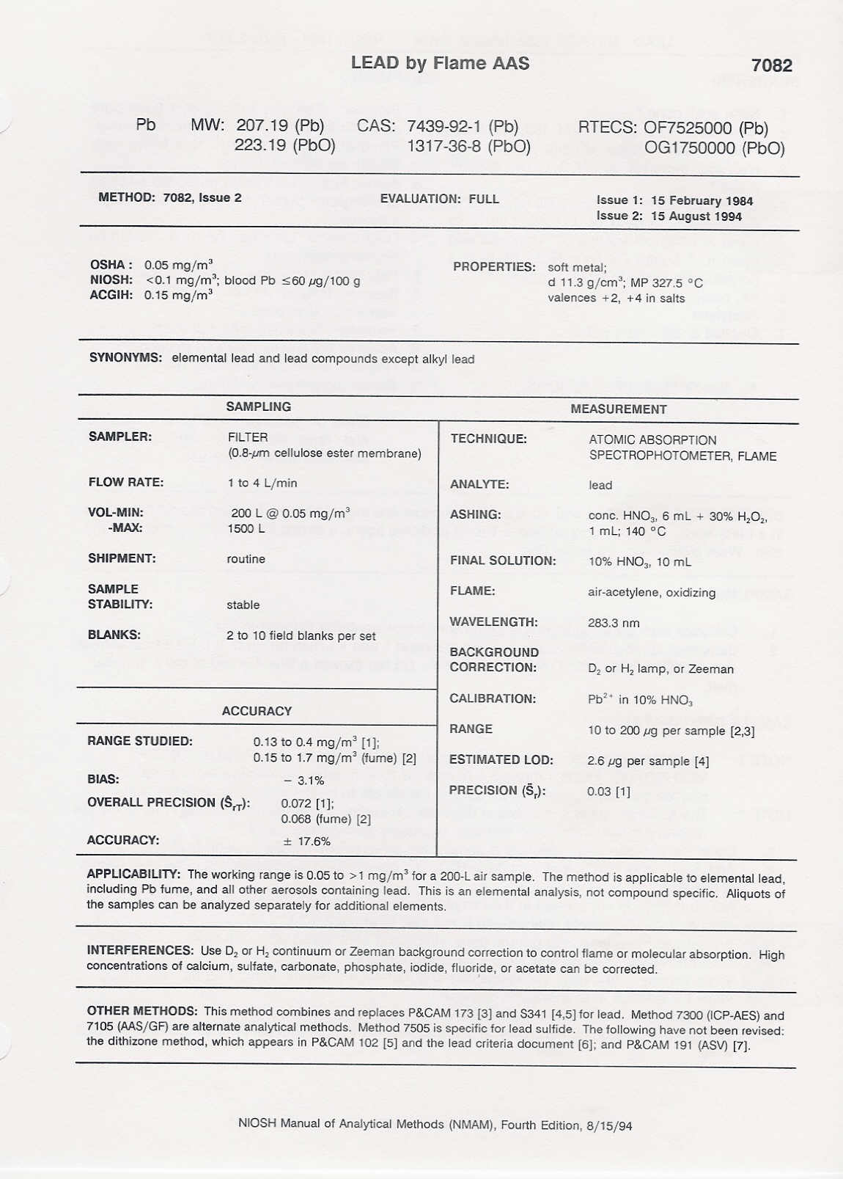

Supplementary information
Thermal cutting: Flame cutting uses a fuel gas such as acetylene, hydrogen, natural gas or propane that bums and produces sufficient heat to vaporize and separate the metal. Principal hazard is exposure to metal fume.
Scarfing/Gouging: Uses electrode in a manual arc welding holder with integral compressed air supply to blow away the molten metal when the electric arc creates a puddle of metal as it melts. The principal hazard of this opertion is exposure to metal fume.
Lead paint on steel structures : Lead has been added to paint (as red lead, lead silico chromate, lead sulfate, etc.) as an anti-corrosive coating. Corrosion can cause steel structures to collapse.
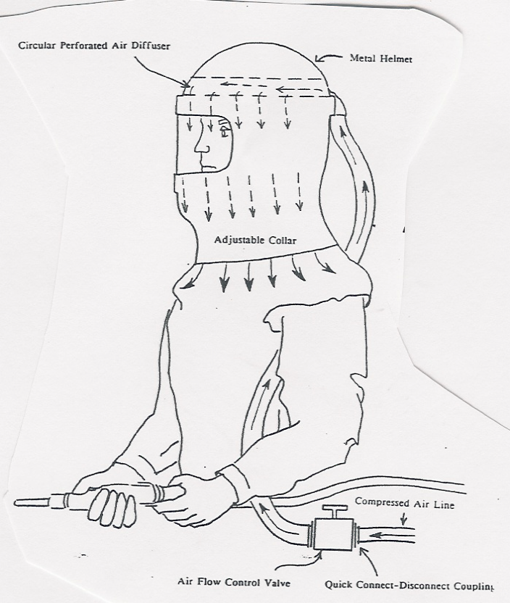
Abrasive Blasting: Worker uses compressed air to project abrasive under pressure onto surface to be cleaned. Worker wears air supplied blasting hood while working.
Lead can enter the body through inhalation or digestion. When lead is swallowed, 10-15% of lead that reaches the digestive system is absorbed into the blood. When it is inhaled lead is efficiently absorbed into the blood stream where it affects the nervous system, blood, kidneys, heart and reproductive system. Acute effects include depression, irritability, headaches, fatigue, loss of appetite, difficulty concentrating, sleep problems, aches and pains in muscles and joints, stomach cramps, reproductive problems. Chronic or long term exposure can cause permanent damage to the nerves of the hands and feet, brain, kidneys and reproductive system. PEL and TLV-TW A = 50 micrograms/cubic meter with Action Level of 30 micrograms/cubic meter.
Iron oxide is the main constituent of the fume when steel is flame cut. Iron oxide is considered a nuisance dust that may cause a benign condition called siderosis of the lung. REL and TL V = 5 milligrams/cubic meter.

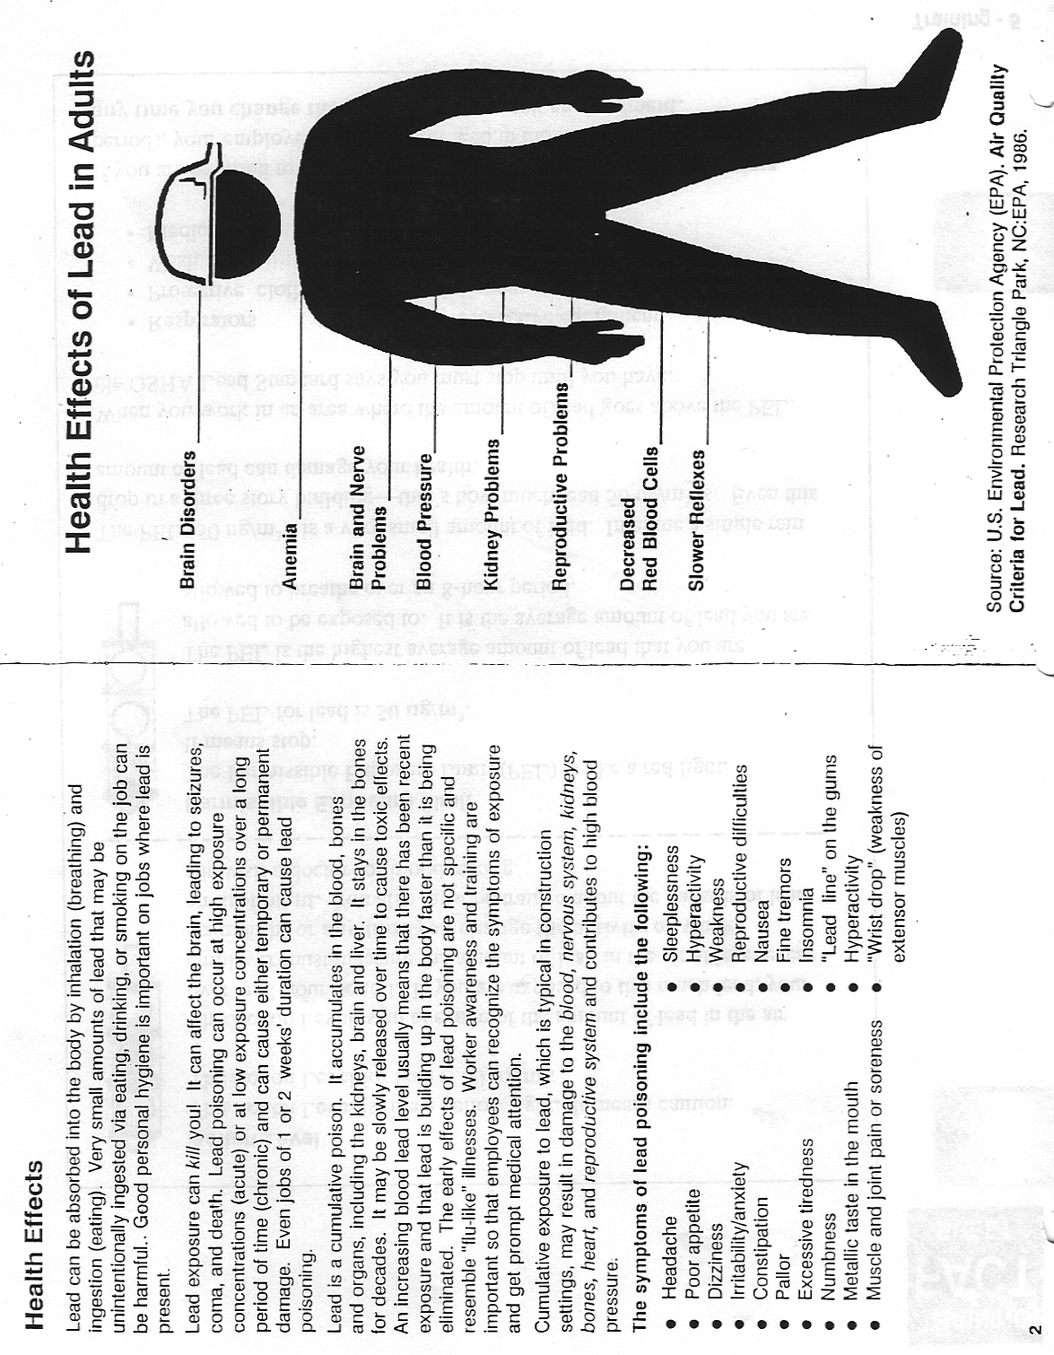
Part II
The following samples were taken:

Table I
Sample Number | Type | Time (hours) | Description
301 | task | 3.2 | Torch Cutting
303 | task | 3.8 | Use hand tools on bridge surface
306 | task | 1.1 | Setting up/cleanup and tarp hanging/removal
308 | area | 7.2 | In containment while blasting
311 | personal | 7.6 | George K. Laborer
312 | personal | 7.1 | Franklin V. Ironworker

Table I tells the type of sample, the length of sample and the sample #. It is the kind of information collected on the day of sampling. Table II is the kind of information received from a commercial lab. It tells the type of analysis done on the filter sample, the amount of air collected (pump flowrate times time sampled), the analytical results and the air concentration. The connection between the two tables is via the sample number. Note that sample # 308 had two kinds of analysis done on it. First the samples was weighed to determine the total mass on the filter (Grav) and then analyzed by atomic absorption spectroscopy (AA) for lead (Pb) which was a subset of the mass on the filter.

Table II
Techno Laboratories Report

Sample # | Sample Air Volume (m³) | Type of Analysis | Results (ug) | Air Conc (ug/m³)
301 | 0.384 | Pb | 274 | 714
303 | 0.456 | Pb | 34 | 75
306 | 0.132 | Pb | 38 | 288
308 | 0.864 | Pb | 3176 | 3675
308 | 0.864 | Grav | 12 mg | 14 mg/m³
311 | 0.912 | Pb | 178 | 195
312 | 0.856 | Pb | 516 | 603

Part II Questions

- Based on the data you were given calculate the daily TWA for each of the 3 workers using the task level and the time each worker spent doing that task.
  - How does the TWA calculated from task levels compare with the full-shift TWA sample that was collected on the worker?
Laborer:
(5 hr clean x 288 ug/m³ sample #306) + (4 hr scrape x 75 ug/m³ samp # 303)
9 hrs worked
= 193 ug/m³
compare to Georges TWA of 195 ug/m³

Blaster:
3 hr setup x 288 ug/m³ sample #306) + (6 hr blast x 3675 ug/m³ samp # 308)
9 hrs worked
= 2546 ug/m³

Ironworker:
(2 hr setup x 288 ug/m³ sample #306) + (8 hr cut x 714 ug/m³ samp # 301)
10 hrs worked
= 629 ug/m³
compare to Franklin’s TWA of 603 ug/m³

  - Using these daily TWA estimates, is this worksite in compliance with the OSHA standard? Which of the workers is over exposed and which workers exposures are within the standard ?
All are overexposed to 0.05 mg/m³ = 50 ug/m³ but this is 8 hr TWA PEL so since they work over 8 hrs PEL will be even less!

- The workers on this worksite had shifts greater than 8 hours. To adjust for this additional exposure several approaches are possible…one such formula is
Adjusted OEL = OEL x 8 hours
# hours worked
If you apply this adjustment to the measured TWA exposures does it change the compliance status of any of the workers?
Adjusted OEL = 50 ug/m³ x 8/9 = 44 ug/m³
Adjusted OEL = 50 ug/m³ x 8/10 = 40 ug/m³
So because not in compliance with 8 hr standard, then way out of compliance with 9 and 10 hour standards.

- What respirators would you recommend for the 3 workers on this site? (see attached fact sheet).
Laborer: Class I Powered Air Purifying Respirator (PAPR) ½ mask
Blaster: Class III pressure demand supplied air
Iron worker: Class II Full Face PAPR
- Can the gravimetric sample taken on this site be compared with the PNOS/PNOC standard?
No, lead, which is regulated and is toxic is part of the dust so does not meet criteria for PNOS/PNOC

- What, if anything, is gained by having both the mass concentration and the lead concentration for the sample #308?

Well if you assumed all dust was lead then could compare that to standard or use to choose respirator. Alternatively, if lead always the same % of dust you could estimate lead concentration from a dust sample. Since dust measurements are cheaper and easier than lead (which must undergo chemical analysis) this might be an advantage. Might also be able to use continuous direct reading instruments to monitor dust in that case. Generally though for lead people do sampling for metal itself not a surrogate like dust concentration.

