3. Orthogonal property of the optical modes and the coupling coefficients of incident beam to the optical modes

We now show that the modes with different effective indices (propagation constants) are orthogonal. Suppose and are two optical modes with the propagation constants  and , respectively. The overlap integral of the two optical modes can be calculated in the I, II, and III regions:

, (14)

Using Eq. (1), one can express the overlap integral in the I region as:

, (15)

Applying integration by parts for two times and using Eq. (1), one gets the overlap integral in region I:

, (16), which can be simplified as:

, (17)

Similarly, the overlap integral of the two optical modes in regions II and III can be written as:

, (18)

, (19)

Combining Eq. (17) through Eq. (19) and applying the boundary conditions of and continuous at the material interfaces, one gets:

, (20)

Eq. (20) indicates that two modes with different propagation constants (effective indices) are orthogonal.

Since the proof of the orthogonal property only involves the Helmholtz equations, the boundary conditions at the material interfaces, and the assumption that the **E** field are zeros at -∞, and +∞-, one can argue that the guide modes and radiation modes are also orthogonal.

The **E** field of the input light E0 can be written as the superposition of the guided modes and the radiation modes:

, (21)

where,  and are the guided and radiation modes, respectively. and are their coupling coefficients. Since only the optical power of the guided modes is preserved after it travels a distance along the waveguides, we focus on the coupling coefficients of the guided modes. According to the orthogonal property, if one normalizes the guided mode profile, i.e. , the coupling coefficient can be written as:

, (22)

The power profile of each mode can be expressed as:

, (23)

4. Optical power distribution in the coupled waveguides and its variation along the z-direction

Since only the optical power of the guided modes is preserved after it travels a distance along the waveguides, the **E** field along the z-direction after a distance can be written as the superposition of the guided modes:

, (24)

where, is the coupling coefficient of the input beam to the ith-order mode as defined by Eq. (22), and is the propagation constant of the corresponding mode. The integrated powers in the left, center and right waveguides at different z-positions, i.e. , , and are also calculated using the BPM and the TMM methods. Figure 4(a), (b) (c) show the comparison of the results for integrated powers in the left, center and right waveguides (i.e. , and ), respectively. The integrated powers , and  at different z-positions are almost identically for both of the BPM and the TMM methods.

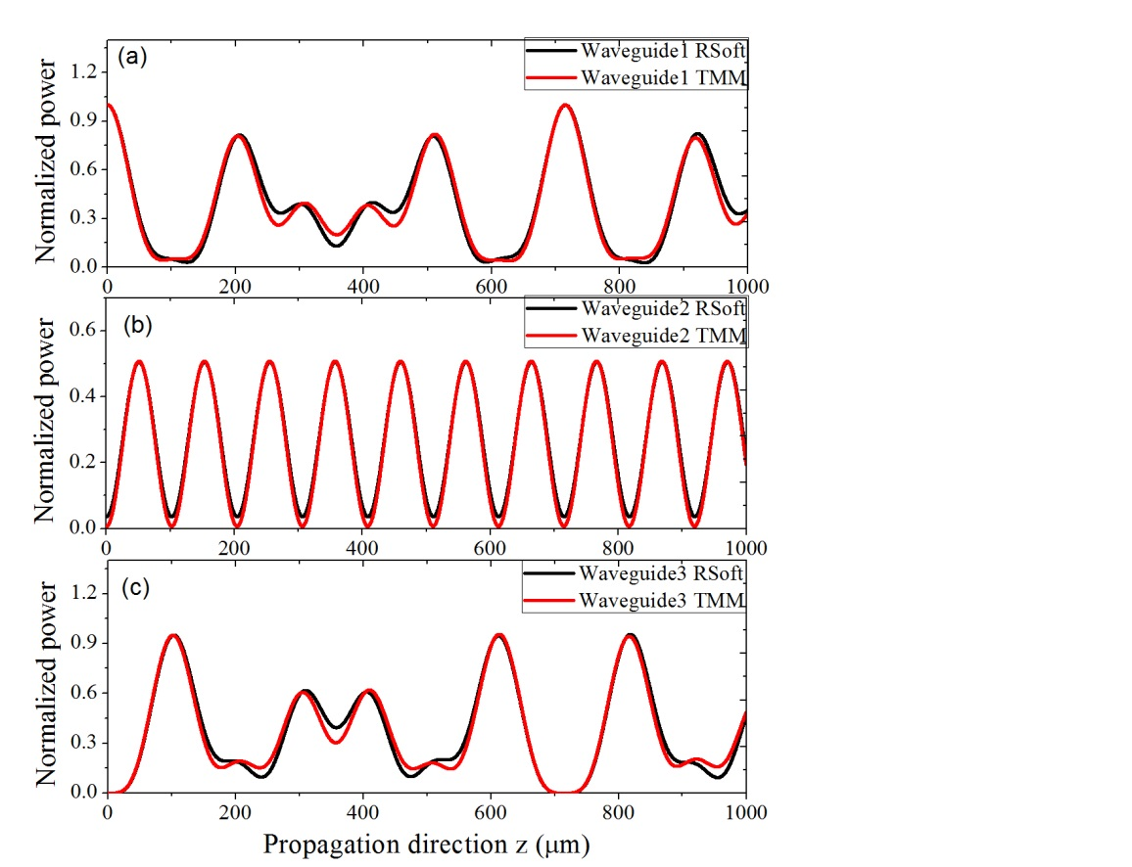

Note that the TMM method only considers the guided modes and ignores the radiation (leakage) modes. The results given by the TMM method are only accurate after it travels a distance along the z-direction where only the power of the guided modes is preserved.

Since the TMM method calculates the power distribution profile , which is an interference of the optical modes in the waveguides, this suggests that the mechanism of the power coupling between the waveguides are due to the interference of the modes in the waveguides. To our best knowledge, such interference-based power coupling mechanism has not been reported before.