Charles Guthy
16.541 Introduction to Biosensors
4/12/2007
Project Plan (Bio/Gas Sensor)

- Participants

The participants in this project are Charles Guthy and Angel Madera.

- Responsibilities/Roles

With the electronic design and testing complete, Angel and I will now focus our efforts on the completion of the airtight test chamber. Once this has been built and qualified, this project will be a success.

- Objectives

We are to design, test, and implement a test setup that will characterize and qualify gas sensors made from polymer-coated silicon wafers. These gas sensors’ resistance changes as they are exposed to and chemically interact with whatever gas happens to be flowing over them. By measuring the voltage across the sensors, we are able to test their accuracy, selectivity, sensitivity, and time response with different concentrations of gas and in different mixtures with other gases.

- Literature Review/Background

Over the past several weeks, we have not had much of a chance to review literature related to the project. We did come across a paper online, “A Summary of Gas Detection” by Brent Klaven of Advanced Calibration Designs of Tucson, AZ, which list various types of gas sensors, how they worked, and what their advantages and disadvantages were. Among the nine sensors mentioned (catalytic, electrochemical, photo-ionization, flame ionization, infrared or ultraviolet absorption, thermal, colorimetric, and light scattering), we noted that Mr. Klaven included metal oxide sensors, the very kind of sensor that we are testing.
Because of many metal oxides’ semiconductor properties, they are ideal for many gas detection applications. As we have read in other papers, the resistance across a sample metal oxide sensor varies logarithmically with exposure to various concentrations of gases. Because of their relatively cheap cost and durability, these sensors can be used in a wide variety of environments, including breweries, oil fields and refineries, and even in residential buildings. Unfortunately, since metal oxides react to many different gases, it may be difficult to differentiate between a potentially lethal gas like carbon monoxide and a benign gas like nitrogen. With any luck, the gas sensors that will eventually be produced by Professor Shen will not have this problem.

- Approaches
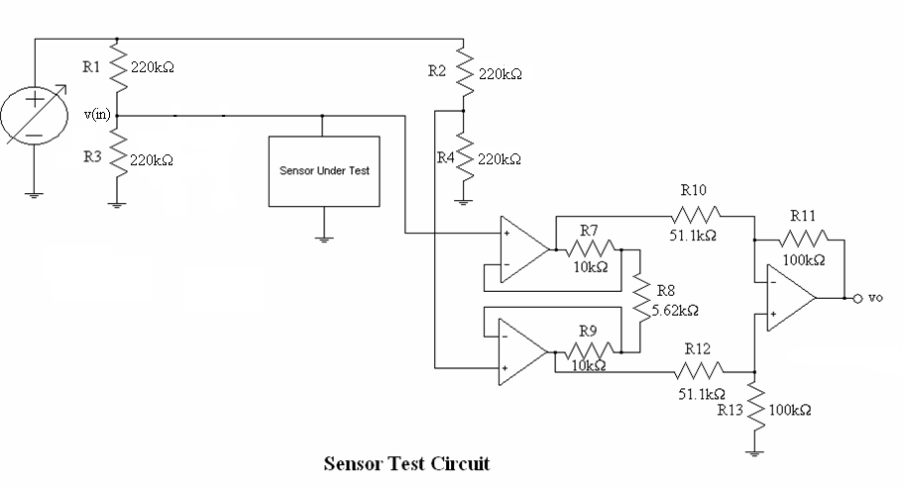
Figure 1: The Sensor Test Circuit

Over the past two weeks, Angel and I built, tested, and qualified the test circuitry needed to characterize resistive gas sensors. After doing some slight redesign, the sensor was moved to the other side of the Wheatstone bridge, and the potentiometers were, for the time being, removed to better facilitate qualification testing. In the final product, a parallel array of potentiometers will be installed in the place of R4.
At first, we used a photo-resistor in place of the sensor. While certainly not a gas sensor, it is resistive in nature, its resistance increasing or decreasing with the level of ambient light. However, since the maximum resistance measured across the photo-resistor was only about 15 kΩ, and since its parallel connection to a 220 kΩ resistor limited the total resistance to about 14 kΩ, input voltage did not change appreciably with changes in light exposure, usually only by a few millivolts.
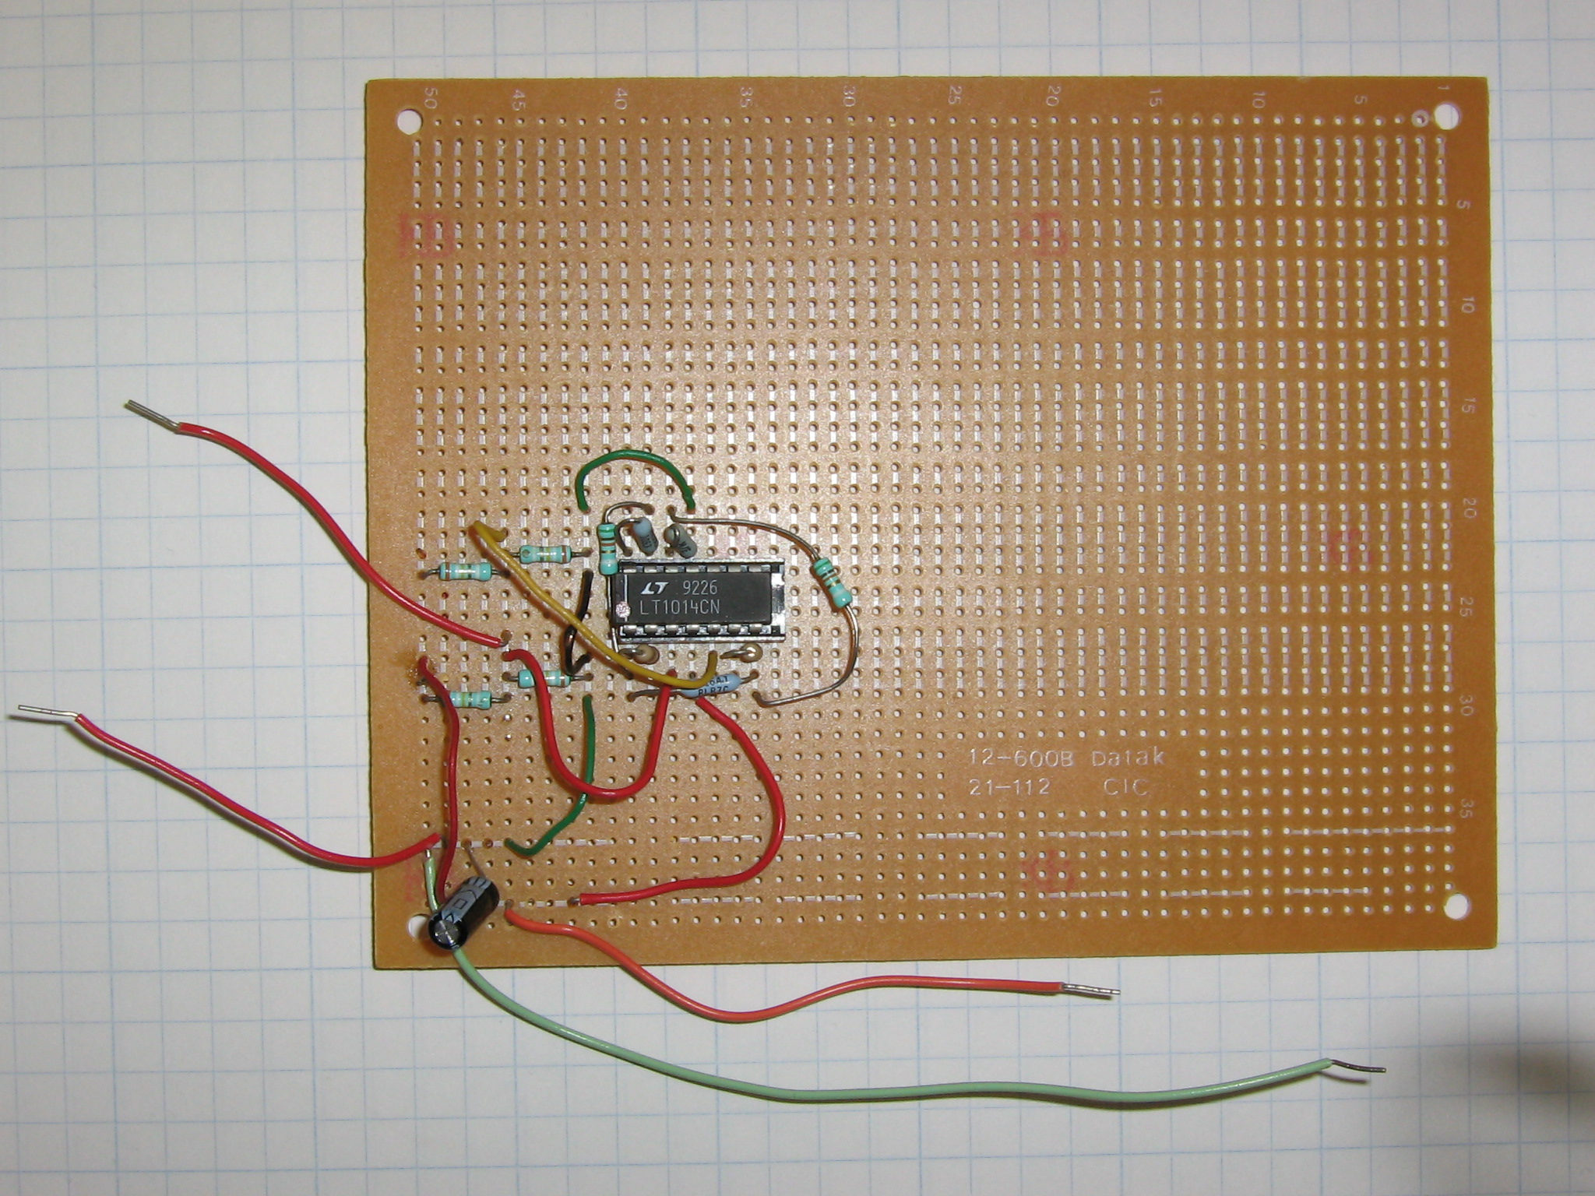
It was clear that larger resistances would be necessary to qualify the test circuit. Using a decade box, we measured the input and output voltage of the circuit using a simulated sensor resistance range of 10 kΩ to 500 kΩ. The results can be seen below.

Results were very encouraging. Output voltage showed a definite, inverse, predictable relationship between the input voltage across the simulated sensor and the output voltage of the circuit. With the test circuit qualified, Angel and I could now focus our attention on procuring the other parts needed for a complete gas sensor test setup.

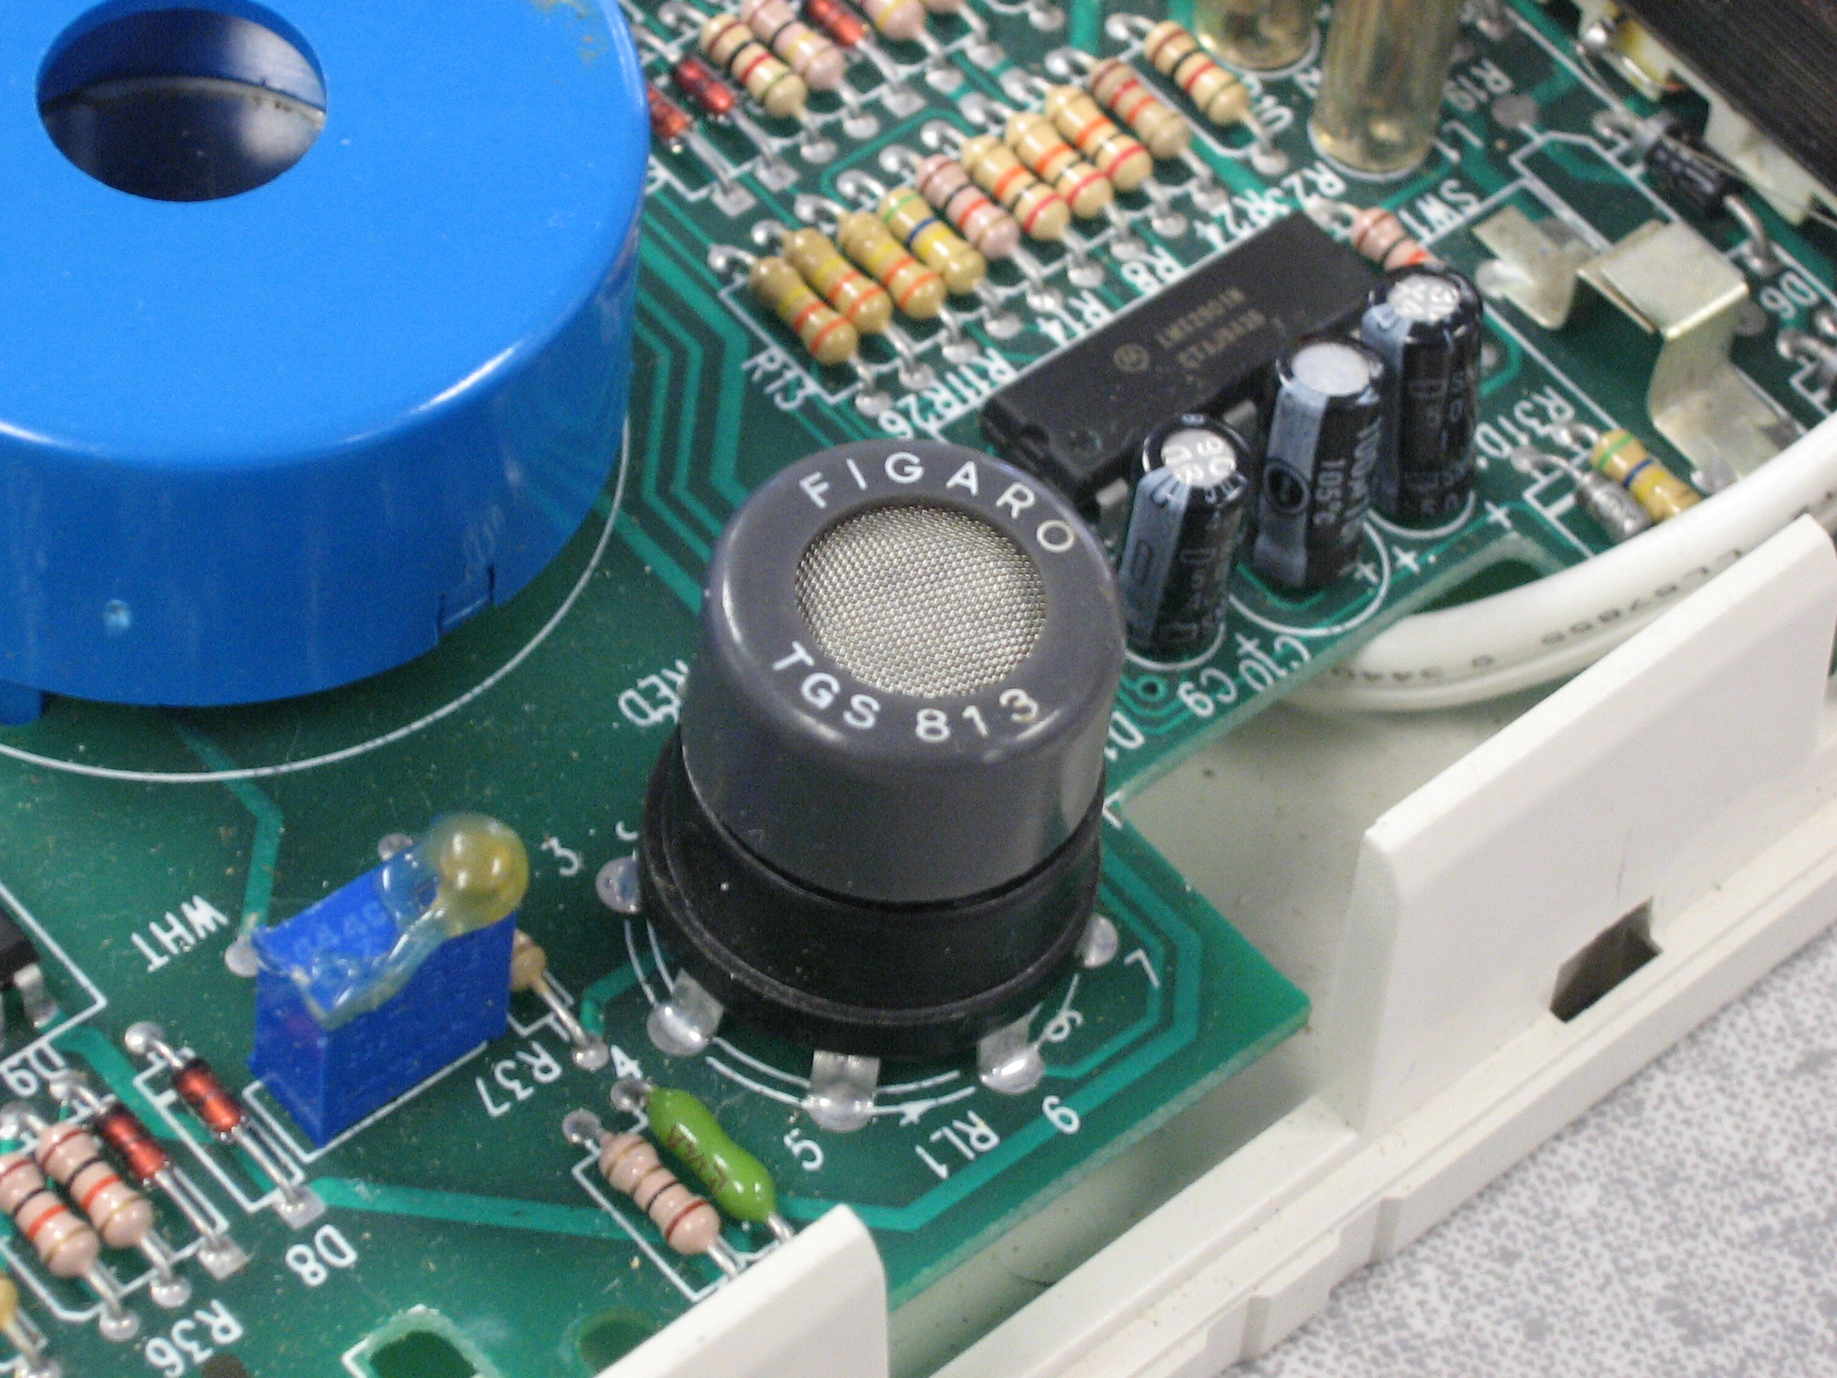

Originally, the goal of this project was to begin the characterization of polymer-coated, silicon gas sensors made on-site using a femtolaser. However, since the laser will not be operational until after the semester is over, it became necessary for Angel and I to look for competitive gas sensors. After looking around my basement, I came across an old combustible gas detector, complete with a Figaro Sensor gas sensor (TGS813). While not a carbon dioxide sensor, I was able to get in contact with a sales representative and received a quote for carbon dioxide, carbon monoxide, and oxygen sensors. Once we have these sensors, and once we build the airtight gas chamber, Angel and I will be finally able to truly qualify the whole bio/gas sensor test system.

- Plan/Timetable

Angel and I plan to devote the rest of the semester to building the airtight test chamber.

4/8-4/15 | Order everything needed for test chamber, put test circuitry in plastic enclosure
4/16-4/23 | Build/Qualify test chamber using a gas sensor from Figaro
4/24-5/1 | Finish testing/troubleshooting test setup
5/2-5/9 | Refine final setup/Peer Review

- Materials Needed/Budget

The List of Materials has not changed appreciably.

ITEM | # of Units | Price Each | PRICE
canister of CO2 | 1 | $105.50 | $105.50
tubing | 1 | $0.00 | $0.00
valves | 10 | $6.70 | $67.00
Tupperware containers | 1 | $0.00 | $0.00
wire, small guage | 1 | $0.00 | $0.00
resistors and potentiometers | 1 | $0.00 | $0.00
programmable op-amps | 5 | $0.00 | $0.00
variable DC sources | 1 | $0.00 | $0.00
tube for chamber | 1 | $0.00 | $0.00
sealant (glass cement) | 3 | $4.90 | $14.70
gen'l electronics supplies (breadboard, solder, flux, etc. | 1 | $0.00 | $0.00
potting material (fluorocarbon) | 1 | $0.00 | $0.00
data acquisition system w/PC | 1 | $0.00 | $0.00
computer w/DAC GUI for oscilloscope | 1 | $0.00 | $0.00
standard fasteners | 1 | $0.00 | $0.00
gas/valve comparator
flow measures | 2 | $0.00 | $0.00
thermocouple array | 10 | $11.98 | $119.80
mechanical latch | 1 | $0.00 | $0.00
polyurethane foam | 1 | $0.00 | $0.00
small phalanges and seal rings (nylon) | 1 | $0.00 | $0.00
Total: |  |  | $314.50

- Evaluation

The test circuit’s design and implementation is now complete. What remains now is the successful building of the airtight test chamber. This entails procuring the materials necessary for its construction and setting aside the time to put it all together. So far, this has been an exciting and worthwhile project, and one that Angel and I are anxious to complete.

