Photo-acoustic Imaging to Detect Tumors
Report -2
Shiva Subhashini Pakalapati, Vu Tran, Haifeng Wang
4/5/2011
s

Abstract:

Imaging modalities play an important role in the clinical management of cancer, including screening, diagnosis, treatment planning and therapy monitoring. Owing to increased research efforts during the past two decades, photoacoustic imaging (a non-ionizing, noninvasive technique capable of visualizing optical absorption properties of tissue at reasonable depth, with the spatial resolution of ultrasound) has emerged. Ultrasound-guided photoacoustics is noted for its ability to provide in vivo morphological and functional information about the tumor within the surrounding tissue. With the recent advent of targeted contrast agents, photoacoustics is now also capable of in vivo molecular imaging, thus facilitating further molecular and cellular characterization of cancer. This report introduces the role of photoacoustics and photoacoustic augmented imaging in comprehensive cancer detection, diagnosis and treatment guidance. It will briefly discuss the experimental setups with more focus on specific techniques for the diagnosis of cancer using PAI including the current research such as photo acoustic probe.
Introduction
Cancer is a vicious disease that killed approximately 570 000 people in 2010 in the USA alone[1]. To develop successful therapeutic strategies and prevent recurrence of the disease, its structural, functional and metabolic properties need to be well characterized. Research efforts are focused not only on developing new treatments and discovering the root cause for the disease, but also on developing imaging technologies that can aid in early detection of cancer and can provide comprehensive real-time information on the tumor properties. Currently, ultrasound imaging (USI), magnetic resonance imaging (MRI), X-ray computed tomography (CT) and nuclear imaging techniques, such as positron emission tomography (PET) and single photon emission computed tomography (SPECT), are being used to detect tumors in patients[2]. With the development of various targeted contrast agents, these imaging techniques are also able to provide molecular information about the malignant tumor tissue. However, microscopic optical imaging techniques have higher resolution (0.1–100 mm) compared with USI (50–500 mm), MRI (10–100 mm), CT (50–200 mm), PET (1–2 mm) and SPECT (1–2 mm), and can detect a lower number of cancer cells per imaging voxel[3]. Traditional diffusive regime optical imaging techniques, such as diffuse optical tomography (DOT), have high detection sensitivity; however, their resolution is limited to approximately 5 mm. The need for an imaging technique that can provide high optical contrast images at a microscale resolution and at a reasonable penetration depth has now been filled by photoacoustic imaging (PAI).

When combined, PAI and USI can simultaneously provide anatomical and functional information of tumors. For example, an in vivo study on human breast tissue has shown that an ultrasound image can depict the structure of ductal carcinoma, whereas photoacoustic (PA) images show the associated scattered distribution of vascularization.

With the availability of various targeted contrast agents, such as gold nanoparticles (AuNPs) nano rods and photoacoustic probe several new avenues have opened for in vivo molecular PAI. This has facilitated highly sensitive and specific detection of tumors. Though a lot of work is published on the application of photoacoustics to different areas of medicine, an accurate review on the usage of photoacoustic Imaging to detect cancer using above technology is unavailable. A speedy advent of technology in this field is one of the reasons.
Principle of PAI
Introduction of Ultrasound

Based on the frequency of sound, we can divide sound into three categories. The first one is Infrasound. The second one is acoustic. The last one is Ultrasound. The ultrasound with the frequency range from 20 kHz to 2MHz can be used for medical and destructive usage. The ultrasound with higher frequency can be used for diagnostic and nondestructive testing.

- Ultrasound in optical fibers

Advantage of all optical fiber ultrasonic generator-receivers is its compact size. They can be used in a limited space such as artery.

- Principle of photo acoustic imaging by endogenous cells or tissues

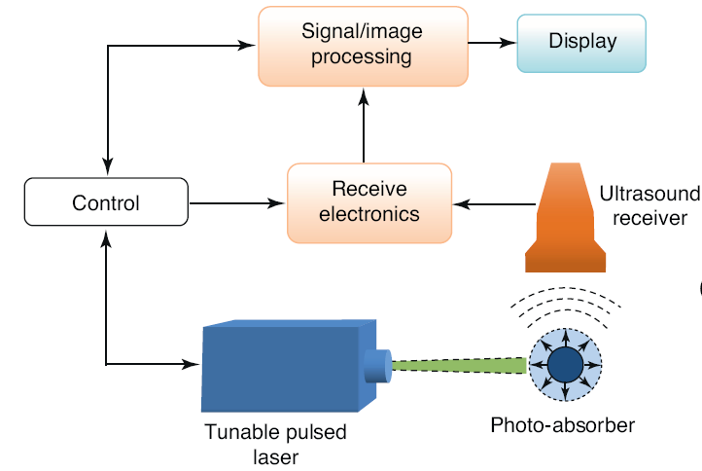
When a laser shines on biological cells like endogenous chromophores in the body, the light energy is converted into thermal energy via energy absorption layer. This thermal energy converts into mechanical wave and because of thermal expansion an acoustic wave is generated. The optical absorption of these endogenous chromospheres is wavelength dependent; therefore, the PA signal intensity at different optical wavelengths can be used to characterize optical properties of tissue [5].

- Principle of photo acoustic imaging by exogenous contrast agents like gold nano particles

When a laser shine on pahotoacoustic structure (on the tip of fiber, the light energy is converted into thermal energy via energy absorption layer;The thermal energy converts into mechanical wave because of thermal expansion; An acoustic wave is generated

- Photoacoustic molecular imaging
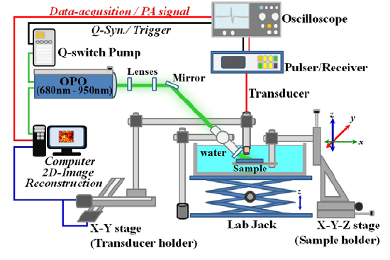
The picture illustrates the experimental setup for photoacoustic molecular imaging [8]. Pulsed Laser pumps an optical parametric oscillator to generate 5 ns pulses at 10 Hz. The range of wavelength was tuned from 680 nm to 950 nm. The laser beam of OPO output was directed to illuminate on the surface of cells in the gelatin coated well. The slide was held by a sample holder connected to X-Y-Z manual translational stage for positioning. A focused single element ultrasonic transducer was used to detect the PA signal. A motorized X-Y translational stage was used to move the transducer to scan horizontally the samples. The PA signal was averaged three times at each scanning grid point to minimize the pulse-to-pulse energy variation. The ultrasonic transducer output was, digitized, and recorded by a digital oscilloscope synchronized to the laser. The boundary along the circumference and center of each individual well (2 mm in diameter) was identified by eye and used as a global marker to guide for both fluorescence and PA scanning area. Three sets of PA images were obtained at three different locations within this microscopy imaging.
- Scanning photoacoustic probe – An upcoming technology
A scanning photoacoustic probe contains an angled photoacoustic source for ultrasound wave generation and a fiber-optic ultrasonic receiver. A fiber-optic interferometer based on Fabry-Perot cavity on the tip of the fiber is used as the receiver.

PAI system using Photoacoustic Probe

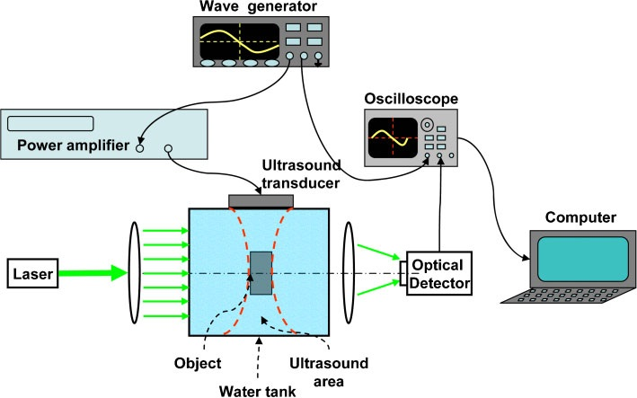

Photoacoustic probe is an optical fibre which is used to propagate the wave from a laser source to the target organ. The target tissue expands due to Thermo-Elastic expansion and thus transmits ultrasound waves which are then detected by an ultrasonic detector at the receiving end. The signal is then processed to image the target tissue.

Tumor Detection Using PAI
Malignant tumors have dense and unorganized vasculature compared with normal tissue. The high density of blood vessels in tumors enhances PA image contrast, thereby enabling tumor detection. Sequential PA images can be obtained safely and noninvasively at different stages of tumor progression to monitor angiogenesis and to determine whether a tumor has progressed to malignancy[4]. Compared with other vascular imaging techniques, including dynamic-enhanced MRI, CT perfusion and functional PET, PAI detects tumor vasculature at a better or comparable resolution.
Metastatic spread of the primary tumor often leads to death in patients with cancer. Highly sensitive detection of circulating tumor cells (CTCs) would greatly enhance overall patient survival, if treated. PAI has been used to detect CTC in the blood stream, with the goal of detecting metastasis. The label free detection of CTCs in-vivo in a blood vessel using PAI could provide higher detection sensitivity (100-fold) compared with existing ex-vivo CTC detection assays that use a small amount of blood.

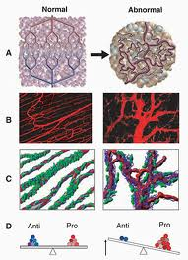

- Tumor Detection using Endogenous Contrast
Endogenous meaning from within the body, as the name suggests these contrasting agents are present within the tissue such as melanin, water, hemoglobin, fat e.t.c. In vivo PAT and US dual-modality imaging of a canine prostate with a subsurface lesion suggested that PAT, with its high optical contrast and good spatial resolution, may not only visualize local prostate lesions in a noninvasive manner but also characterize the functional parameters in lesions such as total hemoglobin concentration. It also deciphered that the ability to achieve high image quality including good spatial resolution and less artifacts is strongly dependent on the total view angle [6].
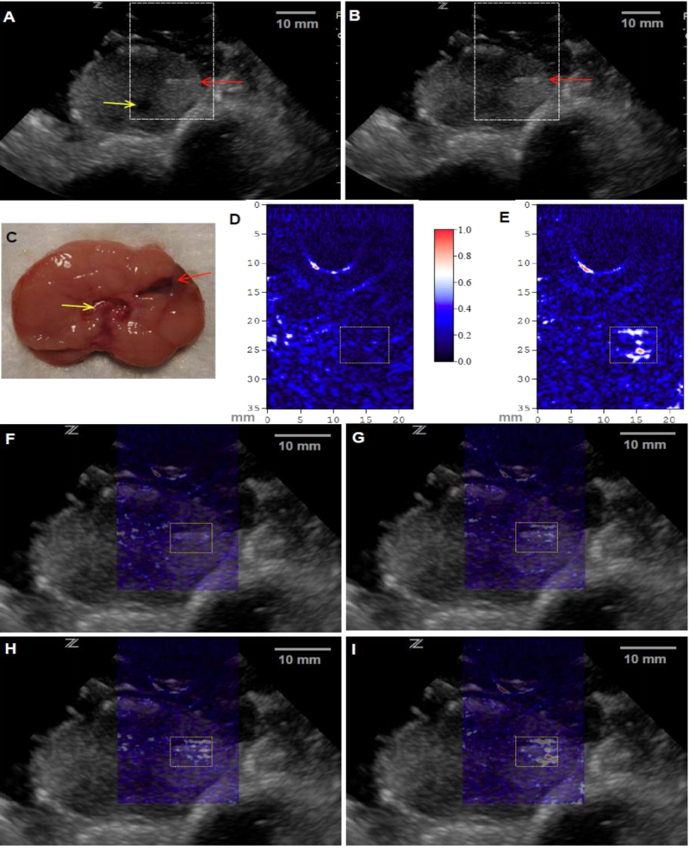
In vivo PAT and US dual-modality imaging of a canine prostate with a subsurface lesion induced. Gray scale US images of the prostate acquired (A) before and (B) after the generation of the lesion (0.1 mL of injected blood). The red arrow indicates the plastic canula inserted into the prostate for the injection of blood. The yellow indicates the urethra. (C) Anatomical photograph of the imaged cross-section in the prostate with the lesion marked. PAT images of
the prostate right lobe acquired (D) before and (E) after the generation of the lesion (0.1 mL of injected blood), where the image intensities are demonstrated with an image color bar. The PAT imaging plane is the same as that in US images, where the reconstructed area is indicated with the dashed rectangles in the US images in (A) and (B). In (F)-(I), PAT images are superimposed on the US image in (B). (F) was acquired before the generation of the lesion; (G), (H) and (I) were acquired after three injections of blood, where the total blood volumes in the lesion were 0.025 mL, 0.05 mL and 0.1 mL, respectively. The area of the lesion is marked with a dotted rectangle in each image.

Another technique based on the compressed sensing (CS) theory, a new mathematical framework for data acquisition and signal recovery, and inspired by the idea of “single-pixel”camera using the CS theory proposes an artifact free photo acoustic imaging. By employing spatially and temporally varying random illuminations for PAT acquisition and CS for image reconstruction, the image can be reconstructed free of artifacts using limited-view acquisition[7].

The high density of blood vessels in tumors enhances PA image contrast, thereby enabling tumor detection. For example, the Twente Photoacoustic Mammoscope, developed to detect breast carcinoma, was based on this principle .Figure (a) depicts a melanoma and surrounding vasculature obtained by spectroscopic PAI[5].In the figure below an X-ray mammogram (figure b-i) and a sonogram (figure b-ii) are compared with a PA image (figure b-iii) obtained with a 1064 nm optical source. PAI can also provide information on angiogenesis or changes in vasculature. As shown in figure c sequential PA images can be obtained safely and noninvasively at different stages of tumor progression to monitor angiogenesis and to determine whether a tumor has progressed to malignancy.

Besides imaging melanin and blood vessels, PAI systems have been used for measuring the oxygen content of blood to study hypoxia in tumors. Hypoxia is often linked to malignancy and resistance to therapy. The amount of oxygen saturation in blood (SO2 ) can be estimated by comparing the PA signal strength of HbO2 and Hb obtained from spectroscopic PA images. Figure d shows in vivo functional imaging of a mouse brain with a glioblastoma. The blue hypoxic region (circled) indicates the location of the tumor in the brain. The results clearly depict that the tumor has a lower percentage SO2 than the surrounding normal tissue[5].

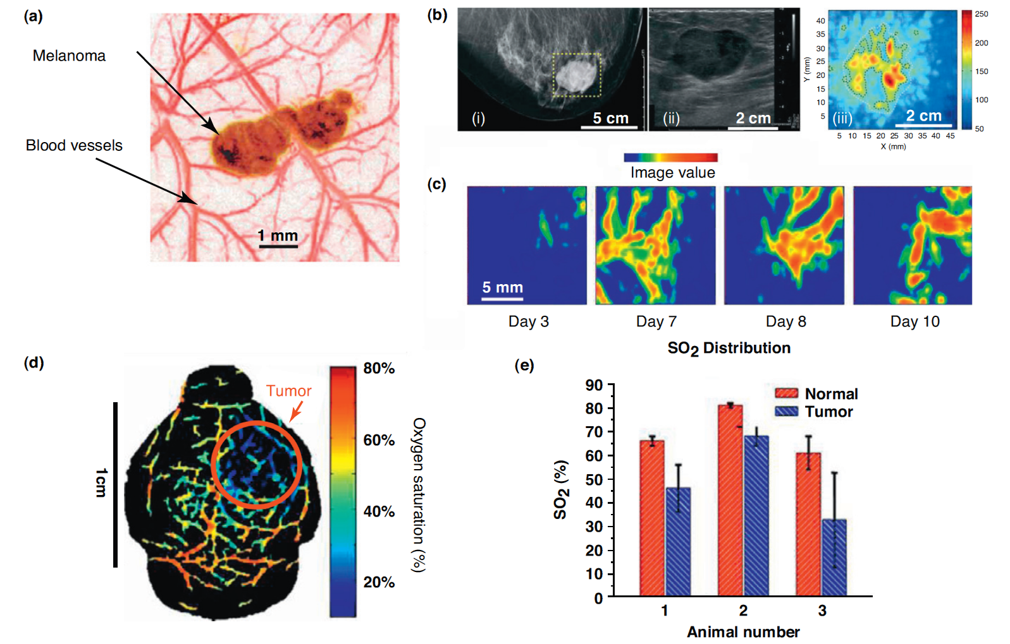
PAI of tumors using endogenous contrast (a) Overlaid maximum amplitude projections of PA images at 764 nm and 584 nm showing a tumor and its surrounding
vasculature, respectively. The image clearly shows the vessel branching and structure around the tumor. (b) Images of the breast of a 57-year-old woman with invasive
ductal carcinoma: (i) X-ray mammogram; (ii) sonogram; and (iii) PA image at 1064 nm. The X-ray mammogram and the sonogram depict the gross anatomical features of
the tumor, but do not provide functional information. The high PA amplitude corresponds with abundant vasculature associated with malignant tumors. The PA image
clearly depicts higher vascular densities in the tumor periphery, whereas the core of the tumor has minimum vasculature. (c) Pancreatic tumor cells were inoculated on a rat
hind leg on day 1. PAI was used to monitor angiogenesis associated with the tumor growth.PA images obtained from the tumor region on days 3, 7, 8 and 10 are maximum
intensity projections of the PA source strength in the xy-plane (i.e., top view on the tumor tissue). (d) In vivo functional imaging of a mouse brain with a glioblastoma
xenograft obtained using PAI. Spectroscopic PAI (wavelengths from 764 nm to 824 nm) was used to detect hypoxia in a brain tumor. The heat map represents the
percentage SO 2 in the blood vessels (blue = hypoxic; red = hyperoxic). The area indicated by the red arrow is the tumor. (e) A comparison of normal (red bars) and brain
tumor (blue bars) vasculature SO 2 in three mice. Three normal vessels and three tumor vessels were chosen from each SO 2 image that had been processed from
spectroscopic PA images, such as the one shown in (d). The results clearly indicate that the percentage SO 2 in tumors is lower than in the surrounding normal tissue, thus
indicating hypoxia.

Metastatic spread of the primary tumor often leads to death in patients with cancer. Highly sensitive detection of circulating tumor cells (CTCs) would greatly enhance overall patient survival, if treated. PAI has been used to detect CTCs in the blood stream, with the goal of detecting metastasis.

2. Tumor Detection using Exogenous Contrast
The sensitivity of the PAI technique to image deeply situated tumors can be increased dramatically by utilizing exogenous contrast agents. The NIR-absorbing dyes, such as IRDye 800CW [5], Alexa Fluor 750[5] and indocyanine green (ICG)[5], have been used to enhance PA contrast. However, among the exogenous contrast agents, AuNPs have attracted attention in nanoparticle based PAI owing to their unique optical properties from the surface plasmon resonance (SPR) effect. Because of the SPR effect absorbance of these particles is higher than any dyes.
Initially, a 3-D photoacoustic imaging with a resolution of 10 µm was proposed. The PA signals produced at 532-nm wavelength were used. Evans Blue acted as an absorber including the blood tissue. The sample material was either a 10% dilution of Intralipid-10% or real tissue in the form of a block of chicken breast tissue. The lateral resolution was determined mainly by the detector diameter (200 µm).Deep lying blood vessels in real tissue samples were imaged at depths of 5 mm and at 9 mm from the plane of detection in Intralipid. The sensitivity of the technique was proven by photoacoustic detection of single red blood cells upon a glass plate. Lateral resolution, penetration depth and transducer size had to be improved.
Transient illumination of light-absorbing nanoparticles using pulsed laser sources produces rapid and highly localized heating. If a particle absorbs a sufficient amount of laser energy, vaporization of a layer of liquid blanketing the particle follows and the bubble goes through an expansion phase followed by cooling and collapse, a process known as inertial cavitation. Laser-induced cavitation is accompanied by an intense acoustic emission potentially enabling improvements in the sensitivity of photoacoustic imaging of nanoparticles or the depth within scattering media at which they can be detected [8].
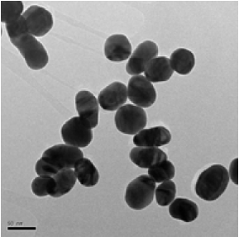
TEM picture of ~50nm gold nanoparticles (scale bar -50nm)

The ability of the gold nanoparticles to serve as contrast agents for in-vivo tumor imaging with PAT was tested by administering PEGylated gold nanoparticles (200μl, 10mg/mL) via tail vein in breast cancer tumor model. The ultrasound transducer was placed in contact with the tumor concurrent with exposure of the tumor to pulsed laser light. These experiments were designed to more directly characterize intratumoral changes in photoacoustic signaling following intravenous administration of nanoparticles to tumor bearing mice. An increase in photoacoustic signaling in gold nanoparticles treated tumor bearing mice compared to control saline injected mice proved the efficiency of GNP’s as a contrast agent[9].

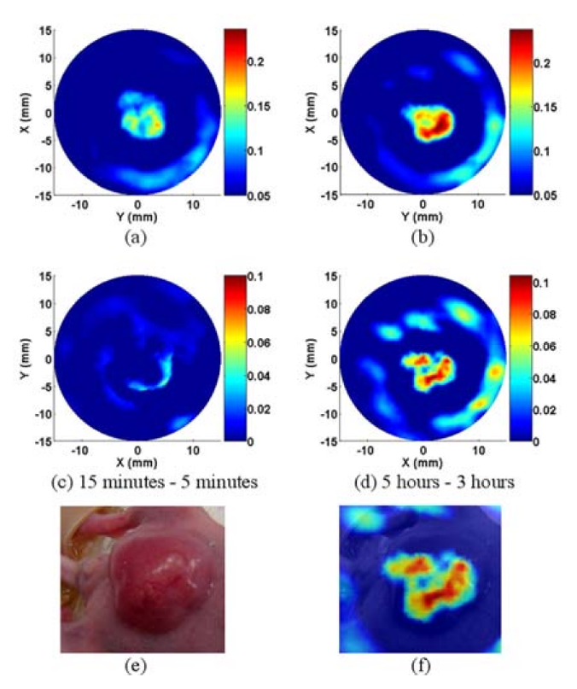
PAT images of tumor at 5 minutes (a) and 5 hours (b) following tail vein injection of gold nanoparticles. (c) and (d) are the subtraction PAT images of tumor following tail vein injection of gold nanoparticles demonstrating increased accumulation of nanoparticles in tumor at 5 hours. The color scale (right) represents optical absorption of tissue (arbitrary units). (e) is gross picture of tumor in mouse and (f) is the fusion image of gross photo and subtraction PAT image, 5 hours following tail vein injection.

The real time and contrast enhanced photoacoustic imaging and spectroscopy of a mature prostate tumor in a mouse window chamber model using a clinical ultrasound system and 14 MHz linear array proved that it is approximately 120 times faster and provided new opportunities for 3D spectroscopic PA imaging in live mice. A clinical ultrasound scanner and linear array enabled real time PA imaging during the injection of GNR’s into a mature prostate tumor. It also provided the additional information related to the origin of the PA signal and spectral content of the GNR’s near the tumor[10].

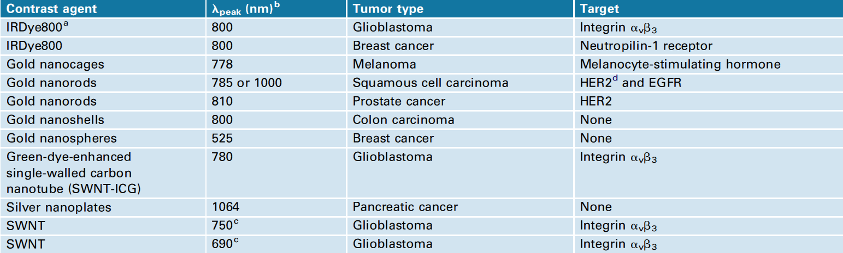

Comparison of PAI with other Imaging techniques
There are some methods which are used to detect tumors in patients: ultrasound imaging (USI), magnetic resonance imaging (MRI), X-ray/computed tomography (CT) and nuclear imaging techniques, such as positron emission tomography (PET) and single photon emission computed tomography (SPECT) [2].
X-ray
X-rays is used to view a non uniformly composed material such as the human body. A beam of X-rays is produced by an X-ray source and then projected toward an object. Due to the different areas of the object have different density and composition, a different proportion of X-rays are absorbed by the object depend on these areas. The X-rays that pass through the object are then captured by a detector (film sensitive to X-rays or a digital detector) which gives a 2D representation of all of the superimposed structures. Because using radiation of X-ray during exam, it is not good for health of patient. [6]
Computed Tomography (CT)
CT imaging uses X-rays to collect the data and then processes by using the computing algorithms to image the object/patient. An X-ray source tube opposite an X-ray detector (or detectors) in a ring shaped rotate around a patient producing a cross-sectional image (tomogram). Each voxel in different part of the patient has a different absorption factor depend on the component of voxel, such as bone, fat, tissue, etc. Each detector collects the sum of these absorption factors in one direction. By rotating the source, and/or the detectors, the sums of these factors in different direction will be collected. By using the computing algorithms, the factor of each voxel will be calculated. The 3D image will be constructed based on these factors. Some contrast agents are often used with CT for enhancement. CT exposes the patient to more ionizing radiation than a radiograph. Spiral Multi-detector CT utilizes 8, 16, 64 or more detectors during continuous motion of the patient through the radiation beam to obtain much finer detail images in a shorter exam time. The same as X-ray method, using X-Ray increase the risk of developmental problems and cancer in those exposed. [7-8]
Magnetic Resonance Imaging (MRI):
MRI makes use of the property of Nuclear magnetic resonance (NMR) to image nuclei of atoms inside the body. A powerful magnetic field is used to align the magnetization of some atoms in the body (hydrogen- H atom), and radio frequency fields are used to alter the alignment of this magnetization. This causes the nuclei to produce a rotating magnetic field detectable by the scanner—and this information is recorded to construct an image of the scanned area of the body. Strong magnetic field gradients cause nuclei at different locations to rotate at different speeds. 3-D spatial information can be obtained by providing gradients in each direction.
MRI provides good contrast between the different soft tissues of the body, which make it especially useful in imaging the brain, muscles, the heart, and cancers compared with other medical imaging techniques such as computed tomography (CT) or X-rays. Unlike CT scans or traditional X-rays, MRI uses no ionizing radiation. Because MRI uses strong magnetic field, it may effect on some implants in patients. Also, a powerful radio frequency can heat the body to the point of risk of hyperthermia in patients. Another disadvantage is acoustic noise when switching of field gradients, therefore appropriate ear protection is essential for anyone inside the MRI scanner room during the examination.
Ultrasound Imaging (USI):
Ultrasound differs from other medical imaging methods in the way it is operated by the transmission and receipt sound waves to produce images (2D, 3D, 4D). The high frequency sound waves are sent into the tissue and depending on the composition of the different tissues; the signal will be attenuated and returned at separate intervals of time. A path of reflected sound waves in a multilayered structure can be defined by acoustic impedance and the reflection and transmission coefficients of the relative structures.[9] It is very safe to use and does not cause any effects. It is also relatively inexpensive, quick and easy to perform. This is commonly associated with imaging the fetus in pregnant women. Doppler capabilities on modern scanners allow assessing the blood flow in arteries and veins. The real time moving image obtained can be used to guide drainage and biopsy procedures. While it may provide less anatomical detail than techniques such as CT or MRI, it has several advantages in studies the function of moving structures in real-time and emits no ionizing radiation.
Positron Emission Tomography (PET):
PET is a nuclear medicine imaging technique which produces a three-dimensional image in the body. The system detects pairs of gamma rays emitted indirectly by a positron-emitting radionuclide (tracer), which is introduced into the body on a biologically active molecule. Three-dimensional images of tracer concentration within the body are then constructed by computer analysis. In modern scanners, three dimensional imaging is often accomplished with the aid of a CT X-ray scan performed on the patient during the same session, in the same machine. [10-12]
Single Photon Emission Computed Tomography (SPECT):
Single photon emission computed tomography (SPECT) is a nuclear medicine tomographic imaging technique using gamma rays. It is very similar to conventional nuclear medicine planar imaging using a gamma camera. However, it is able to provide true 3D information. The basic technique requires injection of a gamma-emitting radioisotope into the bloodstream of the patient. A marker radioisotope has been attached to a special radioligand, which is of interest for its chemical binding properties to certain types of tissues. This allows the combination of ligand and radioisotope to be carried and bound to a place of interest in the body, which then (due to the gamma-emission of the isotope) allows the ligand concentration to be detected by a gamma-camera. SPECT imaging is performed by using a gamma camera to acquire multiple 2-D images from multiple angles. A computer is then used to apply a tomographic reconstruction algorithm to the multiple projections, creating a 3-D image. SPECT is similar to PET in its use of radioactive tracer material and detection of gamma rays. In contrast with PET, however, the tracer used in SPECT emits gamma radiation that is measured directly, whereas PET tracer emits positrons which annihilate with electrons up to a few millimeters away, causing two gamma photons to be emitted in opposite directions. [13-15]
Optical Imaging
When a photon of light interacts with living tissue, it can be absorbed or it can be scattered. Thus the two major types of optical imaging are absorption-based and scattering-based. Most optical methods use relatively simple instrumentation to image-reflected excitation light, or fluorescence emission light, from a surface. Tissue reflectance imaging is high resolution and fast, but because of multiple light scattering, sensitivity is limited. [16-18]
With the development of various targeted contrast agents, these imaging techniques are also able to provide molecular information about the malignant tumor tissue. However, microscopic optical imaging techniques have higher resolution (~0.1–100 mm) compared with USI (50–500 mm), MRI (10–100 mm), CT (50–200 mm), PET (1–2 mm) and SPECT (1–2 mm),[3] and can detect a lower number of cancer cells per imaging voxel. By combining the advantages of optical and ultrasound, PAI can provide high optical contrast images at a microscale resolution and at a reasonable penetration depth. PAI can visualize tumor location deep within a tissue, and is also able to provide information on tumor vasculature [19] or to monitor angiogenesis [4]. PAI can also obtain information on hemoglobin oxygen saturation at high resolution and contrast, without the use of exogenous contrast agents [19], which is a significant advantage when compared with other tumor hypoxia imaging techniques (e.g., blood oxygen level-dependent MRI and PET). Another advantage of PAI is its compatibility with widely available USI techniques [20]; when combined, PAI and USI can simultaneously provide anatomical and functional information on tumors [21].

Advantages of PAI
- Ability to detect deeply situated tumor and its vasculature
- Monitors angiogenesis
- High resolution
- Compatible to Ultra Sound
- High Penetration depth
- No radioactive
- Small size
- No noise

Disadvantages of PAI
1. Limited Path length
2. Temperature Dependence
3. Weak absorption at short wavelengths

Responsibilities
The Whole group will work on refining and improving the Paper.
References:
1. Jemal, A., et al., Cancer Statistics, 2010. CA Cancer J Clin. 60(5): p. 277-300.
2. Fass, L., Imaging and cancer: A review. Molecular oncology, 2008. 2(2): p. 115-152.
3. Frangioni, J.V., New Technologies for Human Cancer Imaging. Journal of Clinical Oncology, 2008. 26(24): p. 4012-4021.
4. Siphanto, R.I., et al., Serial noninvasive photoacoustic imaging of neovascularization in tumor angiogenesis. Opt Express, 2005. 13(1): p. 89-95.
5. Mallidi, S., G.P. Luke, and S. Emelianov, Photoacoustic imaging in cancer detection, diagnosis, and treatment guidance. Trends in Biotechnology. In Press, Corrected Proof.
6. Hall, E.J. and D.J. Brenner, Cancer risks from diagnostic radiology. Br J Radiol, 2008. 81(965): p. 362-378.
7. De Santis, M., et al., Radiation effects on development. Birth Defects Res C Embryo Today, 2007. 81(3): p. 177-82.
8. Brenner, D., Should we be concerned about the rapid increase in CT usage? Reviews on environmental health, 2010. 25(1): p. 63-68.
9. Rapacholi, M.H., Essentials of Medical Ultrasound: A Practical Introduction to the Principles, Techniques and Biomedical Applications. 1982.
10. Khan, T.S., et al., 11C-metomidate PET imaging of adrenocortical cancer. Eur J Nucl Med Mol Imaging, 2003. 30(3): p. 403-10.
11. Minn, H., et al., Imaging of Adrenal Incidentalomas with PET Using 11C-Metomidate and 18F-FDG. J Nucl Med, 2004. 45(6): p. 972-979.
12. Young, H., et al., Measurement of clinical and subclinical tumour response using [18F]-fluorodeoxyglucose and positron emission tomography: review and 1999 EORTC recommendations. European Organization for Research and Treatment of Cancer (EORTC) PET Study Group. European journal of Cancer, 1999. 35(13): p. 1773-1782.
13. Amen, D.G. and B.D. Carmichael, High-Resolution Brain SPECT Imaging in ADHD. Annals of Clinical Psychiatry, 1997. 9(2): p. 81-86.
14. Amen, D.G., C. Hanks, and J. Prunella, Predicting positive and negative treatment responses to stimulants with brain SPECT imaging. J Psychoactive Drugs, 2008. 40(2): p. 131-8.
15. Bonte, F.J., et al., Tc-99m HMPAO SPECT in the differential diagnosis of the dementias with histopathologic confirmation. Clin Nucl Med, 2006. 31(7): p. 376-8.
16. Massoud, T.F. and S.S. Gambhir, Molecular imaging in living subjects: seeing fundamental biological processes in a new light. Genes Dev, 2003. 17(5): p. 545-80.
17. Gibson, A.P., J.C. Hebden, and S.R. Arridge, Recent advances in diffuse optical imaging. Phys Med Biol, 2005. 50(4): p. R1-43.
18. Kovar, J.L., et al., A systematic approach to the development of fluorescent contrast agents for optical imaging of mouse cancer models. Anal Biochem, 2007. 367(1): p. 1-12.
19. Zhang, H.F., et al., Functional photoacoustic microscopy for high-resolution and noninvasive in vivo imaging. Nat Biotechnol, 2006. 24(7): p. 848-51.
20. Emelianov, S.Y., et al., Synergy and Applications of Combined Ultrasound, Elasticity, and Photoacoustic Imaging. IEEE Ultrasonics Symposium (2006), 2006: p. 405-415.
21. Jose, J., et al., Imaging of tumor vasculature using Twente photoacoustic systems. Journal of Biophotonics, 2009. 2(12): p. 701-717.

