92283 209, 210 Homework 4
Class________ Class ID________ Name______________________

By submitting this home work for grading I am acknowledging that the work was completed by me without discussing or seeking help from others. I understand that any questions I may have must be directed to the course instructor. I further understand if this homework is submitted and it is found that any of the work is not solely my own that I am in violation of the University’s Academic Integrity Policy which can result in the disciplinary action outlined in it.
Signature__________________________________ Date_________________________

Show all analytic work for all problems and indicate the technology is used.

- Improving your tips. We want to test if two different messages delivered to customers will result in different percent tips (reference: problem 21.37, book p511)?
Researchers gave 40 index cards to a waitress at an Italian restaurant in New Jersey. Before delivering the bill to each customer, the waitress randomly selected a card and wrote on the bill the same message that was printed on the index card. Twenty of the cards had the message, “The weather is supposed to be really good tomorrow. I hope you enjoy the day!” Another 20 cards contained the message, “The weather is supposed to be not so good tomorrow. I hope you enjoy the day anyway!” After the customers left, the waitress recorded the amount of the tip (percent of bill) before taxes. Here are the tips for those receiving the good-weather message:²²
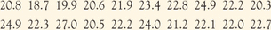
The tips for the 20 customers who received the bad weather message are
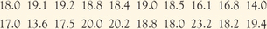
1A. (15 points ) Make histograms for both sets of data. The classes/bins represent the percent tip and the frequency is the number of percent tip that fall into each of the class intervals
1B (10 points) Calculate $\overline{x}$ and standard deviations s for both data sets
1C. (5 points) Using Two-sample t test and state the null and alternative hypothesis.

1D (20 points) At a level of significance α =0.05, perform a two-sample t test. Is there good evidence that the two different messages produce different percent tips? Report your conclusions and show all calculations to support your conclusion
.

- Good weather and tipping. We wish to see there are differences among the tipping percentages for the three experimental conditions (reference: problem 27.35, book p672).

The researchers gave 60 index cards to a waitress at an Italian restaurant in New Jersey. Before delivering the bill to each customer, the waitress randomly selected a card and wrote on the bill the same message that was printed on the index card. Twenty of the cards had the message “The weather is supposed to be really good tomorrow. I hope you enjoy the day!” Another 20 cards contained the message, “The weather is supposed to be not so good tomorrow. I hope you enjoy the day anyway!” The remaining 20 cards were blank, indicating that the waitress was not supposed to write any message. Choosing a card at random ensured that there was a random assignment of the diners to the three experimental conditions. Here are the percentage tips for the three messages:
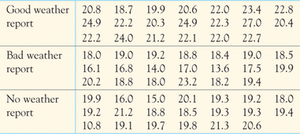
2A. (10 points) Do the data support the hypothesis that there are differences among the tipping percentages for the three experimental conditions? Using ANOVA test and state the null and alternative hypothesis.
2B. (40 points) Perform one way ANOVA test using Excel at a level of significance of α = 0.05 and what is your conclusion? Try to interpret the Excel output of ANAVO
Optional: Extra 20 points
- Using data from problem 2 and calculate the comparative 95 % confidence intervals and draw graphs manually (using graph paper) to compare them, Can you draw any conclusion based on the comparison?

