20.29 Reading scores in Dallas. The Trial Urban District Assessment (TUDA) is a government-sponsored study of student achievement in large urban school districts. TUDA gives a reading test scored from 0 to 500. A score of 243 is a “basic” reading level and a score of 281 is “proficient.” Scores for a random sample of 1400 eighth-graders in Dallas had = 248 with standard error 1.0.¹⁷
(a)We don’t have the 1400 individual scores, but use of the t procedures is surely safe. Why?
(b)Give a 99% confidence interval for the mean score of all Dallas eighth-graders. (Be careful: the report gives the standard error of x, not the standard deviation s.)
(c)Urban children often perform below the basic level. Is there good evidence that the mean for all Dallas eighth-graders is more than the basic level?
20.34 A big toe problem . Hallux abducto valgus (call it HAV) is a deformation of the big toe that often requires surgery. Doctors used X rays to measure the angle (in degrees) of deformity in 38 consecutive patients under the age of 21 who came to a medical center for surgery to correct HAV. The angle is a measure of the seriousness of the deformity. Here are the data:²²
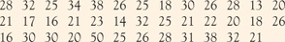
It is reasonable to regard these patients as a random sample of young patients who require HAV surgery. Carry out the Solve and Conclude steps for a 95% confidence interval for the mean HAV angle in the population of all such patients.
20.35 An outlier’s effect. Our bodies have a natural electrical field that is known to help wounds heal. Does changing the field strength slow healing? A series of experiments with newts investigated this question. In one experiment, the two hind limbs of 12 newts were assigned at random to either experimental or control groups. This is a matched pairs design. The electrical field in the experimental limbs was reduced to zero by applying a voltage. The control limbs were left alone. Here are the rates at which new cells closed a razor cut in each limb, in micrometers per hour:²³
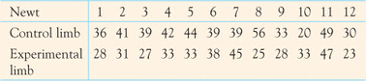
(a)Why is this a matched pairs design? Explain your answer.
(b)Make a stemplot of the differences between limbs of the same newt (control limb minus experimental limb). There is a high outlier.
(c)A good way to judge the effect of an outlier is to do your analysis twice, once with the outlier and a second time without it. Carry out two t tests to see if the mean healing rate is significantly lower in the experimental limbs, with one test including all 12 newts and another omitting the outlier. What are the test statistics and their P-values? Does the outlier have a strong influence on your conclusion?
The following exercises ask you to answer questions from data without having the details outlined for you. The four-step process is illustrated in Example 20.2, Example 20.3, and Example 20.4. The exercise statements give you the State step. Follow the Plan, Solve, and Conclude steps in your work.
20.51 Right versus left . The design of controls and instruments affects how easily people can use them. Timothy Sturm investigated this effect in a course project, asking 25 right-handed students to turn a knob (with their right hands) that moved an indicator by screw action. There were two identical instruments: one with a right-hand thread (the knob turns clockwise), and the other with a left-hand thread (the knob turns counterclockwise). Table 20.4 gives the times in seconds each subject took to move the indicator a fixed distance.³³

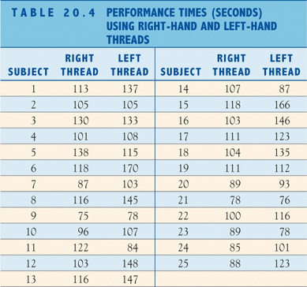
(a)Each of the 25 students used both instruments. Explain briefly how you would use randomization in arranging the experiment.
(b)The project hoped to show that right-handed people find right-hand threads easier to use. Do an analysis that leads to a conclusion about this issue.
20.52 Comparing two drugs . Makers of generic drugs must show that they do not differ significantly from the “reference” drugs that they imitate. One aspect in which drugs might differ is their extent of absorption in the blood. Table 20.5 gives data taken from 20 healthy nonsmoking male subjects for one pair of drugs.³⁴ This is a matched pairs design. Numbers 1 to 20 were assigned at random to the subjects. Subjects 1 to 10 received the generic drug first, followed by the reference drug. Subjects 11 to 20 received the reference drug first, followed by the generic drug. In all cases, a washout period separated the two drugs so that the first had disappeared from the blood before the subject took the second. By randomizing the order, we eliminate the order in which the drugs were administered from being confounded with the difference in the absorption in the blood. Do the drugs differ significantly in the amount absorbed in the blood?

