27.35 Good weather and tipping . Favorable weather has been shown to be associated with increased tipping. Will just the belief that future weather will be favorable lead to higher tips? The researchers gave 60 index cards to a waitress at an Italian restaurant in New Jersey. Before delivering the bill to each customer, the waitress randomly selected a card and wrote on the bill the same message that was printed on the index card. Twenty of the cards had the message “The weather is supposed to be really good tomorrow. I hope you enjoy the day!” Another 20 cards contained the message, “The weather is supposed to be not so good tomorrow. I hope you enjoy the day anyway!” The remaining 20 cards were blank, indicating that the waitress was not supposed to write any message. Choosing a card at random ensured that there was a random assignment of the diners to the three experimental conditions. Here are the percentage tips for the three messages:¹⁹
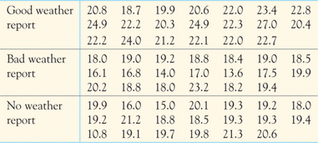
Do the data support the hypothesis that there are differences among the tipping percentages for the three experimental conditions? Does a prediction of good weather seem to increase the tip percentage? Follow the four-step process in data analysis and ANOVA. Be sure to check the conditions for ANOVA and to include an appropriate graph which compares the tipping percentages for the three conditions.
27.37 Logging in the rain forest: Species counts. Table 27.2 gives data on the number of trees per forest plot, the number of species per plot, and species richness. Exercise 27.3 analyzed the effect of logging on number of trees. Exercise 27.8 concludes that it would be risky to use ANOVA to analyze richness. Use software to analyze the effect of logging on the number of species.
(a)Make a table of the group means and standard deviations. Do the standard deviations satisfy our rule of thumb for safe use of ANOVA? What do the means suggest about the effect of logging on the number of species?
(b)Carry out the ANOVA. Report the F statistic and its P-value and state your conclusion

