Problem 6.

Weather and Tipping
In Tech-HW-4, you did ANOVA by Excel. The three data sets and Excel output is below;
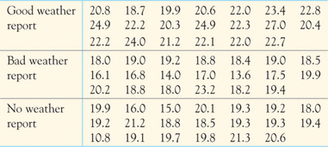
The result of ANOVA is shown below:
SUMMARY
Groups | Count | Sum | Average | Variance | Standard deviation
Good Weather | 20 | 444.4 | 22.22 | 3.837474 | 1.959
bad Weather | 20 | 363.6 | 18.18 | 4.401684 | 2.098
None report | 20 | 374.5 | 18.725 | 5.704079 | 2.388
 |  |  |  | _
ANOVA
Source of Variation | SS | df | MS | F | P-value | F crit
Between Groups | 192.2243 | 2 | 96.11217 | 20.67931 | 1.77E-07 | 3.158843
Within Groups | 264.9215 | 57 | 4.647746
Total | 457.1458 | 59

- We test if there’s differences between weather message and percent tip. State the null and alternative hypothesis

- ANOVA requires that the standard deviation of the groups be the same. What is the rule to determine this condition? Is that rule satisfied in this case?

- At a level of significant of α = 0.05, what is your conclusion about the test?

- What is the pooled standard deviation?

