Labview
ELE 102 Manual

Introduction

Labview is a versatile graphical programming language which, because of its relatively simple user interface, should allow you, the programmer, to be writing functional programs in no time.

This booklet will serve as an introduction to the programming language of Labview and will introduce you to the most important aspects of the programming language, focusing on those parts of Labview you will need to successfully complete the assignments for the Honors Section of Introductory Physics (95.161).

Before we dive in, however, we should understand why we are using Labview and what the advantages and limitations of the program are. Labview is extremely easy to use and, for relatively small programs, easy to debug. All of the programming is done graphically with icons and does not require any sort of complicated syntax. If you can use a mouse, you can program in Labview.

Note that compared to other programming languages, the graphical representation of Labview uses more memory: this reduces the speed of your programs. This is especially true for earlier versions of Labview, though the program has improved in later editions. For our purposes, speed will not be a major concern, so a program like Labview is an ideal introduction to programming.

This manual will walk you through the basics of the Labview programming language. In this course, we will only scratch the surface of Labview’s powerful and extensive capabilities.

The Labview tutorial will consist of the following:

- Getting Started
- Basic Mathematical Functions
- “For” Loops, Sequences, and Plotting
- Boolean Operators, Rings, and Case Structures
- Working with Data Files
- Troubleshooting

We have installed Labview on all the computers in the Physics Department student lounge. If you are having problems in Labview, the help menu in Labview can be of assistance, as well as your TA, and the Labview User Manuals.
- Getting Started

  - On the Windows Start Menu → Programs, click on National Instruments Labview 8.5.
A box will open. On the right side of the box you should see some tabs. If you left-click on the downward-facing black arrow of the New… tab, you will get two choices: New or Blank VI.

  - Select Blank VI.
When you do this, you will see two windows open. The two windows are the “Front Panel” window and the “Block Diagram” window. These two windows are collectively called a blank VI (VI stands for “virtual instrument”). This is the canvas upon which you will write your programs.
The Front Panel window is essentially the control panel of your program – it is where you will input the necessary parameters for your program and also where, oftentimes, the output from your program will be displayed.
The Block Diagram window houses the actual meat and bones of your program. Here is where you will actually ‘write’ the code for your program and where you will process the inputs from the Front Panel.
An appropriate driving metaphor might have the Front Panel as the clutch, gas, brake, gear-shift, steering wheel, dashboard, etc. of your car. The Block Diagram would correspond to the various mechanisms under the hood (engine, radiator, etc.) that actually make the car run.

3) In the Window menu, select Show Tools Palette.
A palette with various blocks on it will appear; this window will allow you to easily switch between the various tools you will need to write your program.
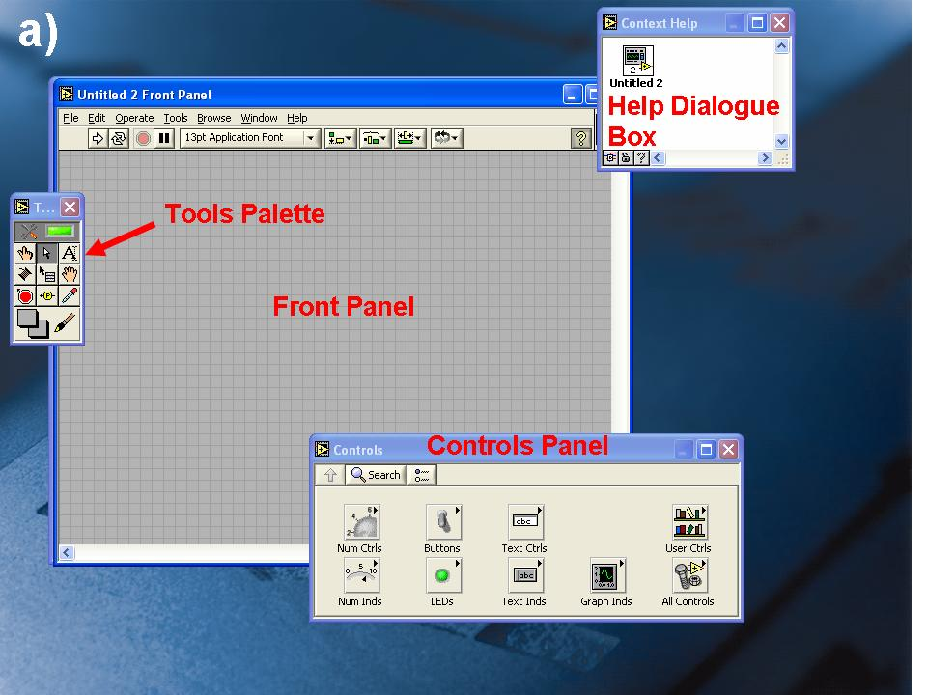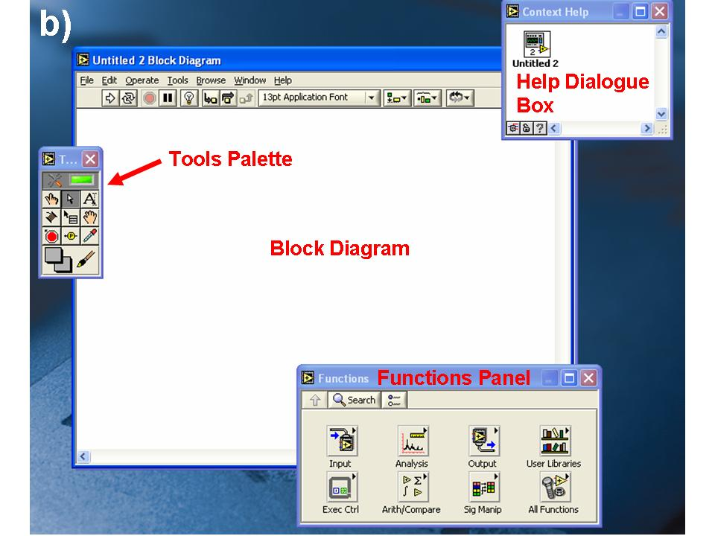
Figure 1: a) Layout of Front Panel b) Layout for Block Diagram panel
When you select the Front Panel, you will also see a window labeled Controls. (If you do not see it, open it by going to Window → Show Controls Palette.) This window is your Controls palette, which will provide you with all the building blocks necessary to construct your Front Panel.
Likewise, when you select the Block Diagram, you should see a Functions palette (Window → Show Functions Palette). This is the Block Diagram equivalent of the Front Panel Controls palette and provides all the tools necessary for building your program in the Block Diagram window.
Finally, you should also see a Help window on the screen (Help → Show Context Help). As you move your mouse over the various figures you will have programmed into your Front Panel or Block Diagram, this window will provide you with information about the various icons comprising your program.

- Basic Mathematical Functions

The first thing you will do is write a simple program that allows you to perform basic mathematical functions. This program will take two inputs, perform a mathematical operation, and display the result.

You will start with a basic multiplication operation. For the program to perform the operation “x times y equals xy” or

x * y = xy

you will need to program with two input variable names and an output variable name: “x”, “y”, and “xy”, respectively.

1) Select the Front Panel, and click on the Num Ctrls icon on the Controls panel.
You will see a new window, with a variety of choices. Each of these choices (Num Ctrl, Fill Slide, Knob, Dial, etc.) is a mechanism for inputting information into your program. Generally, we will simply use Num Ctrl.

2) Click on the Num Ctrl icon.
Your mouse pointer will turn into an open hand.

3) Move the hand to the Front Panel and click where you wish to put the control.
You will see the label “Numeric” highlighted above the control

4) Erase the “Numeric” and type in your own label for the input.
In our case, “x” makes sense.

5) Place another Num Ctrl on the Front Panel, but this time label the control as “y”.
You have just placed the two inputs for your program into the front panel. If you want to enter a number into these controls, you can double-click on the input space (white area) and then type your number. To increment (add) or decrement (subtract) the existing number by one, use the arrows on the left of the input space.
You will want to put a space where you can display the result of your program. Because this is not an input, but rather an output of the program, you will not use a control for this display. Instead you will use an indicator.
Thus, in Labview:

Inputs → Controls
Outputs → Indicators

Because you are now in the Numeric Controls menu of the Controls Panel, hit the “up” button in the top-left corner to get back to the Controls menu.

6) Select Num Inds.
Again, you will have the option of choosing a variety of indicators.
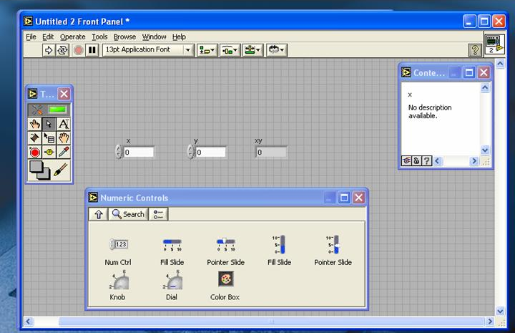
Figure 2: Front Panel after controls “x” and “y” and indicator “xy” have been created. Controls Panel was left in the “Numeric Controls” window. To return to the “Controls” menu, simply click on the “up” arrow in the upper left hand side of the dialogue box.

7) Choose the Num Ind icon, place it on your control panel, and label it “xy”.
We are now ready to go to the block diagram. Before we do, make sure your screen looks something like that shown in Figure 2.

When you go back to the Block Diagram, you should see three rectangles labeled “x”, “y”, and “xy”. These are the graphical representations of the controls and indicators you have just created.
You will notice that the controls have a filled orange border which shows that they are controls and meant to be read by your program. The indicator has an unfilled orange border, labeling it as an indicator and demonstrating that it is meant to be written to instead of read from.

- In the Functions palette, click on the Arith/Compare icon, and then the Numeric icon.
The Numeric window should show you a number of arithmetic operators.

- Choose the multiply operator, and place it on your Block Diagram window.
You now have everything in place to write your program. All that is left is to wire it up.
You will notice that when you put the mouse over the multiply operator, three leads appear, looking like dots with wires protruding slightly from them. These leads are identified in the Help window. For more complicated icons, the Help window not only labels the leads, but describes their purpose and the required input.
As you can see from the Help window, the two leads on the left are for your inputs while the lead on the right is for your output. When you place the mouse cursor over the leads, it will turn into a spool of wire. Clicking on the lead while the pointer is in this form will attach a wire to that lead.

- Attach a wire to the ‘x” lead on the multiply operator, then move your mouse to the “x” rectangle and click.
When a wire can be correctly attached to a control or an indicator, a blinking output lead will appear on the right/left side of that control/indicator.
You have now connected the “x” input to the multiply operator.

- Now do the same for the “y” lead and y rectangle, but click the mouse a couple of times on the Block Diagram “canvas” between the “y” lead and the y rectangle.
You can pin the wire to locations on your block diagram by doing this. This can be helpful for maneuvering wires through more complicated block diagrams.

- Attach a wire between the “xy” rectangle and the output of the multiply operator.
Once you have connected the output lead of the multiply operator to the xy rectangle, you have finished “writing” your program.

- Go back to the Front Panel and enter numbers into the “x” and “y” inputs.
On the upper left hand corner of the front Panel there is a white arrow. This is the run arrow. Clicking the arrow will run your program
If the arrow icon appears broken, there is something wrong with your program. Look for loose wires or misconnected icons.
When the arrow is white, your program will run. Note: a program that is capable of running is in no way a guarantee that it will correctly do what you want it to do!
.
- Click run.
Congratulations! You have just run your first Labview program!

15) Go to File → Save and save your program as “yournamemath”.
This saves your program as a “*.vi” file, which is the Labview format for programs.

Try playing around with your program. Add inputs and/or add operations. Make the math more complex. Familiarize yourself with the numeric operators including the more complicated trigonometric and logarithmic functions.

III) Loops, Sequences, and Plotting

Now that we have mastered the basic set-up for a Labview *.vi program/file, let’s try to write a slightly more complicated program. For this program, you will create a set of numbers, or an array of numbers, and then plot these numbers onto a XY-graph.

1) Open up a new *.vi (File → New VI, or Ctrl + N)
For starters, we will try to create an array consisting of two columns. The first will be the ‘x’ column. The second will be the ‘y’ column, where ‘y’ will be a function of ‘x’. For starters, let’s use the function y = sin(x).
In order to create a graph of y vs. x, you will first need to decide what range of x values you are interested in. For instance, you might want to look at 0 < x < 3.14, at x-intervals of 0.01. In order to determine your range and resolution, you will need to create three controls: the starting point (xstart), the end point (xend), and the resolution (xres). On the Block Diagram window, you should see the variables xstart, xend, and xres displayed.
Because this will be a slightly more complicated *.vi than the yournamemath.vi program in II), we will need to build a sequence. The sequence function is simply a mechanism for chronologically ordering the operations you wish to perform in your program. When Labview encounters a sequence it performs all of the operations programmed into the first frame, “Frame 0”, then moves to the next (“Frame 1”), and the next until it reaches the last frame of the sequence, at which point it moves on to the remaining operation in the program.

- Go to the Functions window (if you don’t see it, just right click the mouse and it should appear), click Exec Ctrl, and select Flat Sequence.

3) Drag your mouse cursor across your Block Diagram window to create a rectangle (it should look like a strip of film).
This is your Sequence.

- Right-click on the edge of the Sequence and select Replace with Stacked Sequence. There are two types of sequences, the “flat” and the “stacked” sequence. From a programming point of view, they are identical. The only difference between the two is the way they are depicted in the Block Diagram window. A stacked sequence shows only one frame at a time, while a flat sequence shows all of the frames at the same time, like a film strip. I find that the stacked sequence is easier to use in a program since it takes up less space, however, many of the freeze screens in this manual use flat sequences, so that you can see the entire sequence in one screen.

- Right-click on the edge of the Stacked Sequence (which looks exactly the same) and select Add Frame After.
You should see a label on the top of the frame appear: “1[1..0]”.
This tells you that you are looking at frame 1 of the two frames in your sequence (frames 0 and 1). To move between frames, click the left and right arrows on either side of this label to move between frames.
When the computer runs your program, it will perform all the requested operations in Frame 0, and then move on and do the same for Frame 1.

Before we start programming, we will need to make a somewhat lengthy digression which will acquaint you with quite a few concepts that you will need to proceed.

A variable in Labview is represented by the rectangle in the Block Diagram window that is created when you place a control or indicator (or Boolean or String, for that matter) on the Front Panel screen. When you create a variable in Labview you may also want to access, or use, that variable more than once in your program. In your previous program, you simply wired your operator directly to the variable. You can imagine that in a complicated program using each variable many times, it could become quite messy to have many wires all going to the same variable.

The solution is called a “local variable”. Local variables are little boxes labeled with the variable’s name which can be used in place of the actual variable of interest throughout your program. We will never wire directly to our variables. Instead, we will always use local variables.

To create a local variable:

i) Right-click on the original variable

ii) Go to Create → Local Variable.
The Local Variable that is created is automatically designed to be written to, i.e. the output of some operation is wired to the local variable. When that operation is performed, the local variable (and thus the original variable) is changed to the value of the output.
If you want to read information from the local variable instead, simply right-click on the local variable and select change to read.

When you defined your resolution (“xres”), your starting point (“xstart”), and your end point (“xend”), you also implicitly defined the number of x-data points you will be plotting. Figure out what the equation is which will give you the number of x data points: it only requires a little math to figure this value out. You will need this value for the program you are now writing. Your program should use “xstart”, “xend” and “xres” to determine the value for “xsteps”. Once you figure out how you will generate ”xsteps”, you have two options for using this new number in your program, both of which will now be explained:

  - Create local variables of each of the three controls “xstart”, “xend”, and “xres”. Change them to read (see above), and then place them inside the sequence.
  - Using the Functions window, create a process that will output the number of points in the x-column

To display a variable or calculated value using an indicator:

In this case, you will display on the Front Panel the number of data points you will be plotting (“xsteps”). Essentially, you are just displaying the value for your own information. Usually, you are not very interested in displaying this number, but sometimes it helps to display results at various points throughout your program before the final result so that you can check for mistakes. This is helpful in debugging, or fixing your program. This is what we will do

i) Go back to the Front Panel, and create a numeric indicator labeled “xsteps”.

ii) In the Block Diagram window, create a local variable (write) called “xsteps” and wire the output of your function into it (see Figure 3).

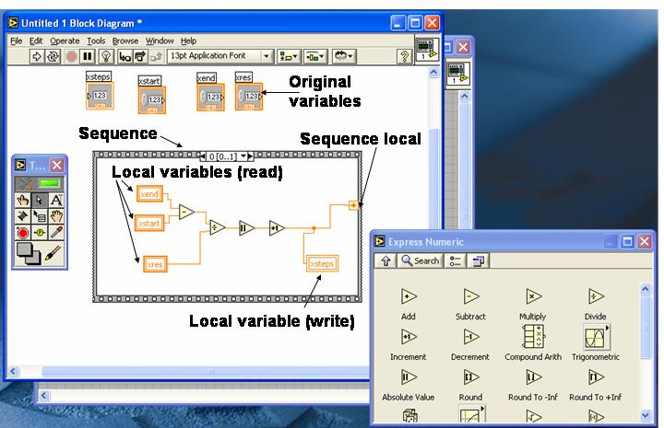
Figure 3: Frame 0 of you sequence, showing the determined number of points in the “x” column wired to the “xsteps” indicator and Sequence Local.

Alternatively, one could eschew the use of an indicator to display a value and instead use wiring to access the number. This is a little tricky because the number will not be used again in this frame of the sequence. Thus, we need to be able to have a way to take the value of “xsteps” we have generated in this frame, and use it in the following frames. To do this, we will use a device called a sequence local.

To display a variable value using wiring:

i) Right-click on the side of the sequence and select Add Sequence Local.
A yellow box will appear on the side of the sequence.

ii) Wire the output corresponding to “xsteps” to this box.
A similar box will appear in the same place on all of the other frames in the program, simply wire to those boxes to access your number in those frames. For the purposes of this tutorial, I will use both the Sequence Local and the Numeric Indicator in my wiring (see Figure 3).

To build a For Loop:

i) Go to the Functions window and select All Functions (we will be using All Functions from now on). Select Structures, and then For Loop.

ii) Drag your mouse across the screen to create the For Loop within the 2nd frame of our sequence.
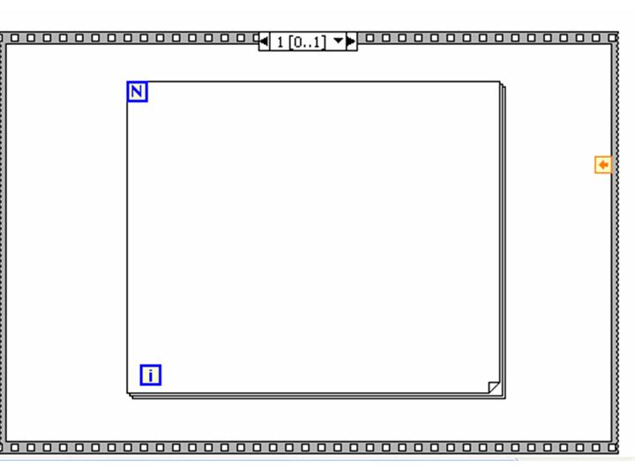
Figure 4: For Loop inside Frame 1 of our sequence. The box with the orange arrow on the right side of the sequence is the output from the sequence local we created in “Frame 0”.
The For Loop can be seen in Figure 4.

There are only two parameters that define a For Loop: N, and i. The routine you put inside the For Loop is referred to as the loop’s subdiagram.

The way N and i are used explains the name “For Loop”. Say you wired the i icon to a multiply icon whose other lead was attached to the number 4. When the Loop starts running, the value of i automatically starts out set to 0. The For Loop in its first loop, or iteration, will calculate 0 * 4 = 0. The program will then go back, or loop back and perform the calculation again, except that this time i = 1. The result of the subdiagram’s calculation for this iteration will then be 1 * 4 = 4.

The For Loop will continue to do this, looping back and incrementing i by 1 in each iteration. The Loop will perform “N” loops, where N is determined by the programmer. Oftentimes, you will want to take some information you created in the n^{th} iteration of the For Loop and use it in the n^{th}+1 iteration. If you want to pass information from one iteration to the next, you will use what is known as a shift register. In many ways, it is very similar to the Sequence Local that we learned about earlier. To create a shift register, simply right-click on the side of the For Loop, and select Add Shift Register.

Now we that we have our tools to write the rest of our program, we will use them.

- Add a Shift Register to your For Loop.

- Wire the appropriate number (“xsteps”) to N either by using the sequence local you created in Frame 0 or by creating a local (read) variable for “xsteps” and wiring it to N. N is always wired from the outside of the For Loop.
Now the For Loop will execute “xsteps” number of loops; one for every point in your x array, i.e. the x values column.

Our next task will be to create a function which generates, in the form of a 1-D array, the x-points we wish to plot.

We know our first point in the 1-D array should be x = “xstart”; our second point in the array should be “xstart” + ”xres”; the next after that should be “xstart” + “xres” * 2 and so on. This is a simple sequence to figure out, so that for the i^{th} point we can say that:

x(i) = xstart + xres * i

- Program this equation in the subdiagram.
This, wiring our x-value equation, is the easy part.

The tricky part is to build an array which will hold our x-points. The first thing we need to do, before we start running our loop, is to create and initialize (set to zero) an array. It is important to initialize the array because Labview will store the array you create in its memory. If you run the program twice in a row, instead of creating a separate array the second time the program is run, it will just add to the first array it created. If you initialize the array each time you run the program, this won’t happen.

To initialize an array:

i) Go to Functions → All Functions → Arrays → Initialize Array.
Place the Initialize Array icon just outside of the For Loop, but inside Frame 1 of the sequence.

ii) To initialize the array, wire the value “0” to both of the inputs on the lower left hand side of the Initialize Array icon.
In order to wire “0”, you will need to create what is known as a numerical constant, and set it to “0”. To create a number, go to Functions → All Functions → Numeric → Numeric Constant and place the number, or numeric constant, on your block diagram. Wire the number into both the “dimension size” and “element” input leads.

This creates a 0x0 array with all elements set to zero.

- Wire the output of the Initialize Array icon into the Left Shift Register (the black downward-facing arrow on the left edge of the For Loop).
What this does is tell the For Loop that the array you are building begins as an initialized, 0x0 array.

10) Next, go to Functions → All Functions → Array → Build Array and place this icon in your For Loop.
Right click on the edge of the Build Array icon and select Add Input.
Your Build Array icon should now have three leads, two input and one output.

- Wire the Left Shift Register to the upper left lead of the build array operator, your value for x(i) (located in the For Loop) into the lower left lead, and wire the Right Shift Register to the right lead.

Your For Loop will now automatically build your x-array.

How a For Loop builds an array:

i) Before the For Loop starts, the array is initialized to 0 and sent to the Build Array icon. A number is also wired to “N”, telling Labview how many iterations to perform. Once this is done, nothing outside of the For Loop will affect the calculations you perform inside the Loop.

ii) At the Build Array step/icon, the output x when i = 0 [ i.e. the function x with i equals 0, x( i = 0 ) ] is added to the array.

Since at first there is nothing in the array because we had initialized it to 0, this just adds the first element of the array.

iii) The new array now is only one element,

array = x( i = 0 )

and this value is sent to the right shift register.

iv) The For Loop now moves on to i = 1.
The value kept in the Right Shift Register shifts to the Left Shift Register.
Once the loop starts running, nothing outside of the loop (i.e. when the
program initializes the array) can have any effect on the loop.

v) For i = 1, the array, now in the left shift register, is transferred to the Build Array icon, where x for i = 1 [ i.e. x( i = 1 ) ], is added to the array.
The new array is sent to the Right Shift Register.
Now the array is two elements, x( i = 0 ) and x( i = 1 ), so that

array = x( i = 0 ), x( i = 1 )

vi) Steps iii) and iv) are repeated, with i incremented each time, until i reaches N-1.
In the end, your For Loop should have done N number of loops, after which your array should be:

array = x( i = 0 ), x( i = 1 ), …, x( i = n-2 ), x( i = n-1 )

The last step which we need to do in creating our array is, once the For Loop stops running, to store the array we have created. To do this we need to create an Array Variable.

- In the Front Panel, go to the Controls palette, select Controls → All Controls → Array & Cluster → Array.
This creates an Array Variable.

- Name your Array Variable “XArray”.
However, we still have to tell Labview what kinds of variables this array holds. You can have arrays of many different types of variables. Labview can deal with arrays of numbers, strings (letters), or even arrays of other arrays. The only requirement is that the array elements must all be of the same data type (strings, numbers, filenames, etc..)

14) Select Controls → Num Inds → Num Ind, and place the Numeric Indicator variable inside the open space of the “XArray” variable.
You have now created a numeric array variable.

- In the Block Diagram, wire the output of the right Shift Register to a “XArray” local variable (write).
You should be able to run the program now.

- Go back to the Front Panel, enter appropriate values into your 3 numeric controls, and run.
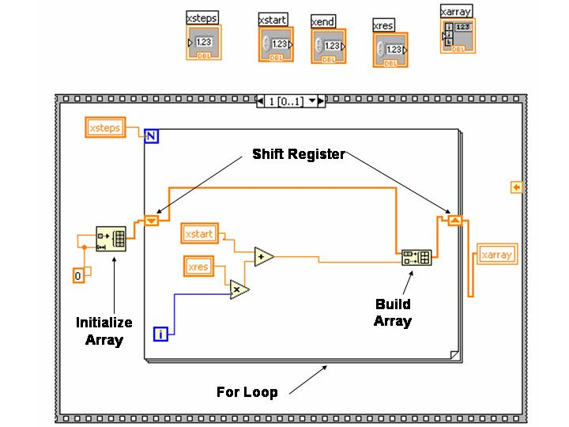
Figure 5: Block diagram of Frame 1 of sequence. Program will now build “xarray”.
Using the up/down arrows on the “XArray” indicator array, you should be able to scroll through the x-array you have just created. The white number on the left indicates the position in the array while the greyed-out number is the value at that location.

Figure 5 shows the Block Diagram of our *.vi at this stage in its development. Now is a good time to save the *.vi (yournameplot.vi).

A simple column of numbers isn’t very interesting – we want to create a plot. To do this, you need to create a second column, the y-column, so that you can plot the x-column vs. the y-column.

Creating the y-column could be done easily by simply repeating the process used to generate the x-column in the same For Loop using a different Build Array icon, a different Shift Register, and different inputs. Instead, we will add another frame to the program, and do it the hard way.

- Add a frame to the Sequence by right-clicking on the edge of your sequence and selecting Add Frame After, then put a For Loop in this frame, and set N = “xsteps”.
This For Loop will generate our y values. It will search through our XArray, pick out the x values corresponding to the “i” value of our loop, generate a y value from this x value, and add the y value to our YArray.
You know how to do all of this except picking out the x-value.

17) Create a local variable (read) of the “XArray” variable, then go to the Functions window, select All Functions → Array → Index Array. Place this in the For Loop.

- To the lead labeled “index” wire the “i” icon. To the lead labeled “array” wire the “XArray” local variable.
The output of the Index Array icon now gives the value of the XArray at the i^{th} element.

Since you want to plot y = sin(x), we simply need to take the sine of the Index Array output, x(i). The sine function can be found in the All Functions → Numeric → Trigonometric menu.

- Wire x(i) into the sine input.

- Use the Build Array icon and another shift register, just as you did for Frame 1, to build your y-column. Store the resulting data by creating a “YArray” variable. Note: you will need to create another Initialize Array operator outside the For Loop and wire “0” into the appropriate inputs, just as you did when you were creating the array of x points.
Now you are ready to plot the data.

- On the Front Panel, select Graph Inds → XY Graph. Place the (rather large) icon on your front panel.

- Go back to the Block Diagram window, add a Frame After to the sequence, and place the entire XYGraph icon into this new frame (Frame 3).

- Create local variables (read) for XArray and YArray, and wire these to the appropriate spots on the XYGraph icon.
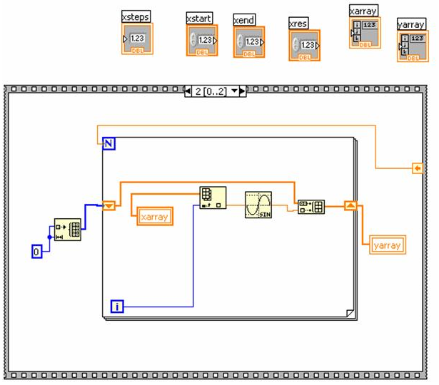
Figure 6: Final Frame 2

- Run your program.
You should see a sine wave generated on the XY plot on the Front Panel.

- Save your *.vi (yournameplot.vi)

26) Go to Save As and save the same file as yournameplot2.vi.

- Boolean operators, Rings, and Case Structures

Using the *.vi you wrote in the previous tutorial, we will now introduce the concepts of Boolian operators, case structures, and rings.

The first adjustment you will make to the program will be to allow the user to choose from a variety of functions to plot. Think of 5 functions you will want to plot where y = f(x). For notational purposes, these will now be referred to as f₁(x), f₂(x), f₃(x), etc.

1) Delete the Sine icon in Frame 2 of the Sequence of your program.

2) In that For Loop, insert a Case Structure (All Functions → Structures → Case Structure).
The case structure is a pretty simple concept. At its most basic, the case structure’s main input is a Boolean, either a “true” or a “false”. Depending on the value of the input Boolean, the case structure will perform different operations.
When you created your case structure, the default Case Structure generated was a true/false case structure (as shown in Figure 7). However, you can change your case structure to perform different operations for a variety of inputs. Figure 7 shows two case structures side by side. For each case, a different operation is performed, and the case structure has a different output. Note that the operation performed depends entirely on the input to the Case Structure. In Fig. 7a), two entirely different operation are performed depending on the input to the structure.

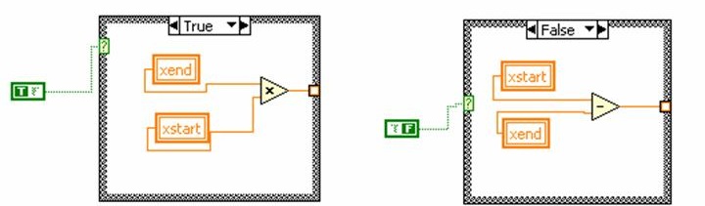
Figure 7: Examples of True/False Case structures. A) The input here is “True”, so the operation “xend” x “xstart” is performed and output from the structure. In b), the input is “False”, so the operation “xstart” – “xend” is performed and output. Note: The operations here are arbitrary and don’t relate to our current program.

3) Go back to the Front Panel. In the Controls palette, select Txt Ctrls → Menu Ring and label the Menu Ring “f(x)” after you’ve placed it on the Front Panel.
The menu ring will allow the user of your program to choose the desired function they wish to plot.

- Right-click on the menu ring icon and select Edit Items; you will see a table appear.
Fill out five of the labels, each describing one of the functions you wish the user to be able to plot.
Go back to the Block Diagram window.

- Create a local variable (read) of your “f(x)” ring variable and wire it into the input of the case structure.

- Right click on the label of the Case Structure and select “Add Case After” and do this until you have 5 cases.
Your cases should be numbered 0 through 4. Each of the choices in your ring menu is also numbered 0 through 4.
When someone chooses, for example, option 3 from the ring menu, the number 2 is fed into the Case Structure and the Case Structure performs the operations programmed into Frame 2. Note that the third choice in your ring menu corresponds to the third frame of the case structure, which is labeled “2”, since the case structure goes from 0 to n-1

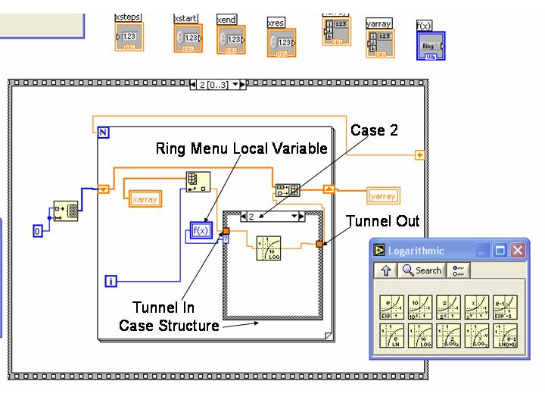
Figure 8: Final diagram for yournameplot2.vi frame2. The function shown for case2 is simply y=f(x)=log(x).
6) Wire x( i ) to the left side of the Case Structure, and wire the right side of the Case Structure to the Build Array icon.
Where each of these wires attaches to the Case Structure, you should see a yellow rectangle. This is a “tunnel” to get data in and out of the structure.
For each case in the structure, you must have something connected to each of the tunnels. If you do not wish to perform an operation on x(i) for a given case, just connect the two tunnels with a wire.

7) Fill in each of the case structures with one of your desired functions f(x). Use the
x( i ) tunnel as your “x”, and wire the output of each function in each case to the output tunnel.

8) Now run the program.
Make sure each case you select from the menu ring gives you the correct plot on your graph.

9) Save this program as yournameplot2.vi.

V) Working with Data Files

At some point in these labs, you will want to read data from a text file or write data to a text file. Labview makes these operations relatively simple.

- Open up yournameplot2.vi and save it as “yournamereadwrite1.vi”.

- In the Block Diagram window, create a new frame between the current Frame 2 and Frame 3, using either Add Frame After or Add Frame Before.
In this frame you will write the data you have created to a file.

- In the All Functions window, select File I/O, and then Write to Spreadsheet File.
Place the newly created Write to Spreadsheet File icon in the new, blank Frame 3.
When Labview performs any operation on a file, it needs to be told the file name and location. This is done through the File Path tab on the Write to Spreadsheet File icon. If you leave this tab blank, a dialogue box will pop up when you run your program, and you will have to choose the file name and location. This is fine for the first time you access (or create) a file, but if you write to or read from the file many times during a program, you do not want to have to manually select the file each time.
To avoid this, you can have Labview remember the file you have created/selected as a variable in your program. These variables are slightly different than the ones you have been using thus far as they are “pathname” variables, not the “numeric” variables in your previous program.

- Leave the File Path tab open, and place new local variables for the “XArray” and “YArray” variables in Frame 3.
You will need to wire the desired data into one of the data input tabs. Because we are interested in storing two arrays (x and y), we will want to wire our data into the 2D Data tab. In order to write both as columns, we will need to combine the arrays.

- Use the All Functions → Array → Build Array icon, and add an input by right-clicking on the icon.

- Wire your XArray local variable into the top input, the YArray variable into the bottom, and wire the Build Array icon output to the 2D Data input of the Write to Spreadsheet File icon.

Because you want to create this data file from scratch, you can leave the Add to File tab unwired. The default setting is a False, meaning a new file.

However, you will need to wire a true constant icon to the Transpose tab. This is because Labview will automatically try to write our data as rows unless we tell it to do otherwise. When you finish this program, try looking at the difference in your files depending on whether the Transpose tab is wired to a true or false constant. The true/false constants can be found in the All Functions → Boolean window.
Additionally, we can choose the “delimiter” for our file. The delimiter is simply the character that will separate the columns of data in our file.
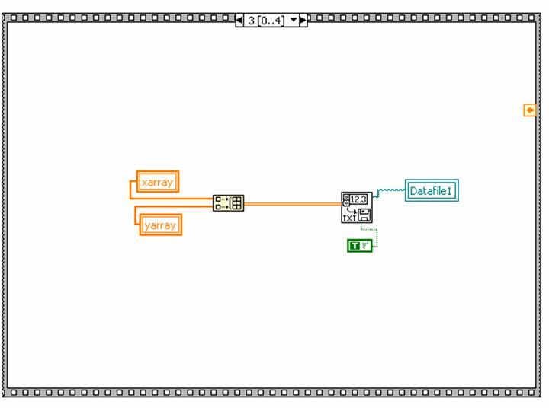
Figure 9: Frame 3 of your program. Shows code for writing data to a spreadsheet file.
By default, the Write to Spreadsheet File icon uses a tab as a delimiter to separate the data. You can wire other characters (a space, comma, etc.) into the delimiter tab to change this.

You want your program to remember the location of the file you have just created when you wish to access it later. To do this, we will carry the filepath information of our data file in a pathname indicator.

To place file location information in a variable:

- Go to the Front Panel and create a pathname indicator (Controls → Text Inds → File Pathname Ind).
Label this Datafile1.
ii) In the Block Diagram window, create a Datafile1 local variable (write), and wire it to the new file path tab of the Write to Spreadsheet File icon.

- Run your program.
When you hit the Run arrow, you should see a dialogue box pop up asking you to name the data file you are about to create. Name the file “data1.txt” and hit OK.
When the program stops running, find the file you just created, open it in Notepad to make sure the file was written correctly. At this point, Frame 3 of “yournamereadwrite1.vi” should look something like what is shown in Figure 9.

Now you will access the data we have just written to our file. This will require opening the “data1.txt” file and reading its contents and plotting your file data by reading the file, not by using not the XArray and YArray local variables as before.

- In Frame 4, erase the XArray and YArray local variables, and in the All Functions → File I/O window, select Read From Spreadsheet File.
Place the icon in Frame 4.

You will need to tell Labview what file to read from. Instead of manually choosing the file, you can just use the local variable we created in Frame 3!

- Simply create a local variable (read) of Datafile1, and wire it into the file path input tab.
Make sure you know that Labview understands what the delimiter is for your data file. If you choose to use commas as a delimiter when you create your text file, you will have to tell Labview this when you try to open the file up and read data from it. Because you chose the default delimiter (tab), you can leave this tab in its default position, i.e. unwired, because this also signifies to use a tab delimiter when reading.

Note: because the data was transposed going into the file (so that the data could be displayed in columns), you will want to transpose the data coming out of our file, so that we are working with rows again. Figure out how to do this.

You will also need to separate the x-data from the y-data in the array we recover from the file. After the data is read and transposed from the file, the output is an array of two rows, each with “xsteps” number of columns. In order to make our graph function work, we will need to extract our x-data and y-data, and then plug them into the XYGraph function.

- Go to All Functions → Array → Array Subset. Place two icons of these Array Subsets, or subarrays, in Frame 4 and wire the array output (hint: how many rows are in the entire array?) of the Read From Spreadsheet File icon to the array input tab of both.
The output of each should go to one of the XInput and YInput tabs of the XYGraph icon.
Each Subarray icon needs to be told which part of the array you want to select.

- For the Subarray wired to the ”X Input” tab, wire “0” to the index input tab, and the local variable “xsteps” to the “length” input tab. For the Subarray wired to the “Y Input” tab, wire “1” to the “index” input tab, and the local variable “xsteps” to the “length” input tab. For both of these Subarrays, wire to the top set of “index” and “length” inputs.
Because our x-axis data is the 0th row, inputting “0’ to the Subarray “index” tab tells the Subarray icon to take the “x” column. Inputting “1” to the other Subarray “index” tab selects the y-axis.
Your Frame 4 should now look like that shown in Figure 10.

- Save your program, and save another copy as “yournamereadwrite2.vi” to use next.

At this point you have been able perform basic read/write operations with spreadsheet files. Spreadsheet files take arrays as input.

You may want to use strings to store information. Strings are simply variables consisting of characters, using something called ASCII to encode the values. In order to get some practice using strings, you will now adjust our “yournamereadwrite1.vi” (now saved as “yournamereadwrite2.vi”) to input the data as strings, not numbers. Additionally, you will do this row by row, instead of saving your data column by column.

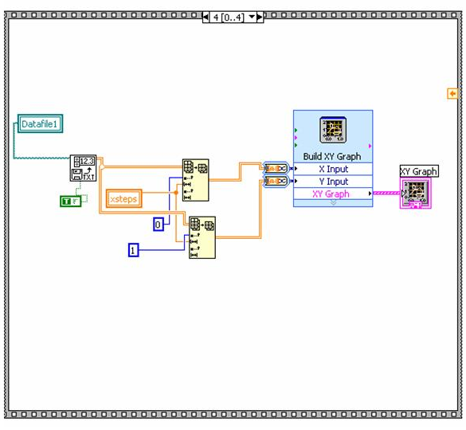
Figure 10: Block diagram for frame 4 of “yournamereadwrite1.vi”. Data is read from the file “Datafile1”, transposed, and read into the XYGraph icon.

Some modifications will have to be made to the program in order to build our next file row by row. More specifically, you will now merge Frames 1 and 2, so that we build our x-array and y-array simultaneously.

You will want to create the data file before we get to the For Loop since you don’t want to open a dialogue box for each iteration of the For Loop.

- Place the All Functions → File I/O → Write Characters to File icon in “Frame 0”

- On the Front Panel, create a string input (Controls → Text Ctrls → String Ctrl), and label it “Description”.
This string will serve as a description of the data file which will be added as a header (to the top) of the file.

- In the Block Diagram window, create a local variable (read) of the “description” string. Place Concatenate String and End of Line Constant icons (All Functions → String) in the frame.

- Wire the “description” local variable to the top left tab of the Concatenate String icon, and wire the End of Line Constant icon to the bottom left tab.
The Concatenate String icon basically acts as an addition operator but for strings instead of numbers.

- Wire the output of the Concatenate String icon to the input of the Write Characters to File icon, and wire the new “file path output” tab to a Datafile1 local variable (write).

- Copy the Case Structure from Frame 2, and paste it into the For Loop of Frame 1.

- Create an “f(x)” local variable (read) and wire it to the input of the Case Structure.

- Create a Shift Register on the For Loop in Frame 1 and wire the value of x( i ) into the input tunnel of the Case Structure.

- Build the y-array using a Build Array icon and the Shift Register, in a similar manner to how you built the x-array in the same For Loop. Think about what you need to create and what you do not.
Look at how you did this in Frame 2. Then, delete Frame 2 (after you have a structure that can build the YArray in Frame 1) by right-clicking on the border of Frame 2 and selecting Delete this Frame. If you need to, remember your previously saved file which contains the structure that builds the YArray.
In order to write to a text file, you will need to change the numbers to strings.

- Place two Number to Engineering String (All Functions → String → String/Number Conversion) icons in the Frame 1 For Loop.

- Wire the x(i) into one of the “number” inputs, and y(i) into the other input.
The outputs of these icons are the number inputs, but in string format.

- Place a new Concatenate Strings (All Functions → String) icon near the Number to Engineering String icons and expand it to have 4 inputs.

- From top to bottom, wire into the Concatenate Strings inputs:
  - the output of the x( i ) Number to Engineering String icon,
  - a Tab Constant, i.e. a tab string constant (All Functions → String),
  - the output of the y( i ) Number to Engineering String icon, and
  - an End of Line Constant (All Functions → String).

- Place a Write Characters to File icon (All Functions → File I/O) in the For Loop and wire the output of the Concatenate String icon to the input that accepts string on the Write Characters to File icon.

- Wire a Datafile1 local variable (read) into the file path input tab. Also, input a true Boolean constant into the “append to file?” Tab.
A true wired to the “append to file?” tab ensures that each iteration of the For Loop adds a row to your file, instead of starting a new file.
Frame 1 should now look like the structure shown in Figure 11.

28) Delete the last two Frames of your program, leaving only Frames 0 and 1.

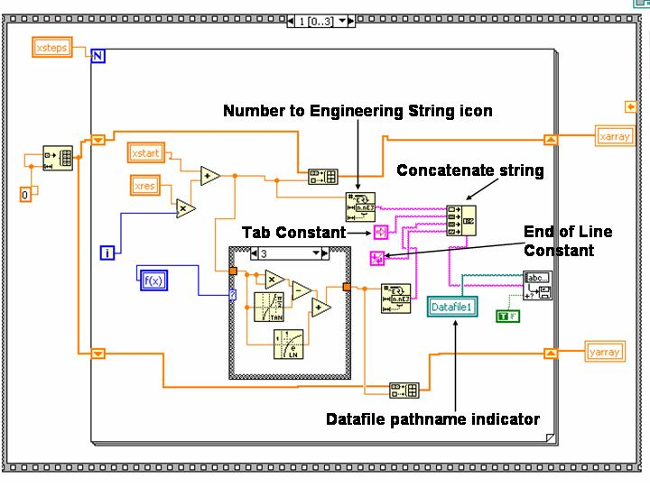
Figure 11: Frame 1 from “yournamereadwrite2.vi”. Data is written to a file in this case as strings instead of as numbers.

Now you have written your data to your file as strings. Like your spreadsheet file, this file can be read, the values extracted, and the data can then be used to create a graph. The rest of the section will give you an outline of how to do this for your new file, but at this point you should be able to figure out the specifics yourself.

28) Create a “Frame After” to be labeled Frame 2, and place a Read Characters from File icon (under File I/O) in the Frame.
A Datafile1 local variable will tell the Read Characters from File icon where to find the data of interest, so wire up one.

- Use a Search and Replace String to search for the header you previously added and replace it with an Empty String Constant. Wire up your program so that this can occur, ask for help only after you have thought about this.
We do this because the output of the Read Characters from File icon still has the Description Header which you do not want for graphing purposes and must shed.

29) Take the remaining string and, using the Spreadsheet String to Array icon, transform the string into a 2D array.

- Transpose the array, and use the same trick you did in the previous section to extract the 1D x-array and y-array from the 2D array.

- Plot the function.

Figure 12 shows what your result should look like.

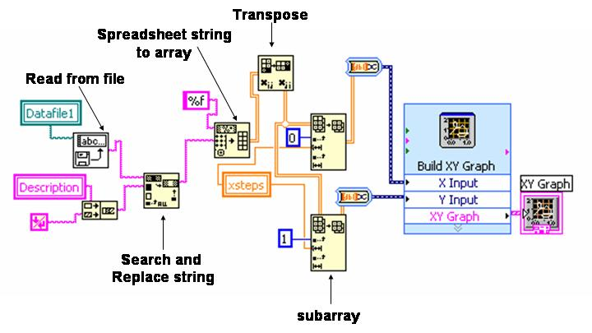
Figure 12: Diagram for extracting array data from string array with header data.

VI) Troubleshooting

Labview has quite a few features which can help you when you run into problems with your program. I will list a few of the most helpful below:

1) Running with a Broken Arrow:

If something is wrong with your program, the “Run” arrow is “broken”. The broken arrow in place of the run button tells you that your program will not run.

A broken run arrow usually means that there is either
a) a broken wire,
b) a mis-wired icon, or
c) you are trying to connect two different data types, i.e. trying to connect an array to a number input or a string output to a numeric indicator.

However, if you try to run with a broken arrow anyway, an error window will appear with a list of the errors in the program. If you click on one of these errors, a longer explanation of the error will appear in a lower window of the error dialogue box. If you double-click on the error message the error will be highlighted in the block diagram so that you can find it.

In Figure 13, I have made a very simple For Loop with N = 10, using two variables, x and y.

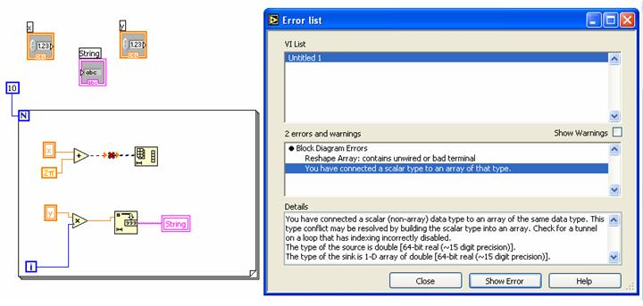
Figure 13: Error list generated by pressing on ‘broken’ run button when a scalar output is connected to an array input.
The y-variable I multiplied by the index i, and then converted the result to a string and wrote it to the string indicator labeled “string”. The x variable is added to 2π and then wired to the input of an array function called Reshape Array.

The input of the Reshape Array function is supposed to be an array, not the number wired to it – the program cannot run. This can be seen by the broken arrow, but also by the red “X” through the wire connecting x + 2π to the Reshape Array function.

2) Using a Probe

Sometimes your program will run, but it will be clear from the output that something has gone haywire in your program. It would be difficult to go through your program piece-by-piece and find where the problem is occurring.

What you could do in this situation is to use the Probe Tool. The Probe Tool is in the Tools Palette when you are in the Block Diagram window. Click on the icon of a “P” in a yellow circle. Your pointer or hand will turn into the Probe Tool.

If you click the Probe Tool on a wire or lead in your program, a little box will pop up in which the value at that node during a running program will appear.

In Figure 14, you can see two nodes which were placed on either side of a Number to Integer Decimal String icon. In the two probe windows, the numbers for i = 10 are shown. While probes are quite useful, they can be difficult to use alone because Labview runs so fast and makes it difficult (or nearly impossible) to read the numbers in the probe window as the program runs.

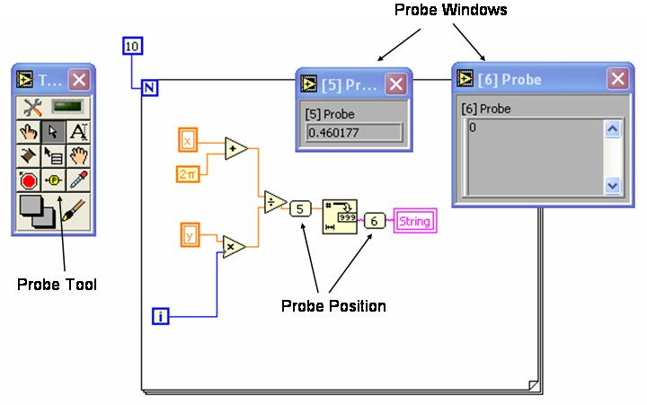
Figure 14: Simple arithmetic program with number to string conversion. Probes have been placed on wither side of the conversion, both are reading values for i=10.

If you would like to read probe values as the program runs, you should use the Stop Tool. After having placed your probes down in the desired locations in your Block Diagram, click on the Stop Tool button in the Tools Palette, which funnily enough looks like a stop sign.

With the Stop Tool, click on one of the probes. The border will become red. From now on, every time you run your program, the program will pause at that probe and will not continue until you hit the Pause button to the right of the run arrow.

You are not limited to placing the Stop Button on probes, though this is the best use for the button; you may also place the stop anywhere you like, e.g. on the actual For Loop, on mathematical functions, on Case Structures, etc.

To remove the stop, just click on a stop location with the Stop Tool.

To remove a probe, simply close the probe window.

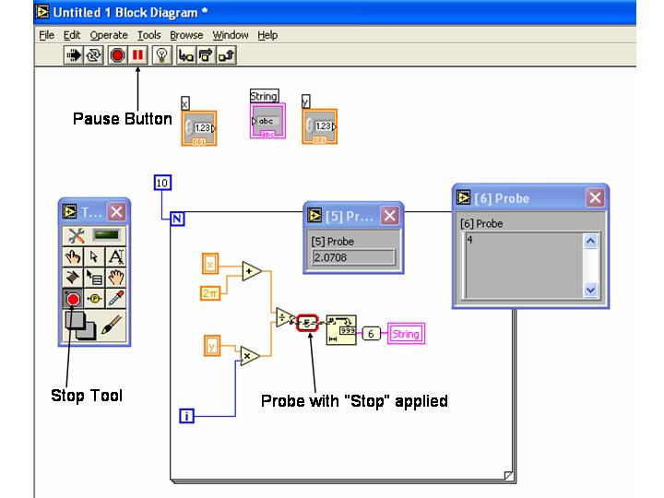
Figure 15: Block diagram screen during pause in run due to stop placed on probe site before Number to Integer Decimal String icon.

3) Highlight Execution

The final tool for troubleshooting is the Highlight Execution button. This button lies directly to the right of the Pause button on the Run toolbar.

If you select the Highlight Execution button before running your program, your program will run in slow motion and you will be able to see the data as it travels along the wires in your program. This button essentially puts a probe at every node and on every wire in your program, allowing you to see everything in your program as it runs.

For a long program, it can be tiresome to troubleshoot using this method, especially if you already have an idea as to where the bug might be. If you have no clue where your problem might be, the highlight execution feature is especially helpful.

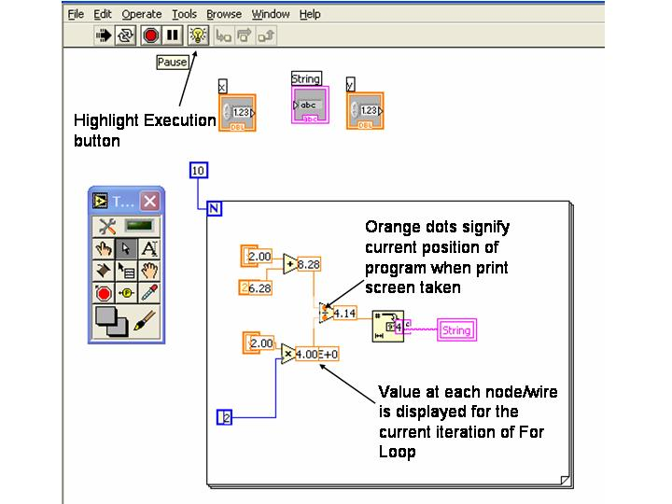
Figure 16: Frozen screen from program run using highlight execution feature.

