[Collect summaries of section 4.1]

Section 4.1:

Key concepts?
..?..
..?..
Absolute (or global) vs. relative (or local) maxima and minima, critical numbers

A function f with domain D has a global maximum at c if f(c) ≥ f(x) for all x in the domain of f. We call f(c) the maximum value of f on D. We say f has a local maximum at c if f(c) ≥ f(x) for all x in some suitably small neighborhood of c (note: this requires that f(x) is defined in some neighborhood of c, so that in particular c cannot be an endpoint of D).

Equivalently, f has a local maximum at c if there exists some δ > 0 such that f is defined for all x in (c–δ, c+δ) and the restriction of f to the interval (c–δ, c+δ) has a global maximum at c.

Global and local minima are defined in the same way, using ≤ instead of ≥.

Note that the function f(x) = x with domain [0,1] has no local maximum or minimum! It does however have a global maximum (at c=1) and a global minimum (at c=0).
The function f(x) = x with domain (0,1) has no global or local maxima or minima!

Ditto for the function f(x) = x with domain R.

The function f(x) = cos x with domain R has global maxima at all points c=2nπ ; it also has local maxima there. It has global and local minima at all points c=(2n+1)π .
What’s an example of a local minimum that is not a global minimum?
..?..
..?..
f(x) = –(x²–1)² with c=0 (with domain R).

Other goods examples are x sin x:
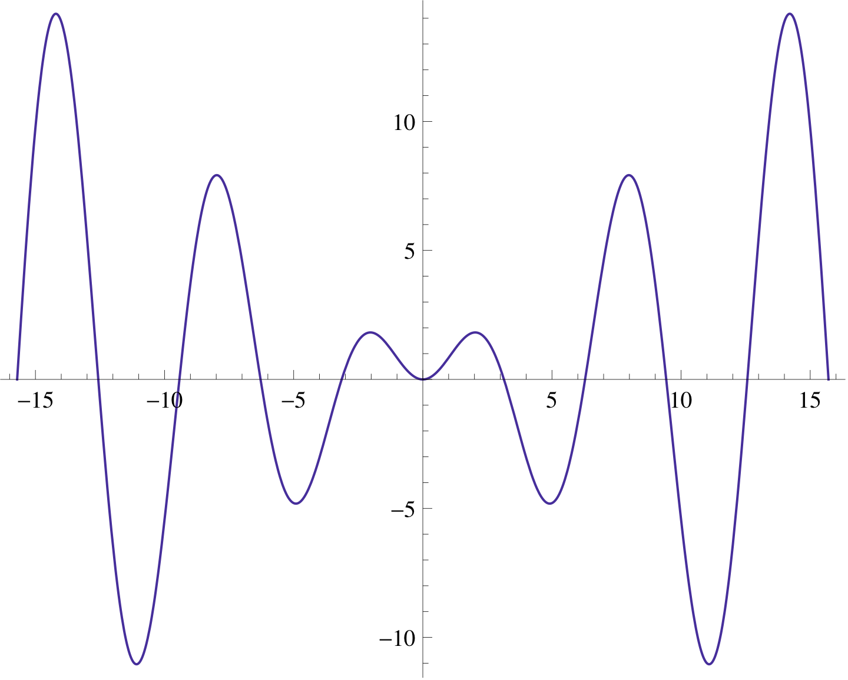
and x³ – 3x:
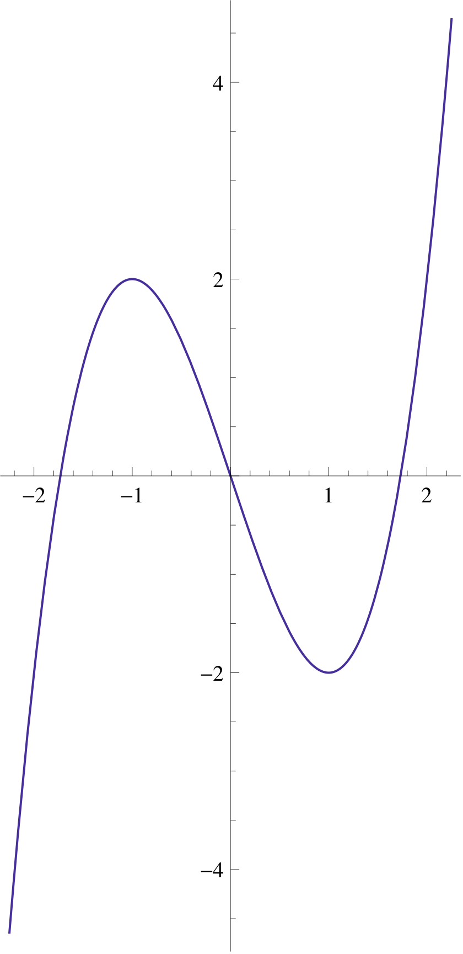
What’s an example of a global minimum that is not a local minimum?
..?..
..?..
f(x) = sqrt(x) with domain D = [0,∞) with c=0.
This is basically the only way this can happen; c must be an endpoint of D. But what’s an endpoint? If the domain of f is the set of irrational numbers, say, then in a sense every x is an endpoint, because the function is undefined for some values in every small neighborhood of every point! But usually D will be an interval or union of intervals, so this sort of issue won’t arise.

If f(x) is defined for all x in some neighborhood (c–δ, c+δ) of the point c (with δ > 0), and f(x) has a global maximum at c, then f(x) has a local maximum at c; and similarly for global and local minima.

Can a global maximum also be a global minimum?
..?..
..?..
Yes, when the function f is constant.
This is the only way this can happen, because if f(c) ≥ f(x) for all x and f(c) ≤ f(x) for all x, then f(c) = f(x) for all x.

Theorem 3 (Extreme Value Theorem): If f is continuous on the closed interval [a,b], then there exist c and d in [a,b] such that f(x) ≤ f(c) for all x in [a,b] and f(x) ≥ f(d) for all x in [a,b]. That is, every continuous function whose domain is a closed interval must have a global maximum value f(c) and a global minimum value f(d).

[Draw a picture; have the students try to disprove it graphically, and see what goes wrong.]

Example: f(x) = x³–x on the interval [–1,1].
Somewhere around c=–.6, the function takes on its maximum value, which is somewhere around .4; f(x) ≤ f(c) for all x in [–1,1].
Somewhere around d=+.6, the function takes on its minimum value, which is somewhere around –.4; f(x) ≥ f(d) for all x in [–1,1].

Is the Extreme Value Theorem true for all functions f (not just the continuous ones)?
..?..
..?..
No; e.g.,
{x² for –1<x<1
f(x) = {0 if x=1 or x=–1
{undefined otherwise
has no global maximum. [Sketch it.]

Is the Extreme Value Theorem still true if the domain of f is permitted to be the open interval (a,b) instead of the closed interval [a,b]?
..?..
..?..
No; e.g., f(x) = x on (–1,1), or f(x) = x² on (0,1).

How do we find global maxima and minima for a function on a closed interval?
We look at endpoints and local maxima and minima.
How do we find local maxima and minima?
We look at all the critical points.

Definition: A critical number of a function f is a number c in the domain of f such that either f ′(c) = 0 or f ′(c) does not exist.

Fermat’s Theorem: If f has a local maximum or minimum at c, then c is a critical number of f.

Note: This does NOT say that every critical number gives a local maximum or minimum.

Examples:

Example 1: f(x) = x². c=0 is a critical number since f ′(0) = 0. f has a local minimum at c=0.

Example 2: f(x) = –x². c=0 is a critical number since f ′(0) = 0. f has a local maximum at c=0.

Example 3: f(x) = x³. c=0 is a critical number since f ′(0) = 0. f has neither a local maximum nor a local minimum at c=0.

Example 4: f(x) = |x|. c=0 is a critical number since f ′(0) is undefined. f has a local minimum at c=0.

Example 5: f(x) = –|x|. c=0 is a critical number since f ′(0) is undefined. f has a local maximum at c=0.

Example 6: f(x) = the cube root of x. c=0 is a critical number since f ′(0) is undefined, but f has neither a local maximum nor a local minimum at c=0.
Upshot: To find the global maximum and minimum values that a function f takes in the interval [a,b], look at the endpoints a and b, and all critical numbers c, i.e., all numbers c for which f ′(c) is either 0 or undefined.

Example: f(x) = x³ – x on the interval [–1,1].
The endpoints are x=–1 and x=1, and the critical points are where
f ′(x) = 3x² – 1 = 0, i.e., x=±sqrt(1/3). So look at all four points:
f(–1) = 0.
f(1) = 0.
f(sqrt(1/3)) = 1/3 sqrt(1/3) – sqrt(1/3) = –2/3 sqrt(1/3)
≈ –.3849.
f(–sqrt(1/3)) = 2/3 sqrt(1/3) ≈ .3849.
The biggest of these four numbers is .3849, and the smallest is –.3849, so these are the global maximum value and global minimum value, respectively.

Example: f(x) = x³ – x on the interval [–2,2].
Look at the four candidate points:
f(–2) =–6.
f(2) = 6.
f(sqrt(1/3)) ≈ –.3849.
f(–sqrt(1/3)) ≈ .3849.
The biggest of these four numbers is 6, and the smallest is
–6, so these are the global maximum value and global minimum value, respectively.

Question: Is 1 a critical number of 1/(1–x)²?
..?..
..?..
“The derivative of (1–x)^{–2} is (–2)(1–x)^{–3}(–1) = 2/(1–x)³, which is undefined at x=1, so 1 is a critical number.”
..?..
..?..
Nope: the original function 1/(1–x)² is undefined at 1, so 1 can’t be a critical number (look back at the definition).

